Console-Based Quiz Application

**Developed by:** Sanjana V U

**Institution Name:** G-TEC JAINx Education Yelahanka Center

**Date:** 24/10/2024

# Context Table

|  |  |  |
| --- | --- | --- |
| Sl. No. | Topic | Page No. |
| 1 | Introduction | 03 |
| 2 | Purpose | 04 |
| 3 | System Requirements | 05 |
| 4 | Application Areas | 06 |
| 5 | Technology | 07 |
| 6 | Architecture | 08 |
| 7 | Source Code | 09-40 |
| 8 | Screenshots | 41-43 |
| 9 | Conclusion | 44 |

# 01. Introduction to the Console-Based Quiz Application

The Console-Based Quiz Application is designed to provide an interactive and engaging quiz experience for users. It features a series of 10 multiple-choice questions, each worth 100 points if answered correctly. Users can utilize one of three lifelines to assist them with difficult questions. The codebase is simplified by encapsulating all functionality within a single Quiz class.

**Lifelines for Strategic Help:**  
Players can access three lifelines, each designed to offer unique advantages:

* **50:50 Lifeline:** Removes two incorrect options, leaving one correct and one incorrect answer.
* **Ask the Audience:** Simulates a poll, providing a hint based on a majority response. (This lifeline is randomized to maintain unpredictability.)
* **Flip the Question:** Allows the user to skip the current question and receive a new one. This lifeline can only be used once.

# 02. Purpose of the Project

## Core Purpose

The application's goal is to serve as an educational and entertaining tool for users. It helps to sharpen users' logical reasoning and decision-making abilities by presenting them with a mix of easy and challenging questions across different topics.

## Detailed Key Benefits

**• Logical and Critical Thinking:** Users apply their knowledge and reasoning skills to make the correct choice. Lifelines offer strategic decision-making options.  
**• User Engagement:** The quiz enhances knowledge retention across diverse topics.  
**• Entertainment with Education:** It functions as a fun competition among friends, making learning enjoyable.

# 03. System Requirements

## Hardware Requirements

• Minimum: Dual-core processor, 4GB RAM  
• Recommended: Quad-core processor, 8GB RAM

## Software Requirements

• Java Development Kit (JDK) 8 or above: Ensures compatibility across systems.  
• Eclipse IDE: Provides debugging and code management for Java-based projects.

# 04. Application Areas

## Educational Use Cases

**• Classroom Environment:** Teachers can use the quiz for testing subject knowledge.  
**• Self-Assessment Tool:** Students can take quizzes for independent learning.

## Entertainment Use Cases

**• Game Nights:** Suitable for friendly competitions among friends.  
**• Game Show Prototypes:** Expandable to professional formats with timers and interfaces.

## Corporate Use Cases

**• Employee Training:** Corporates can use the quiz to make learning more interactive.

# 05. Technology Description

* **Java:**  
  The application uses Java for its object-oriented features and modular design, which make the code easier to maintain and extend. Java’s strong type checking minimizes runtime errors, while its robust exception handling mechanisms ensure stability even in edge cases. Additionally, Java’s JVM (Java Virtual Machine) ensures that the quiz can run on any platform with JVM support, adding platform independence. Its versatility and widespread adoption make it an excellent choice for developing console-based applications.
* **Eclipse IDE:**  
  Eclipse IDE simplifies the development process with advanced features like syntax highlighting, integrated debugging tools, and auto-completion. These tools accelerate code writing and troubleshooting, allowing developers to identify and fix errors efficiently. Eclipse supports fast code testing and iteration, helping maintain high code quality. The Java Development Tools (JDT) extension within Eclipse is particularly useful for Java projects, providing structured project management and build tools to streamline the workflow.
* **Console-Based Interaction:**  
  The application leverages console-based interaction, making it lightweight and ensuring it does not depend on graphical interfaces. This design choice promotes platform independence, as it can run on any system with terminal or command-line support. Additionally, it consumes minimal memory and processing power, making it suitable for low-spec machines. Console-based applications are easier to deploy and require fewer resources, which adds to the simplicity and effectiveness of the quiz application.

# 06. Architecture of the Quiz Class

* **User Input Collection:**  
  Collects basic user data, such as name, age, qualification, and occupation. This personalizes the quiz experience and makes users feel more involved. Basic input validation ensures meaningful data collection.
* **Readiness Confirmation:**  
  Before the quiz begins, the user is asked if they are ready to proceed. This interaction ensures the user is prepared and helps create a smooth user experience without rushing them.
* **Quiz Logic:**  
  Manages the entire question-answer flow and score tracking. Each correct answer awards 100 points, while incorrect answers leave the score unchanged. The quiz asks each question only once, ensuring a streamlined flow. Future enhancements could introduce randomized questions for variety.
* **Lifeline Management:**

1. **50:50:** Removes two incorrect options, increasing the odds of selecting the right one.
2. **Ask the Audience:** Simulates audience advice with random poll results.
3. **Flip the Question:** Replaces a tough question with a new one.  
   Each lifeline is available only once, adding a strategic layer to the quiz.

* **Quiz Completion and Scoring:**  
  After answering all questions, the total score is displayed. This offers closure and highlights the user’s performance. Personalized feedback can encourage users to improve or celebrate high scores, adding a sense of achievement.

# 07. Source Code

The source code is implemented in Java with a single class to manage the entire quiz functionality. The design ensures modularity and reusability.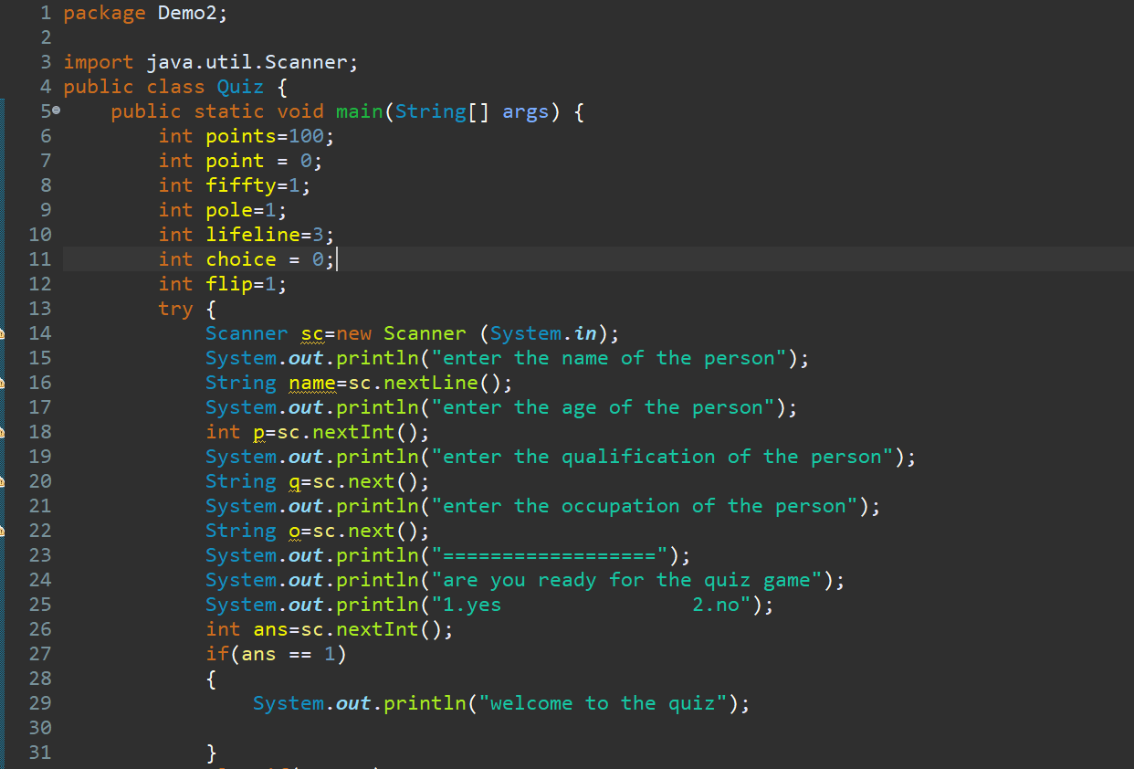 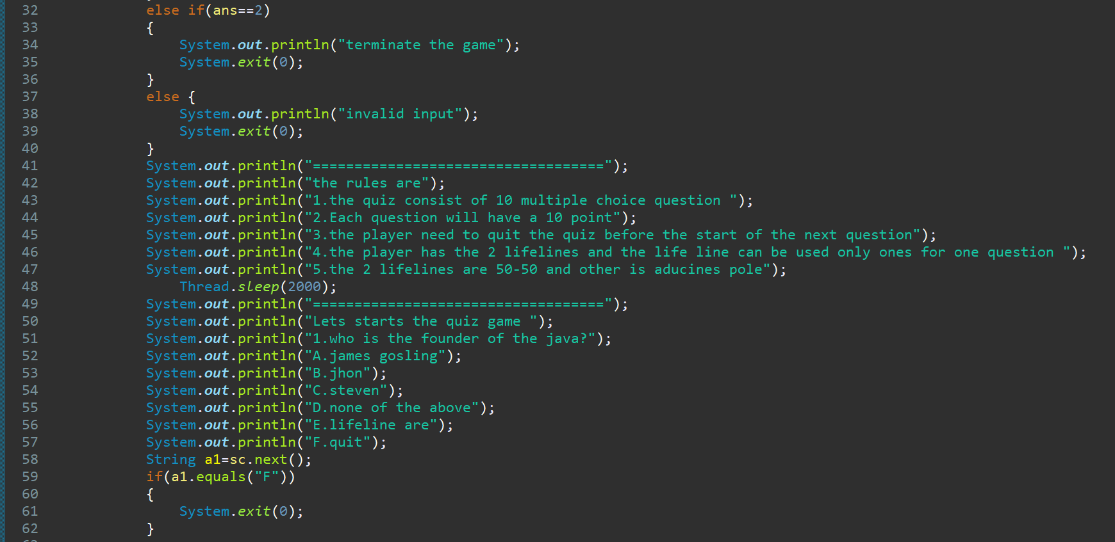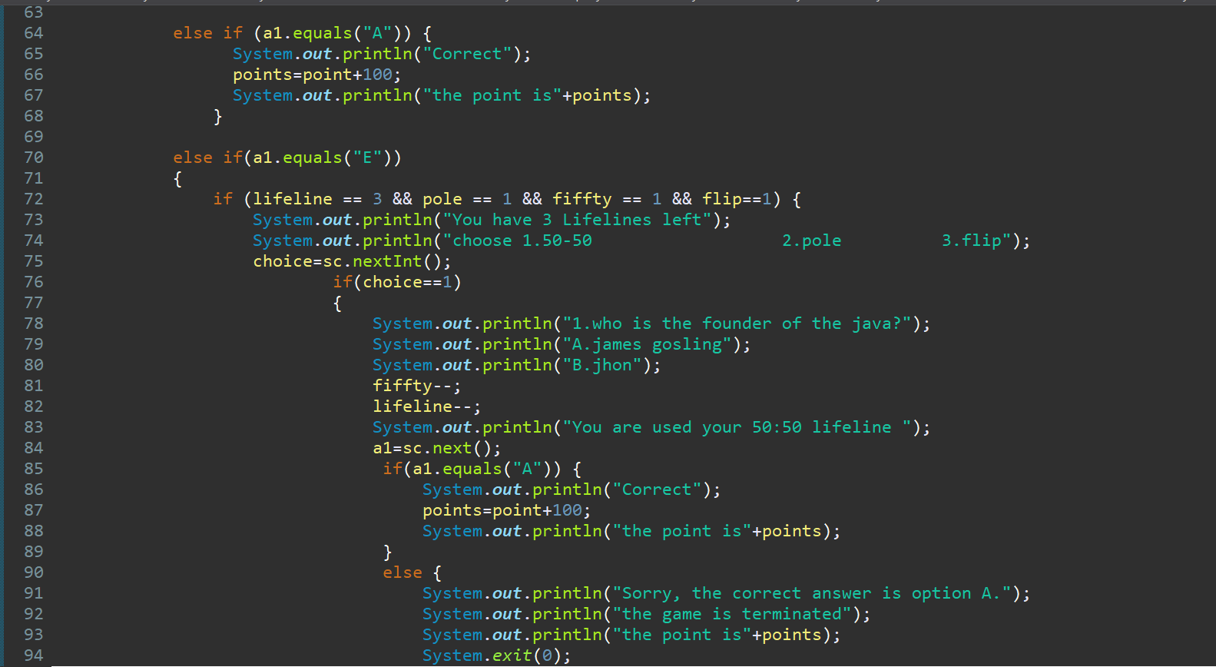

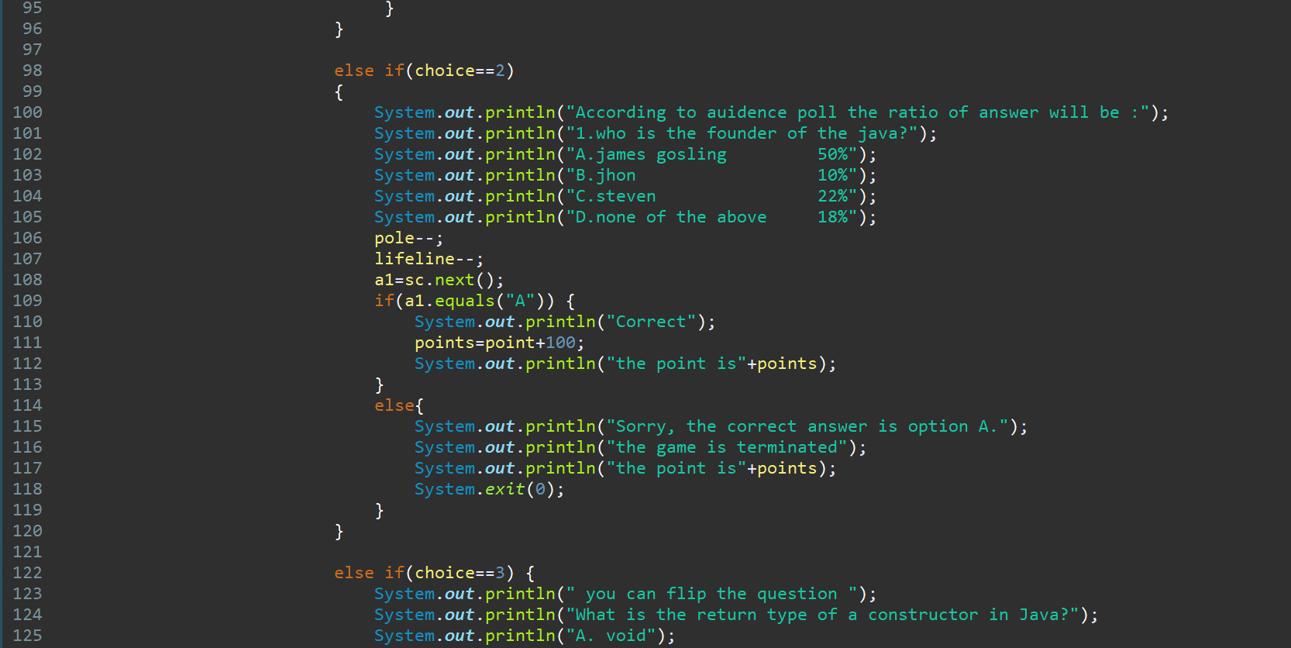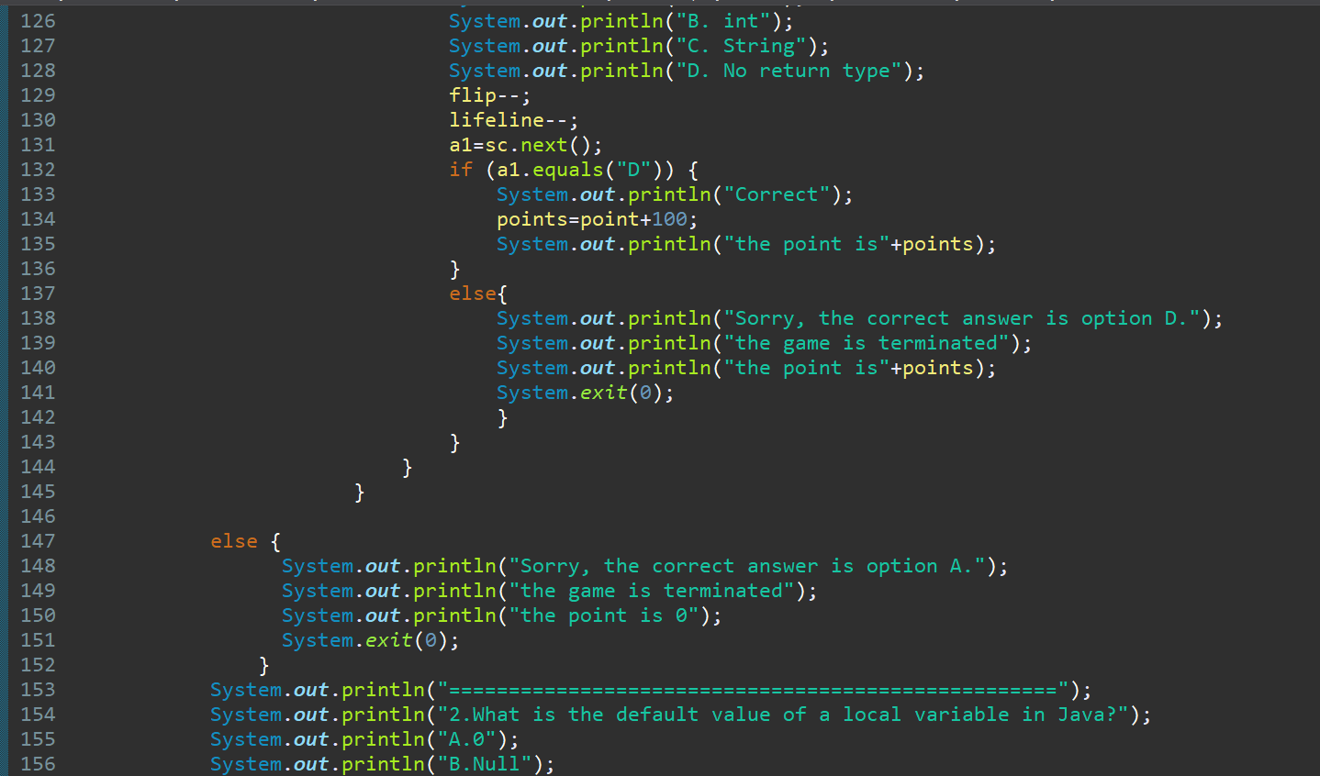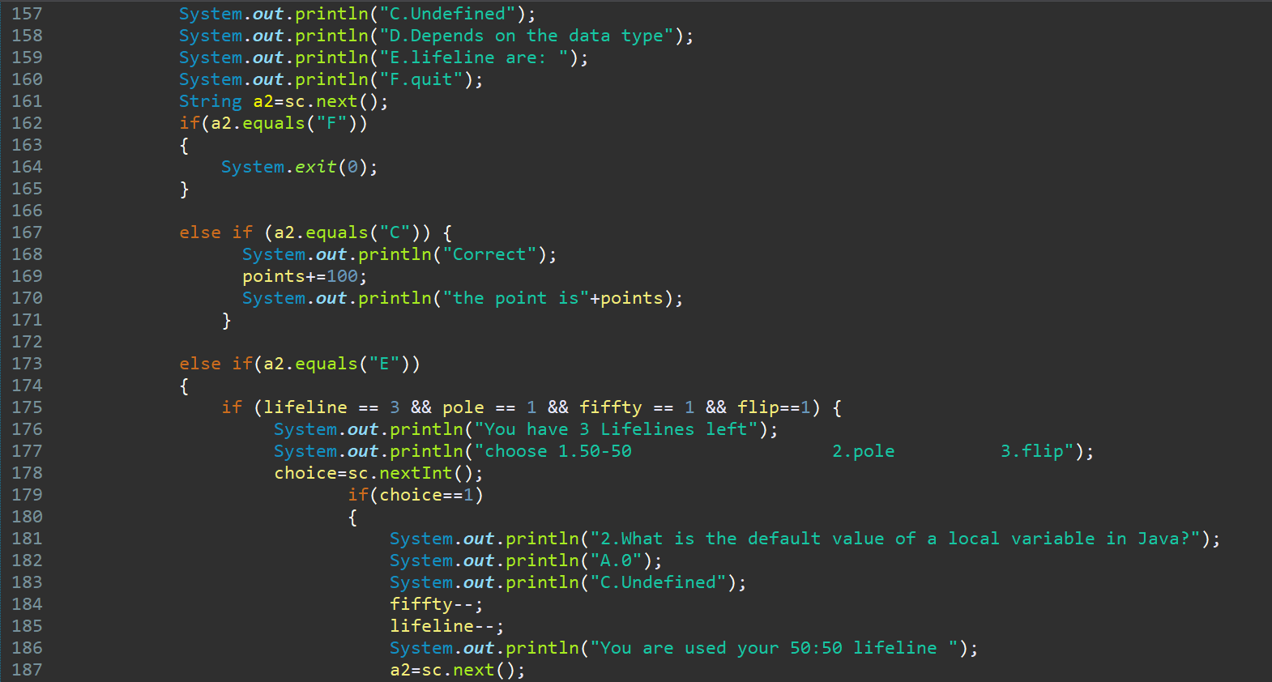

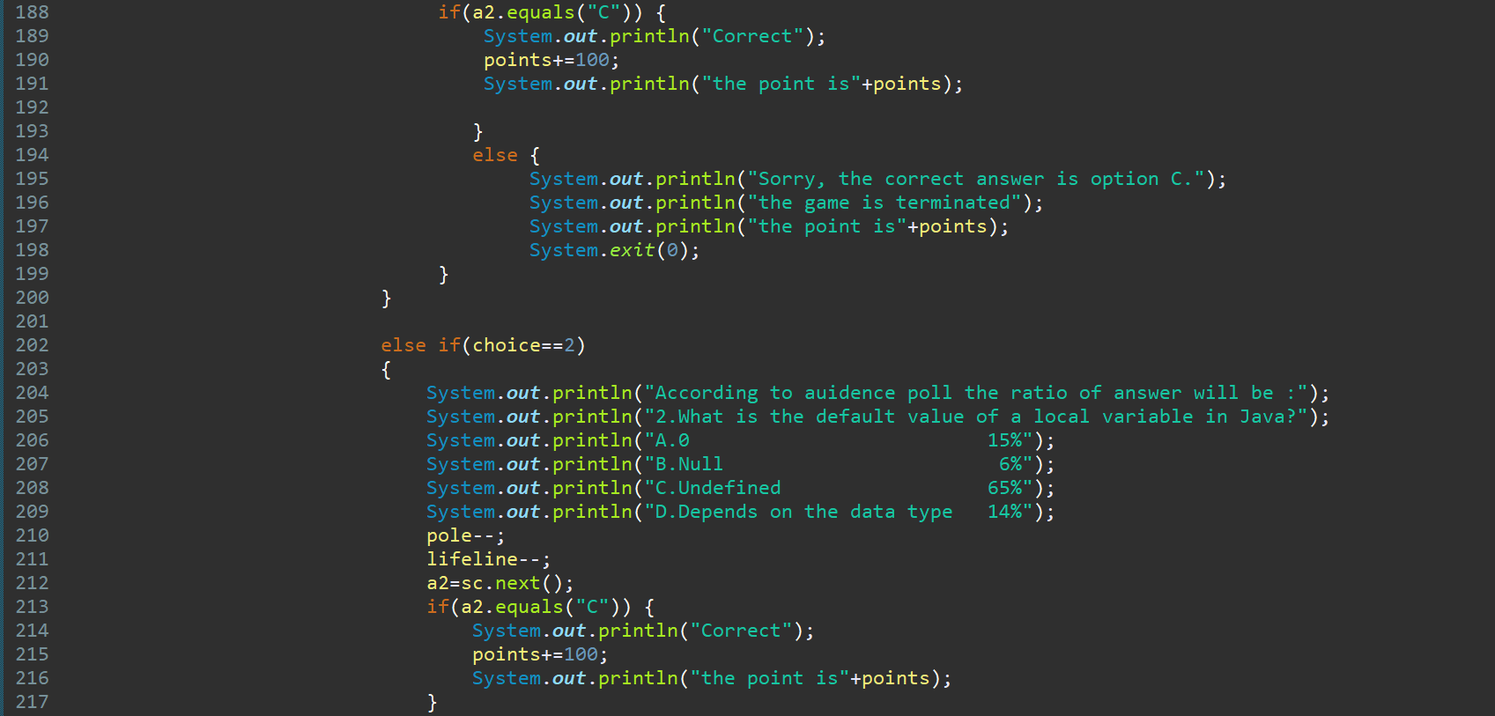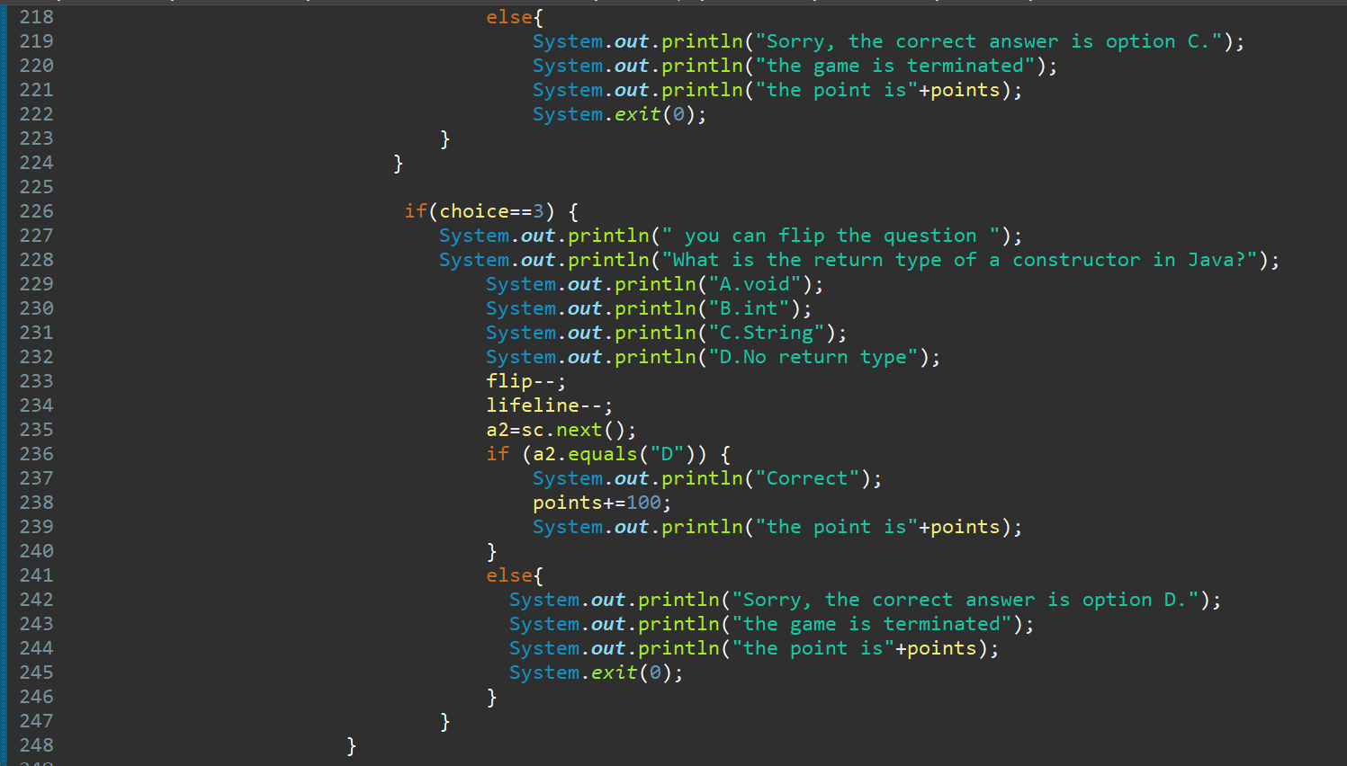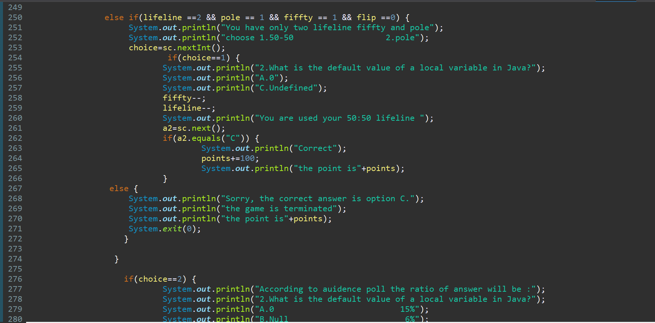

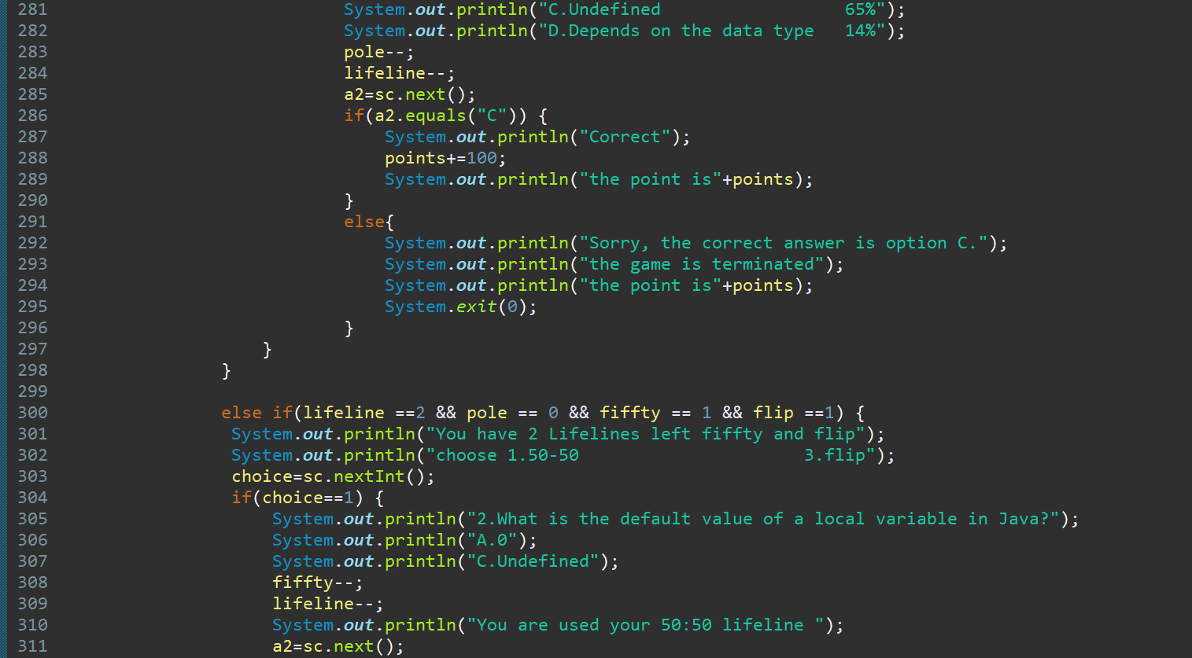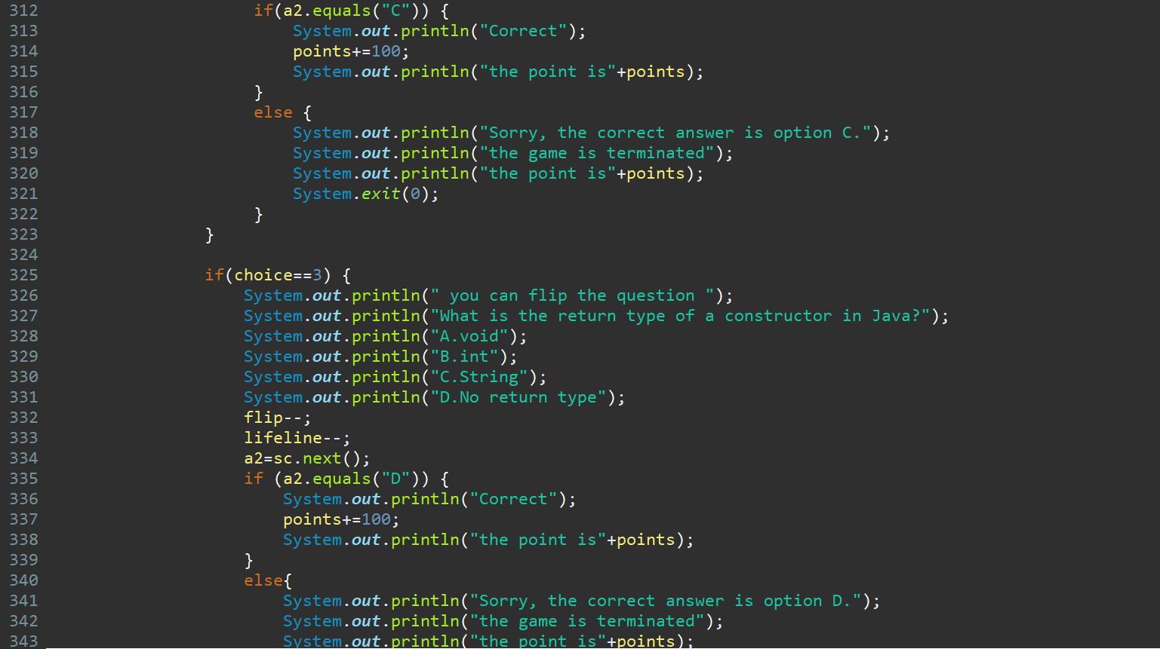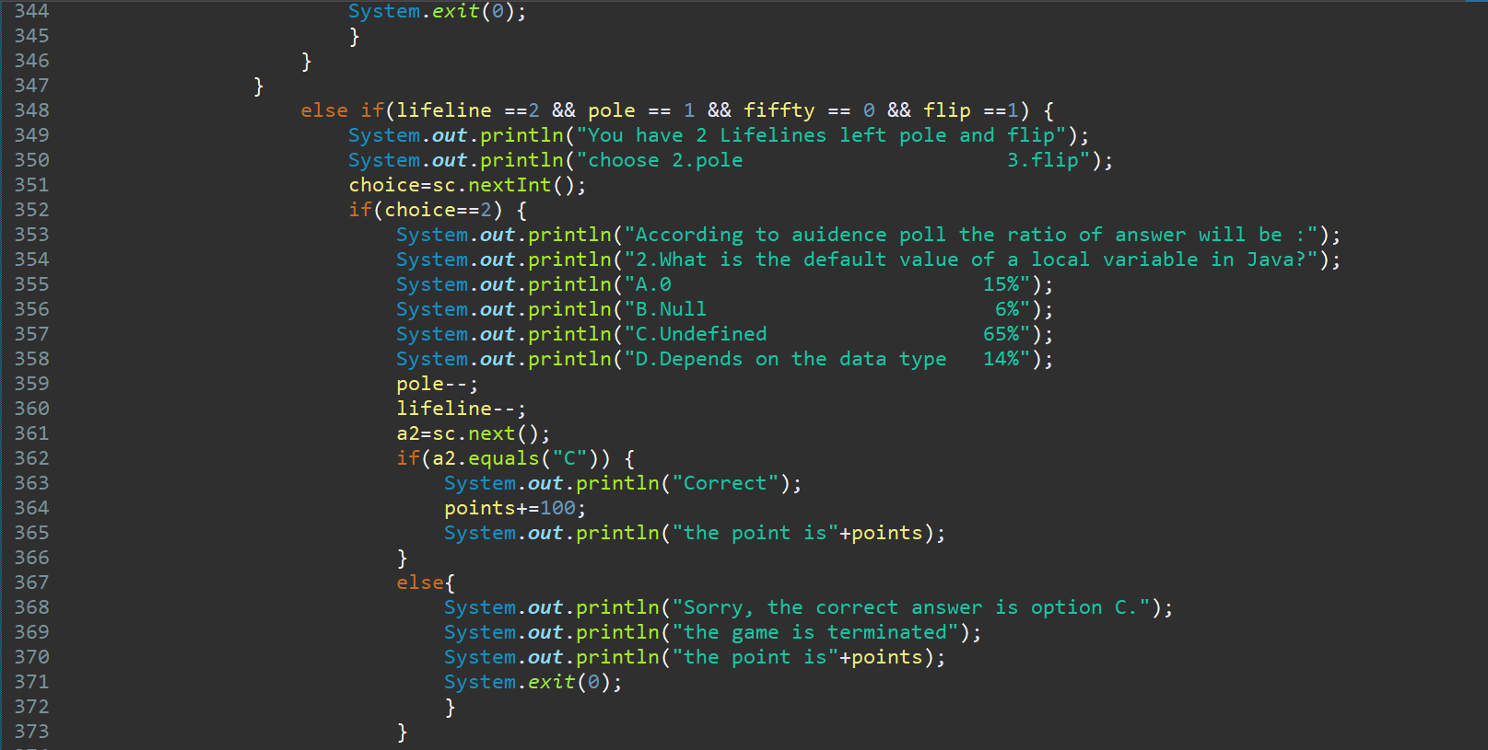

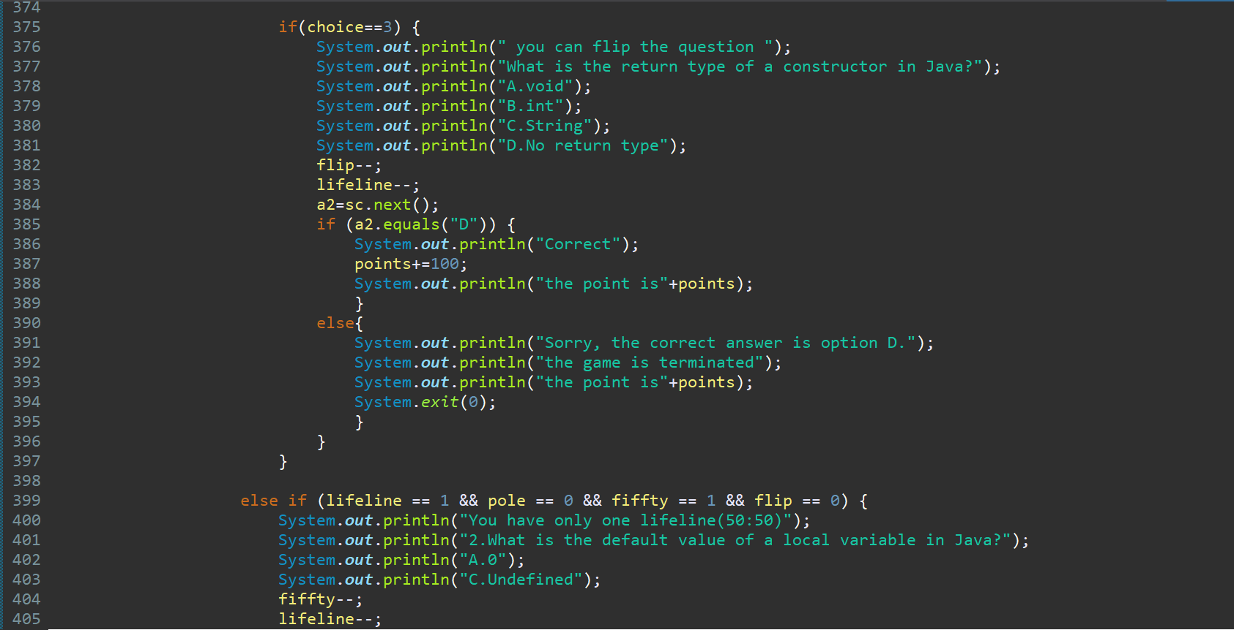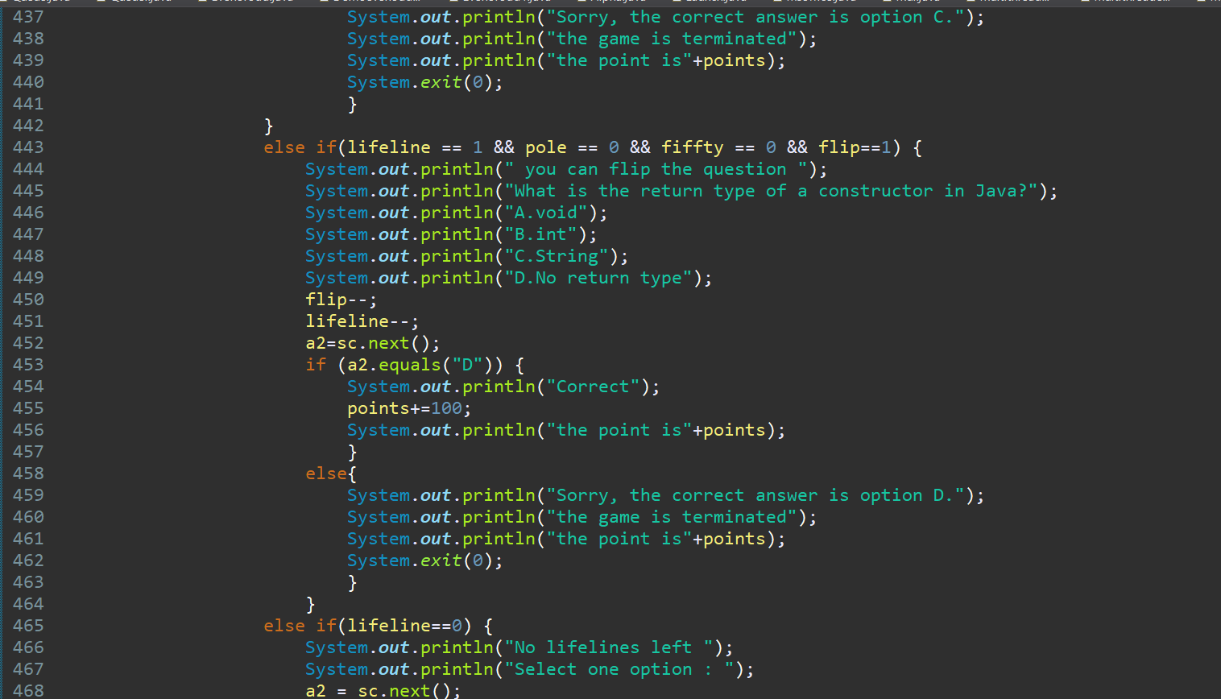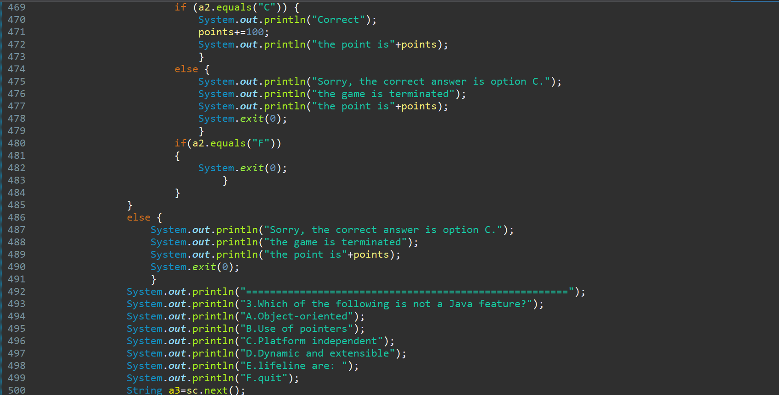

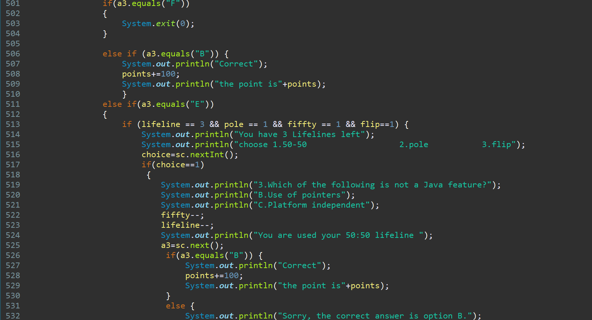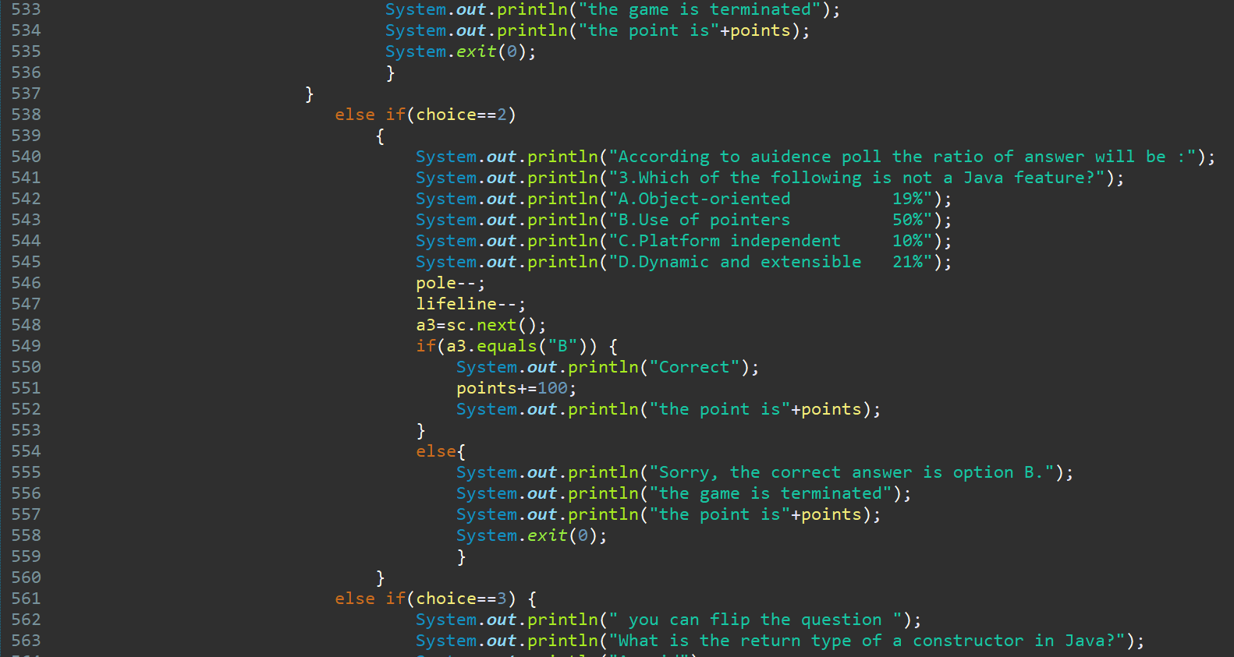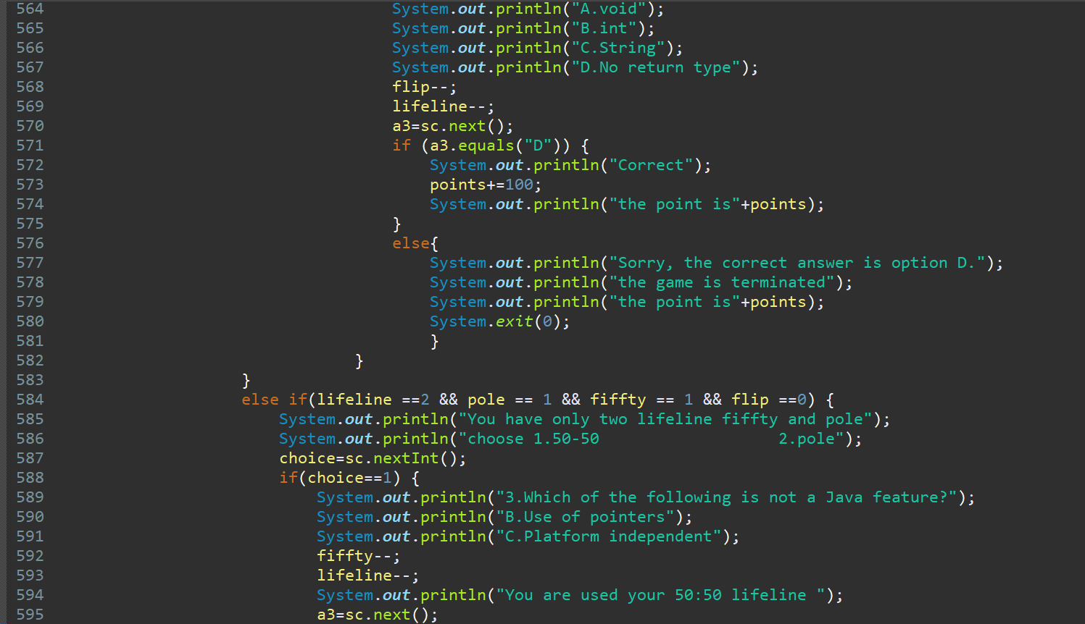

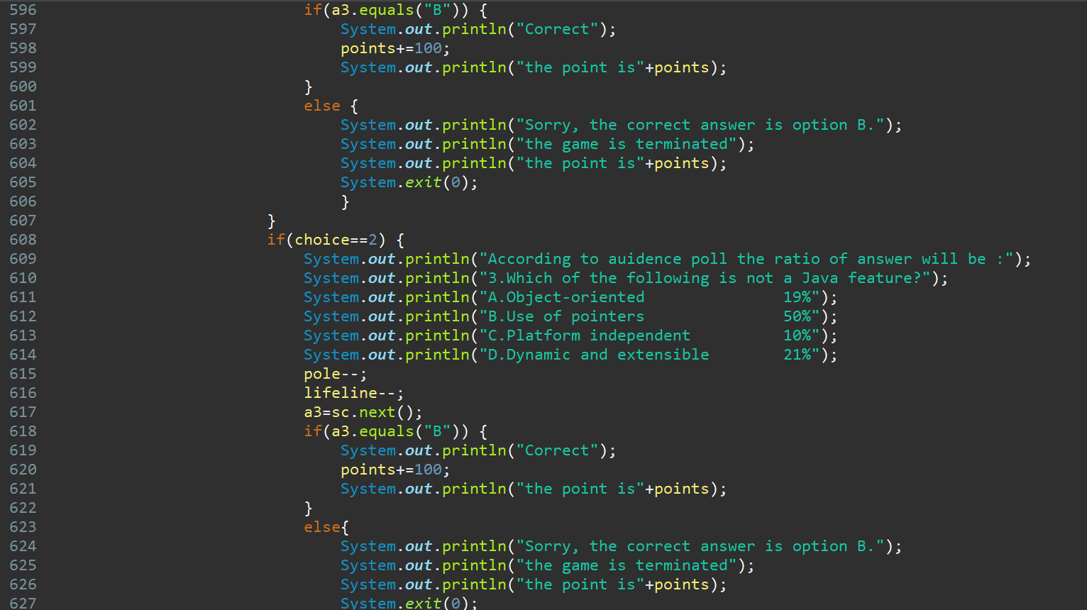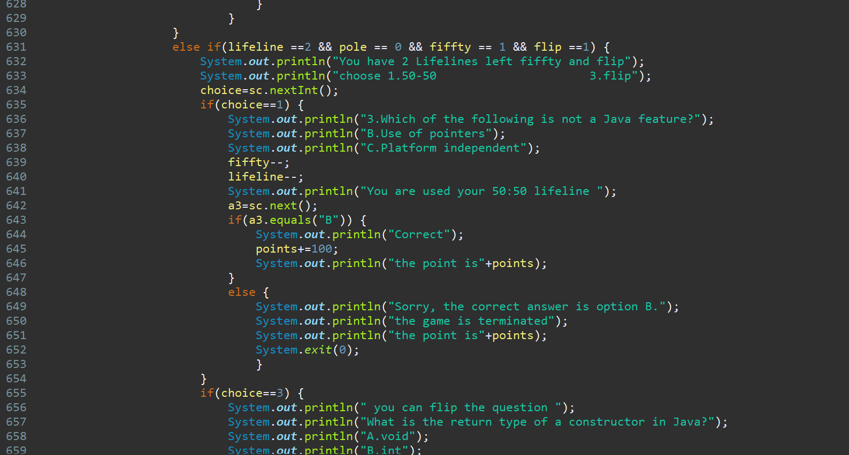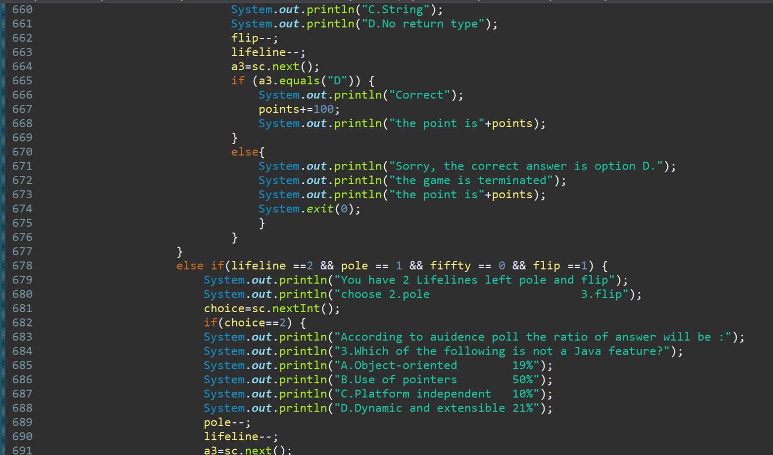

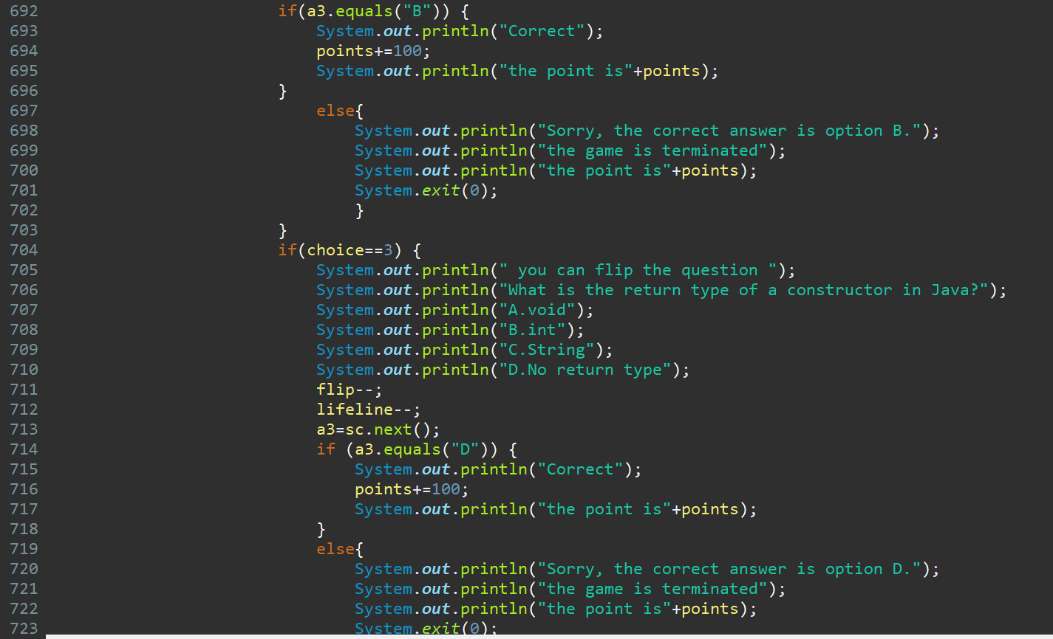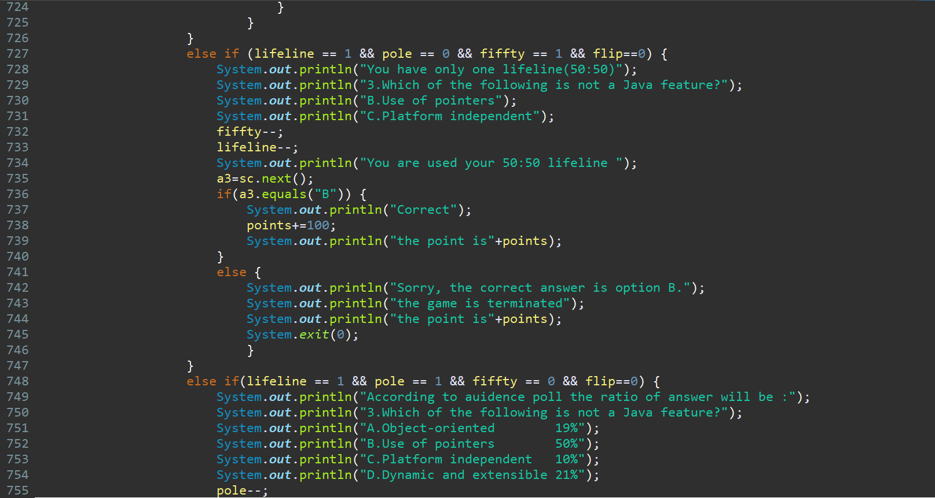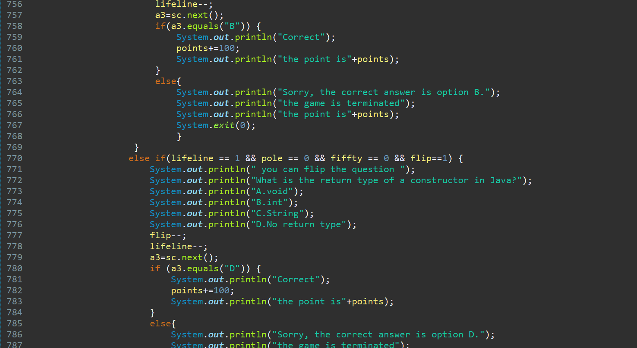

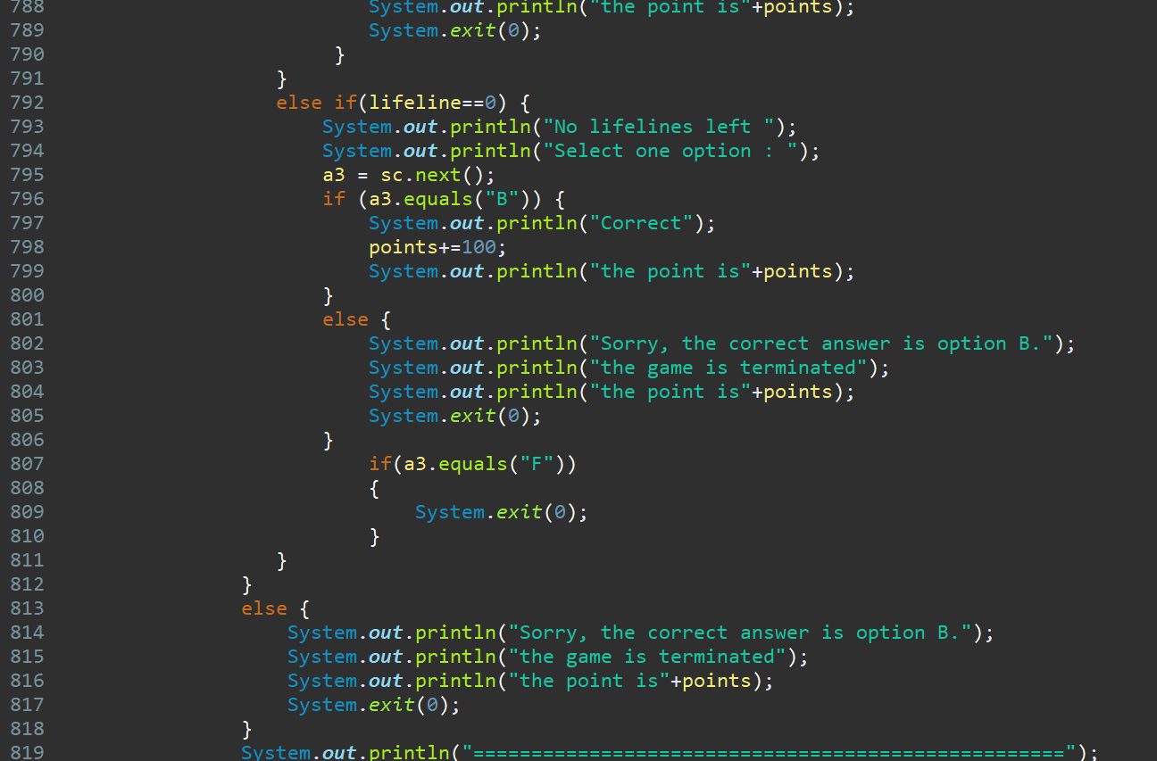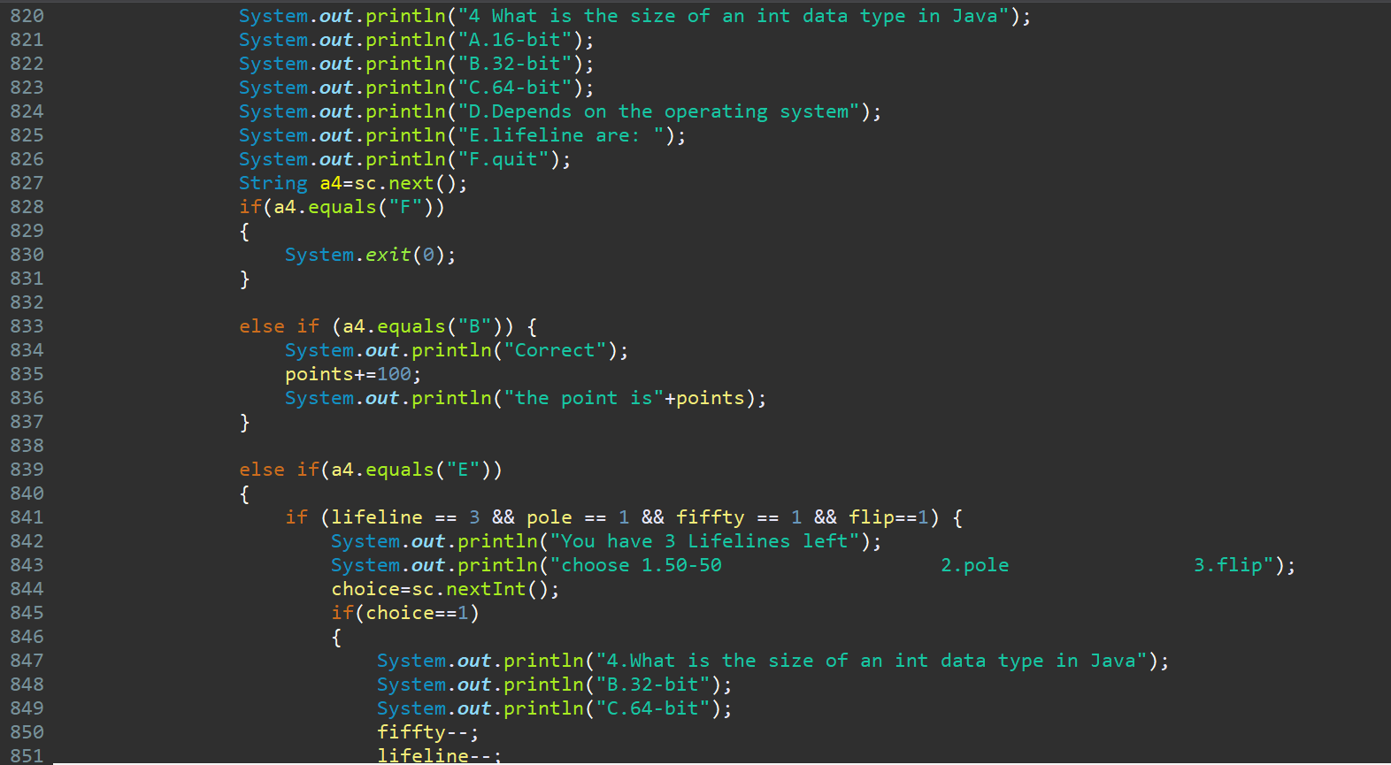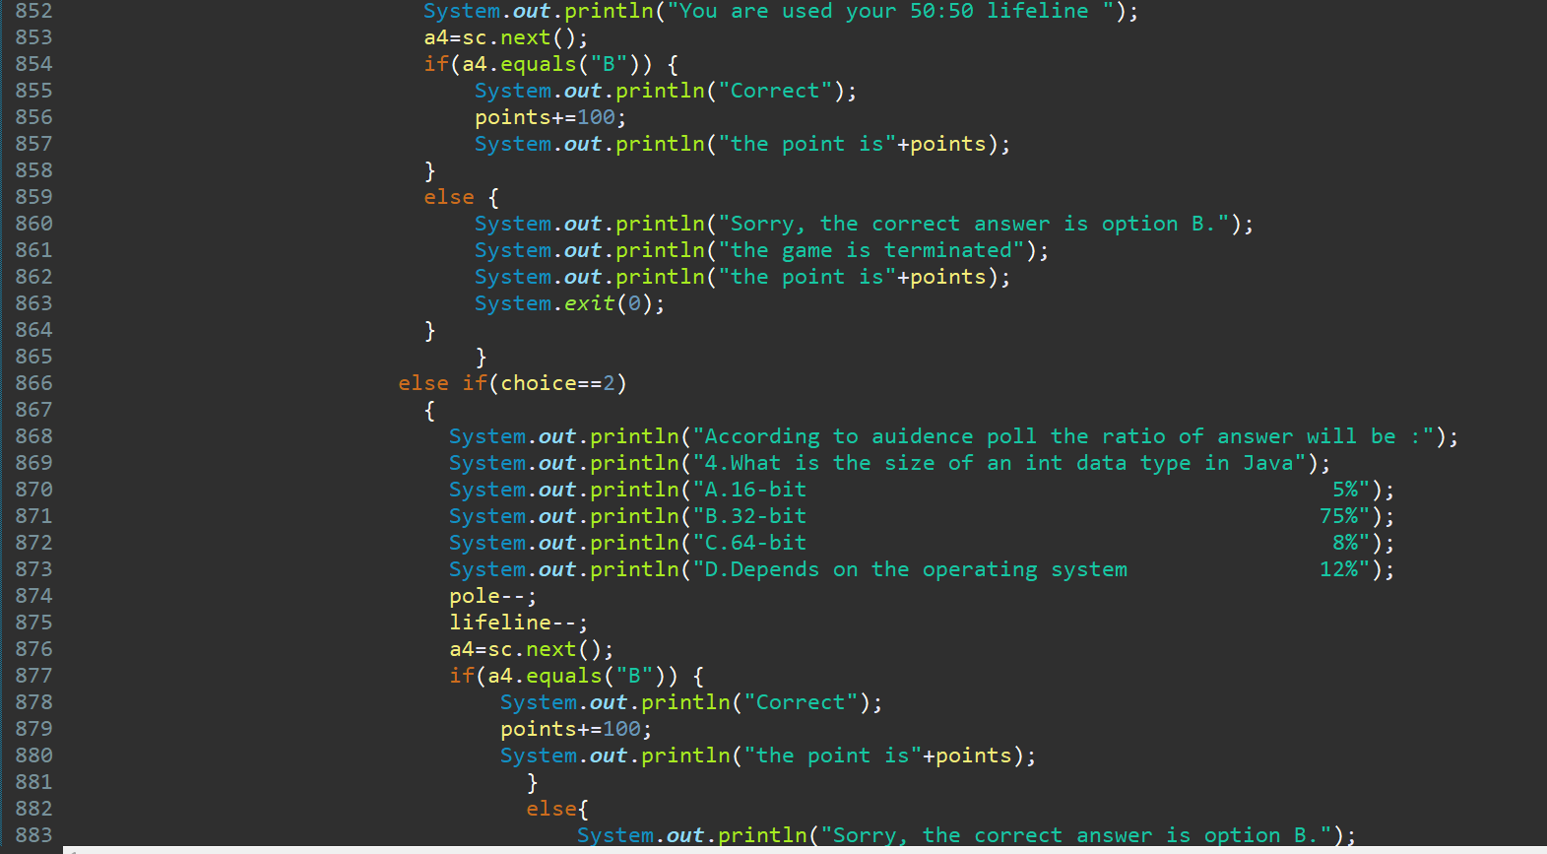

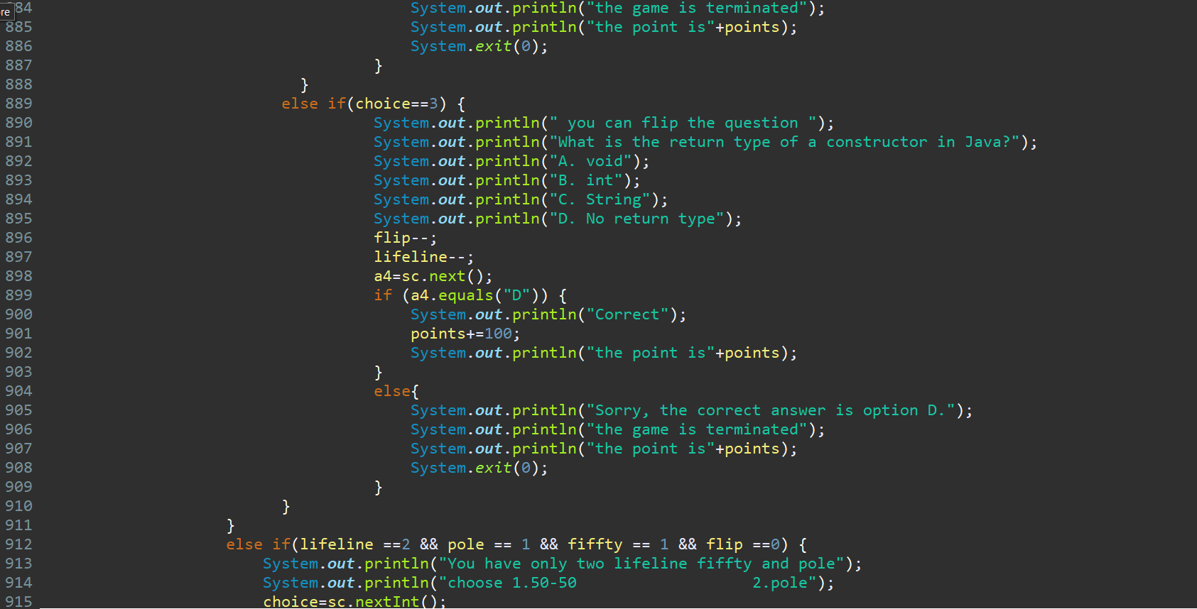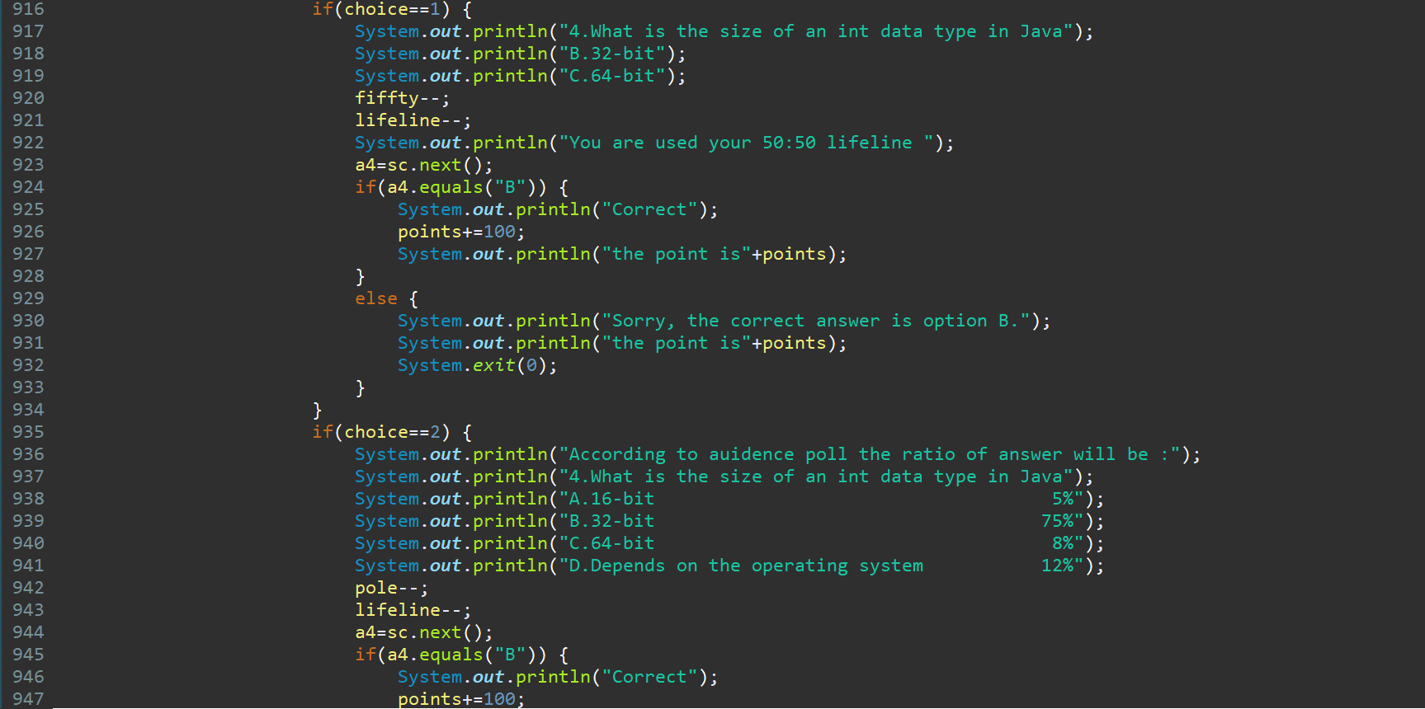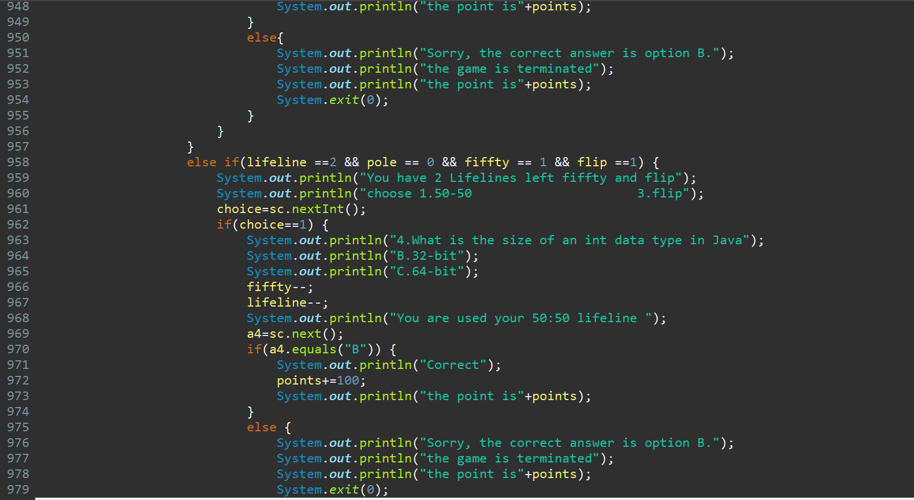

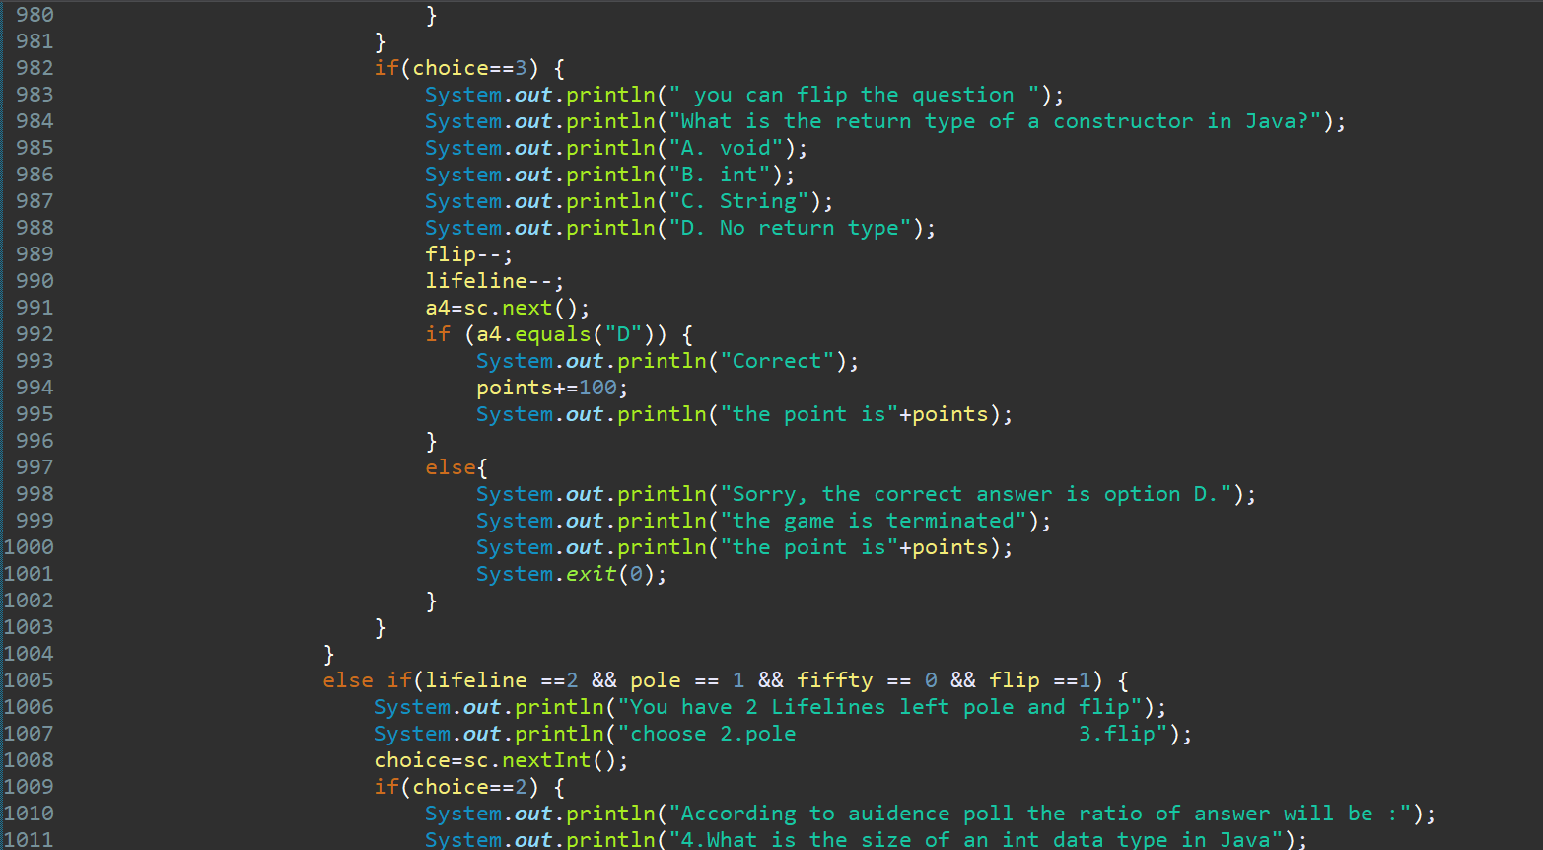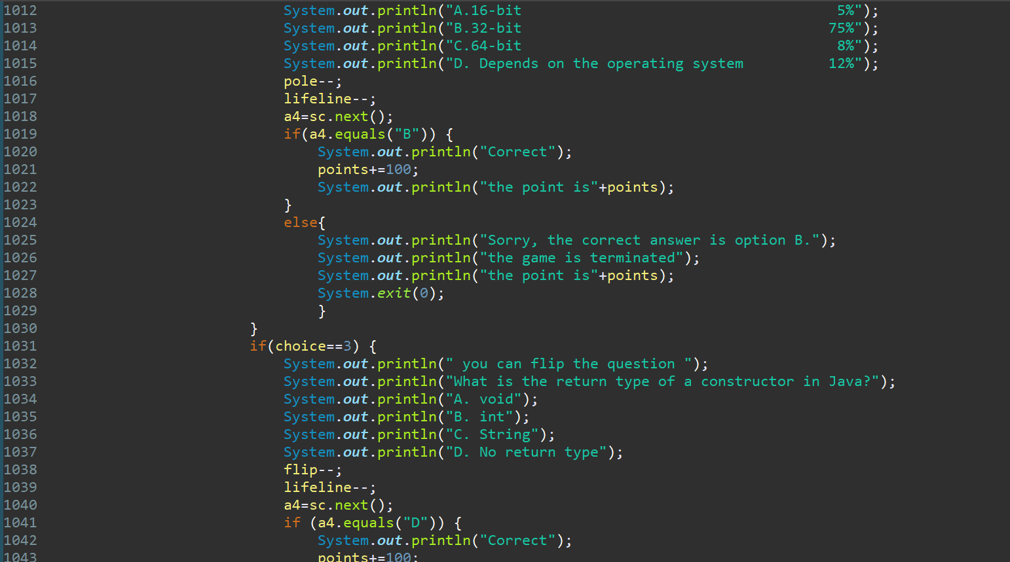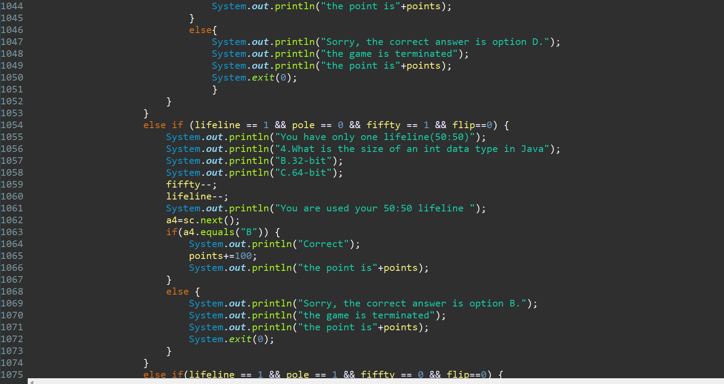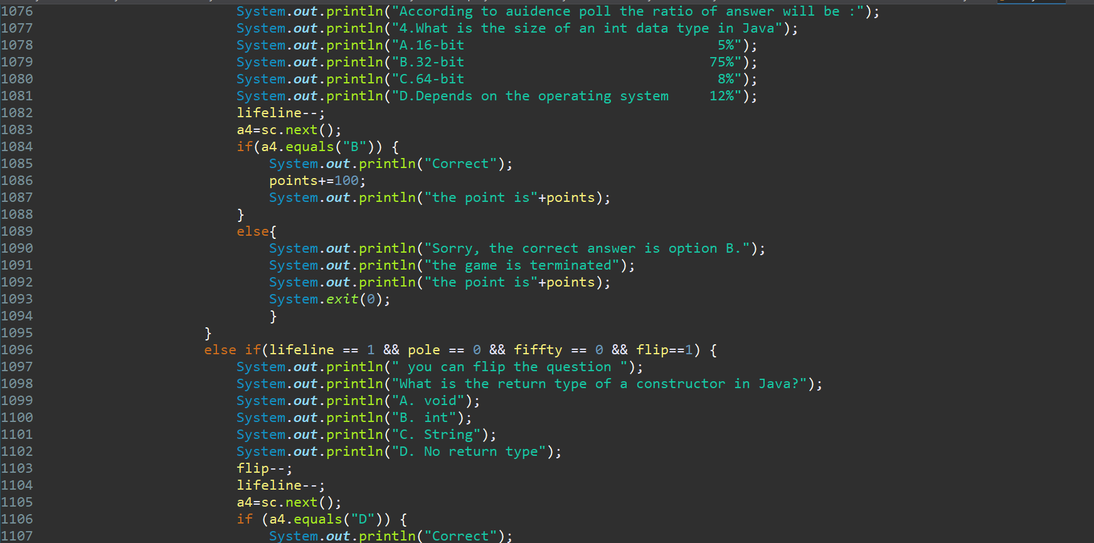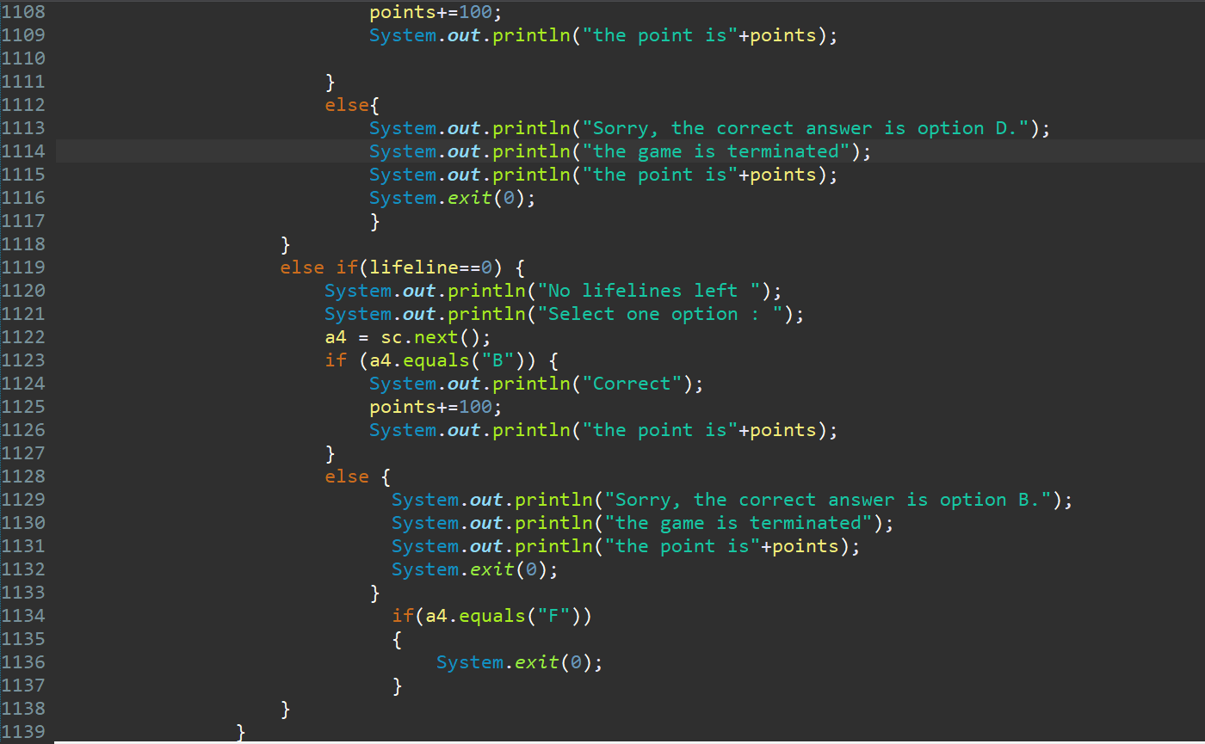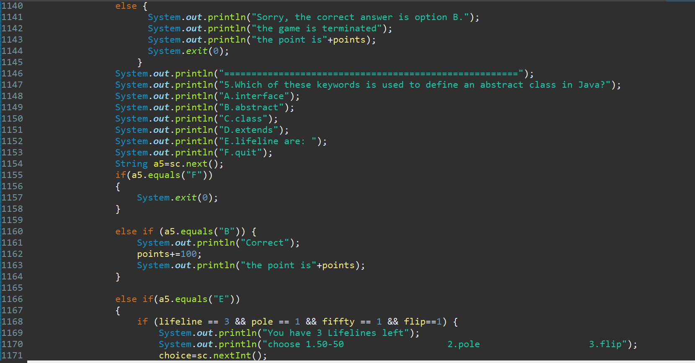

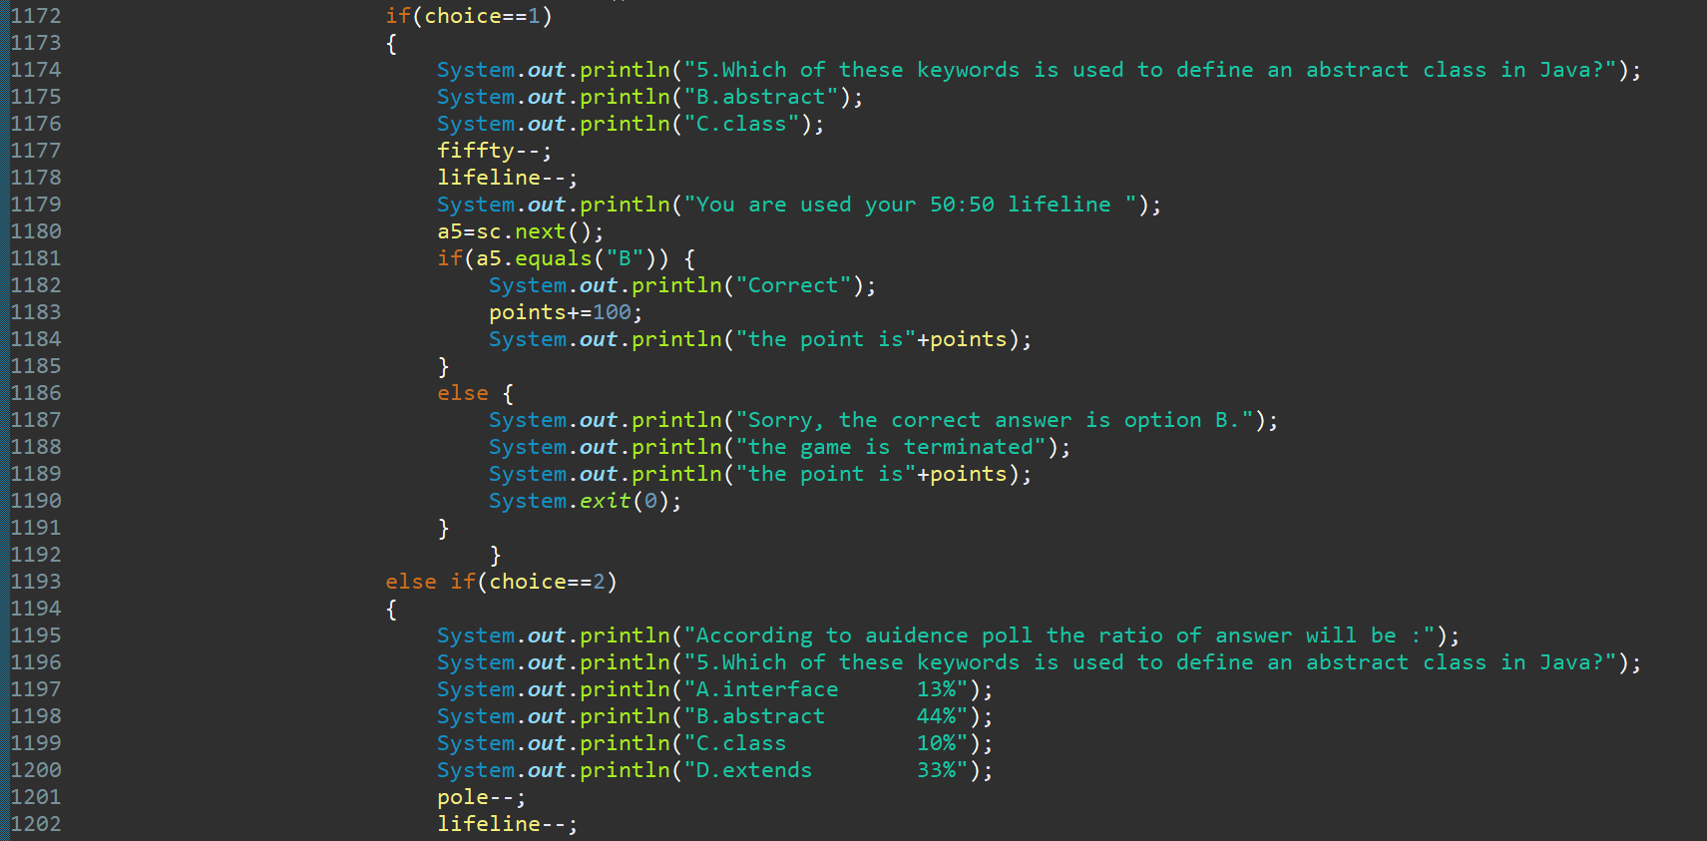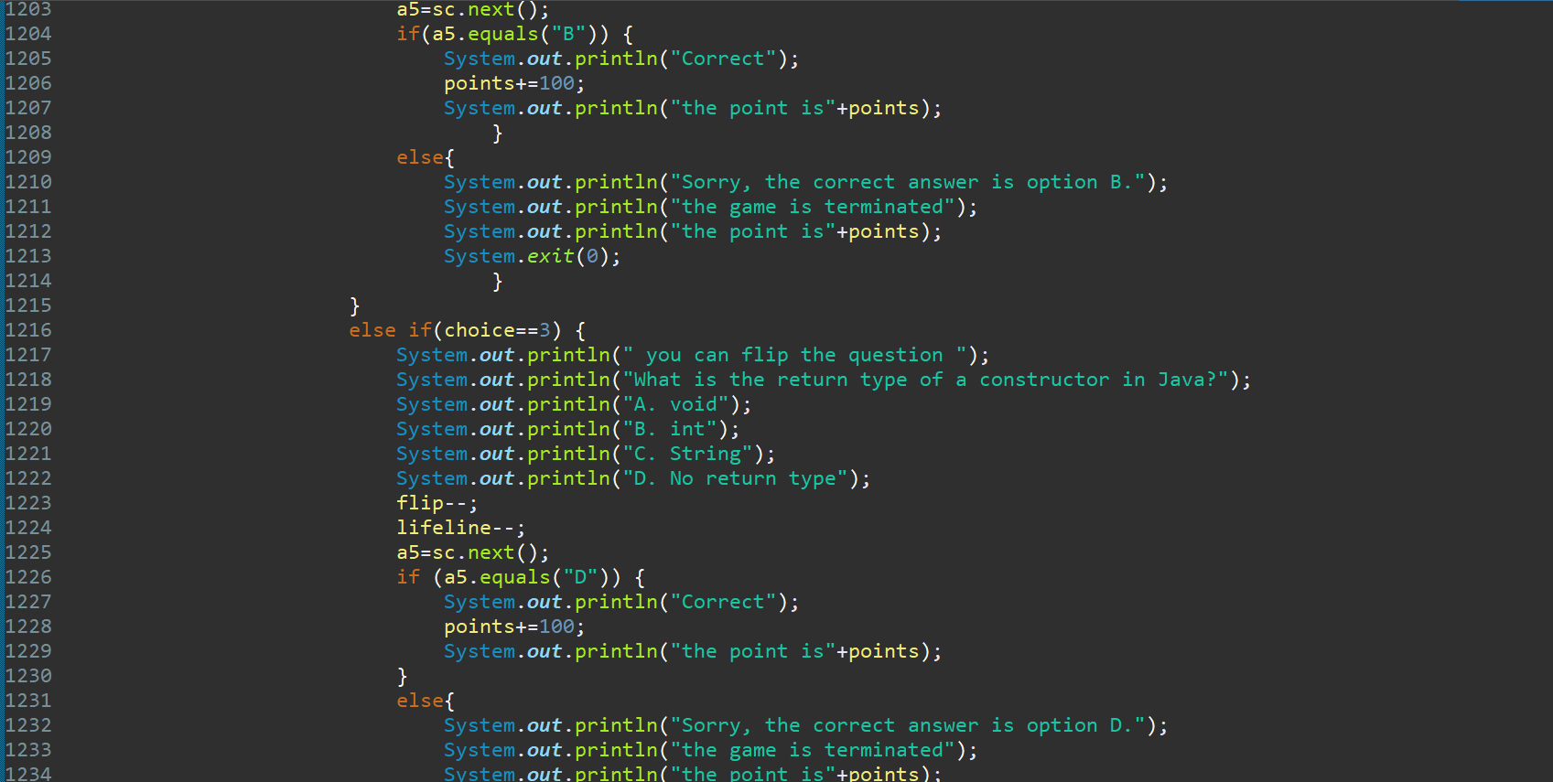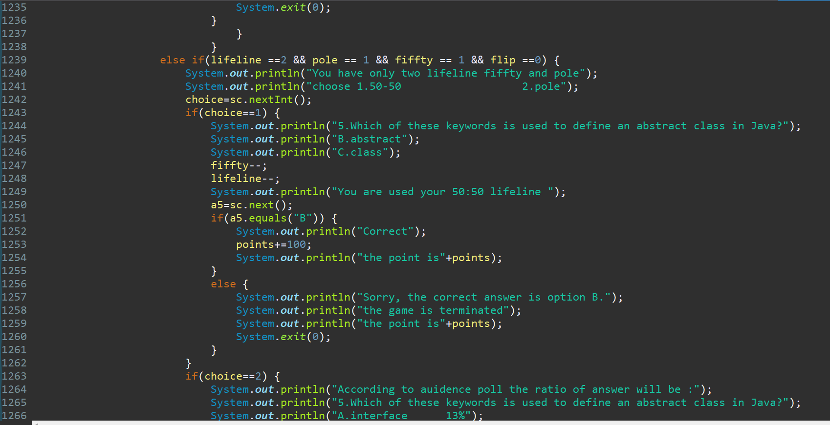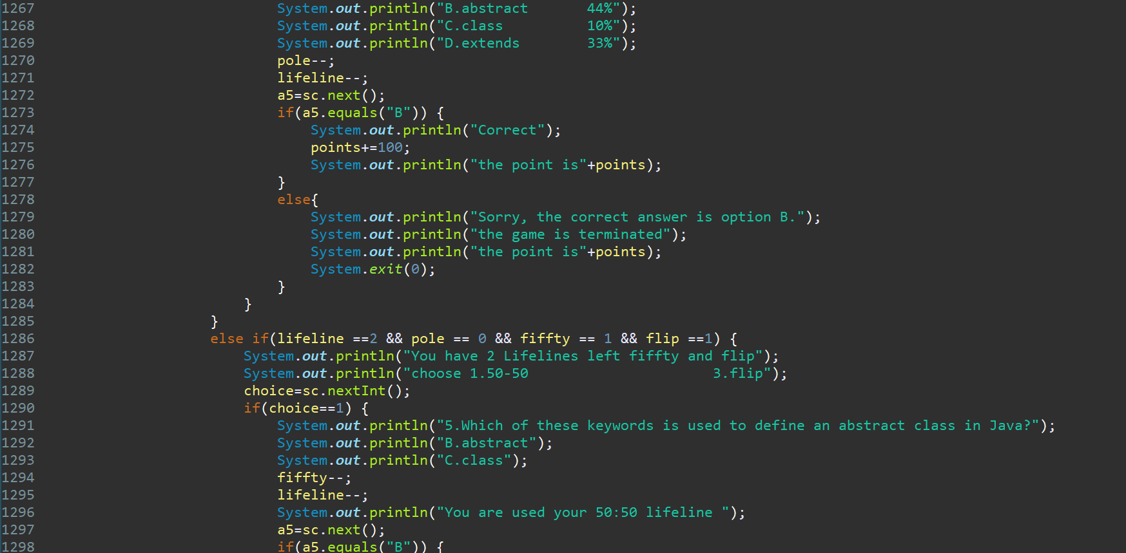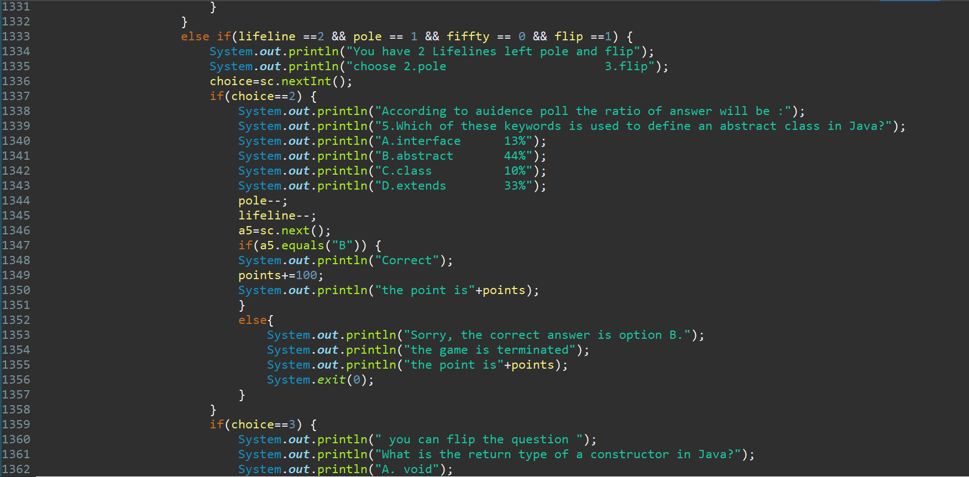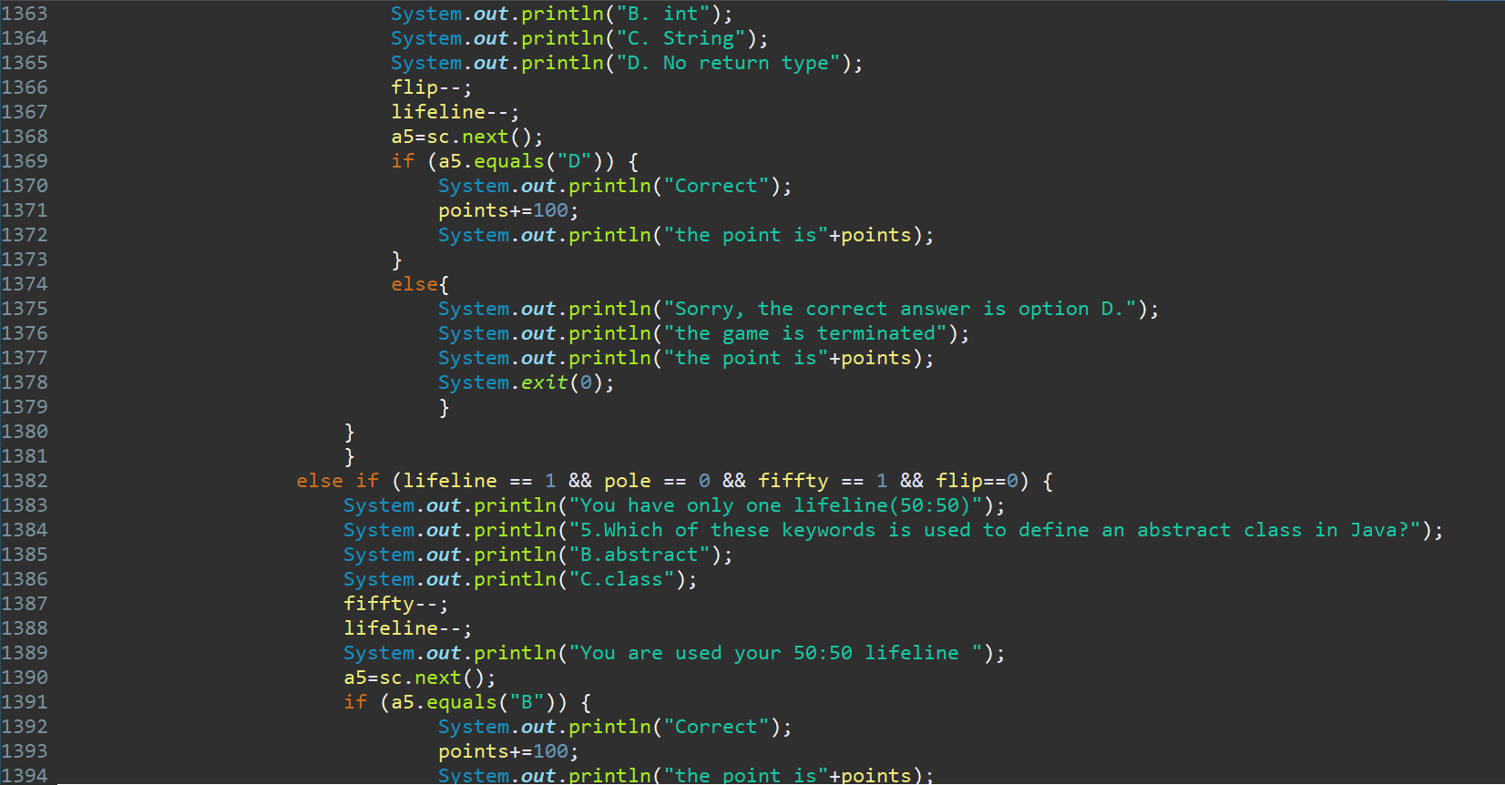

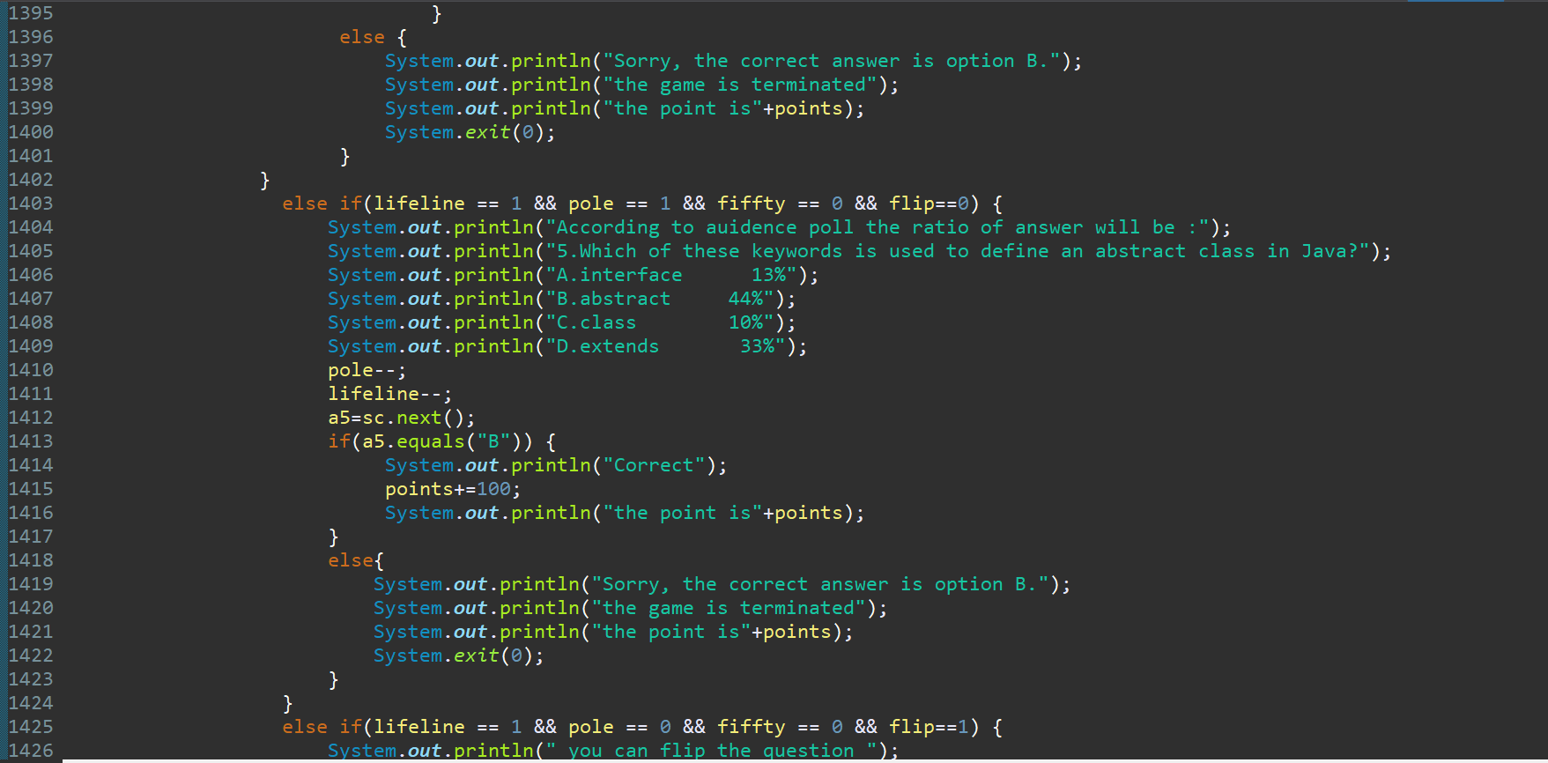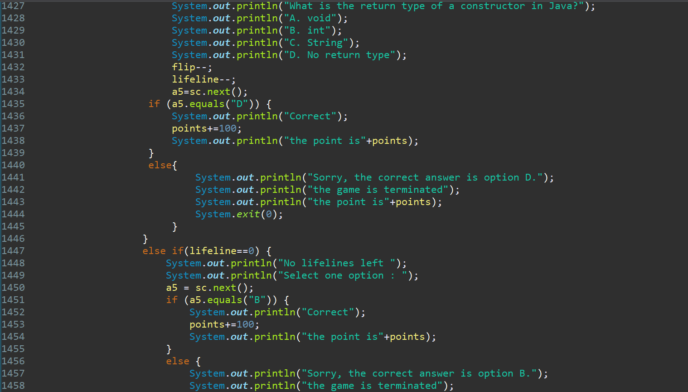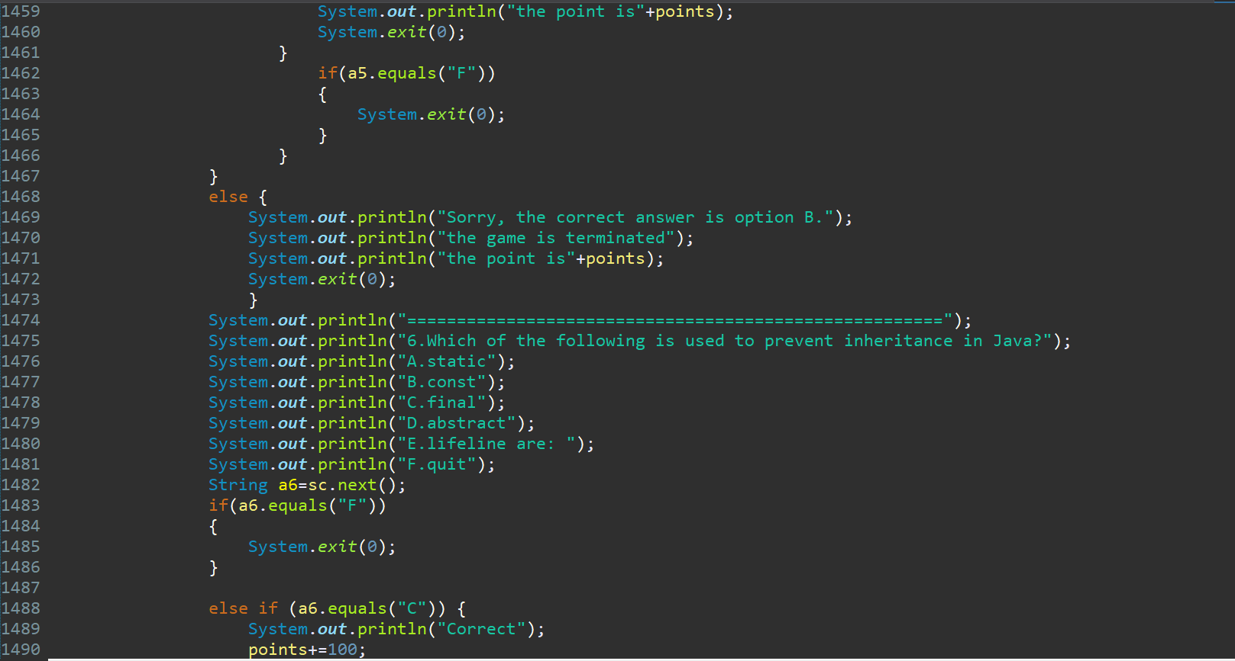

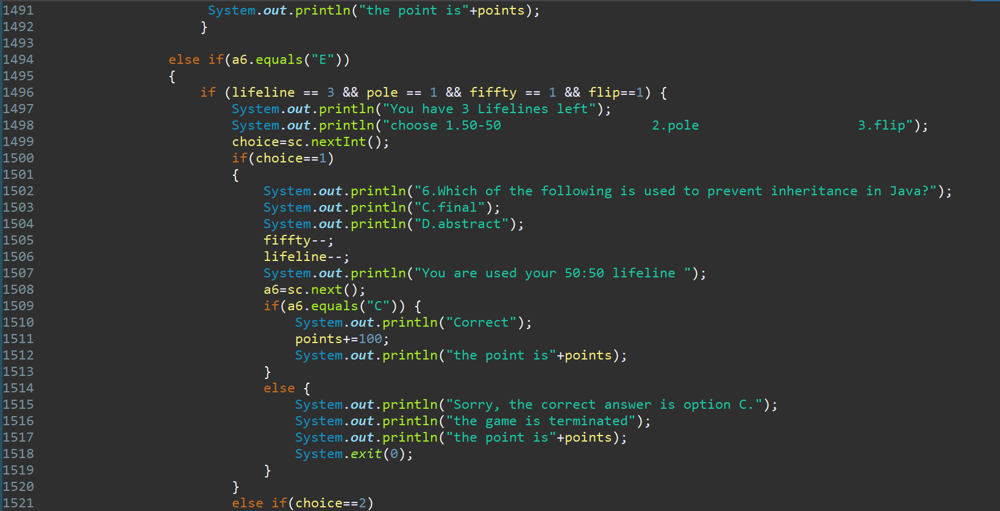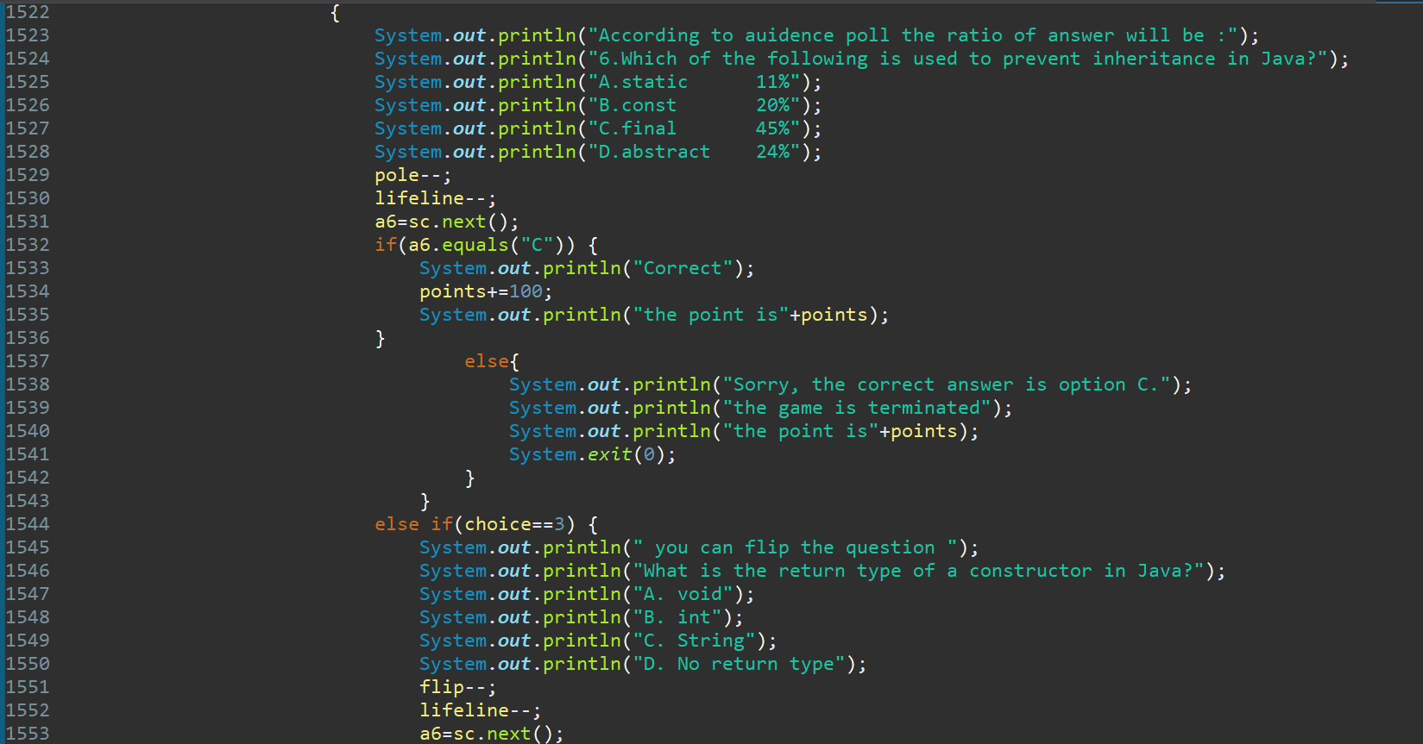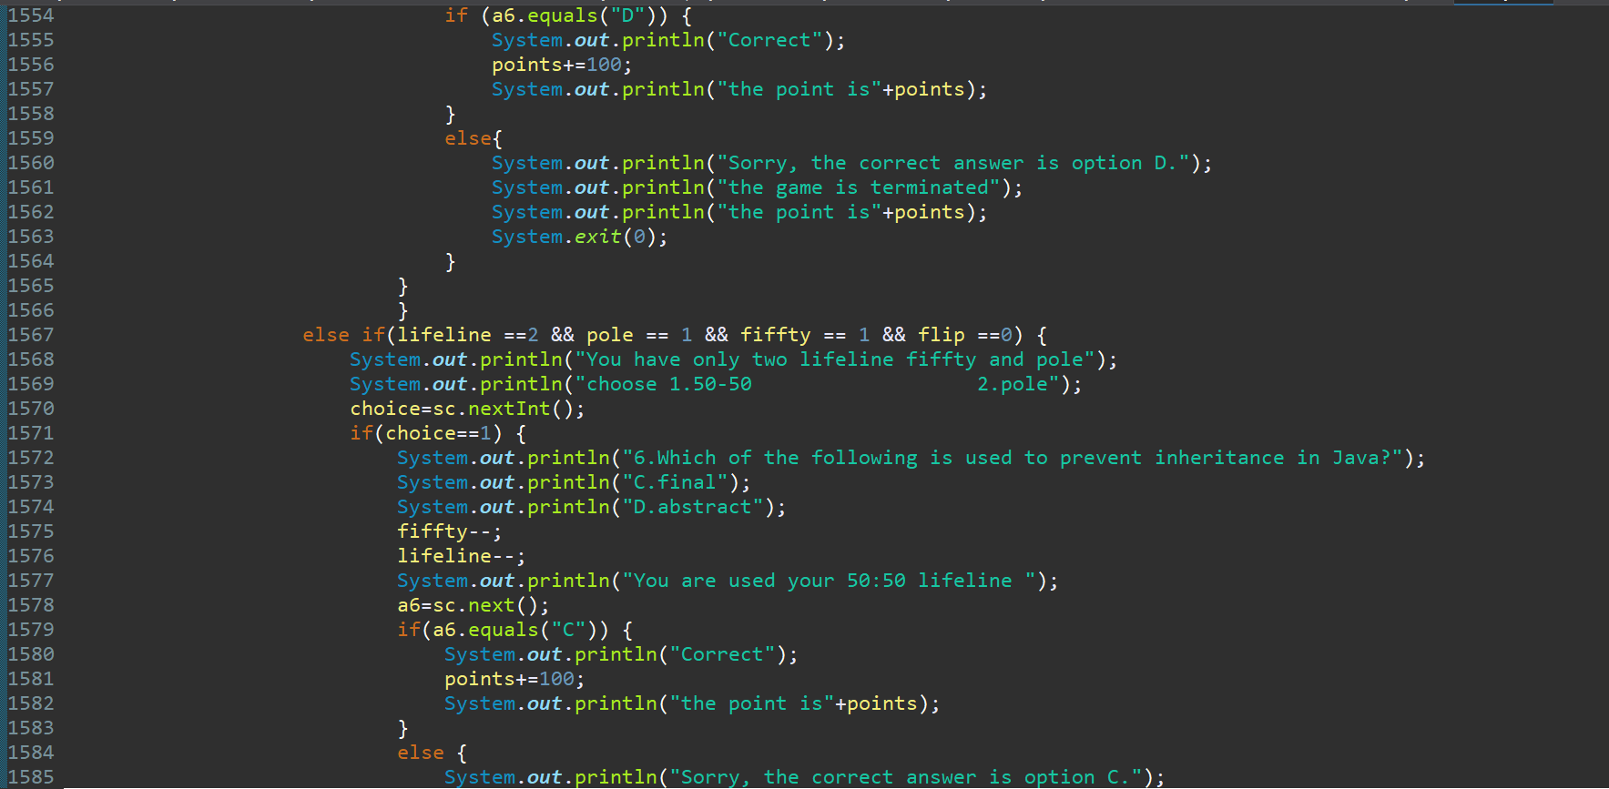

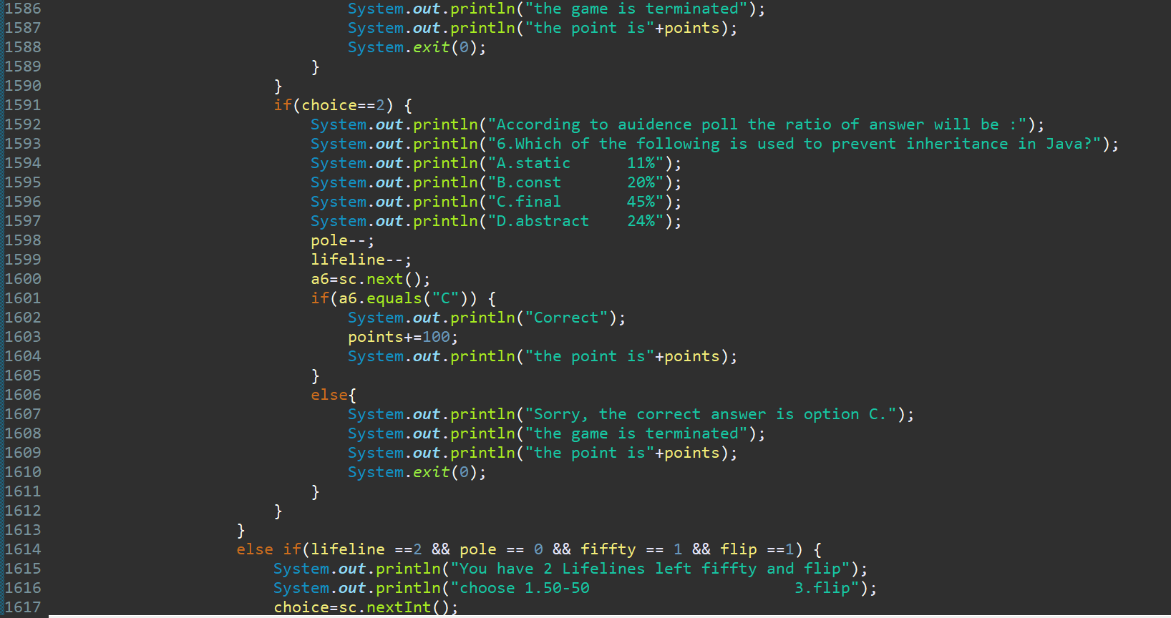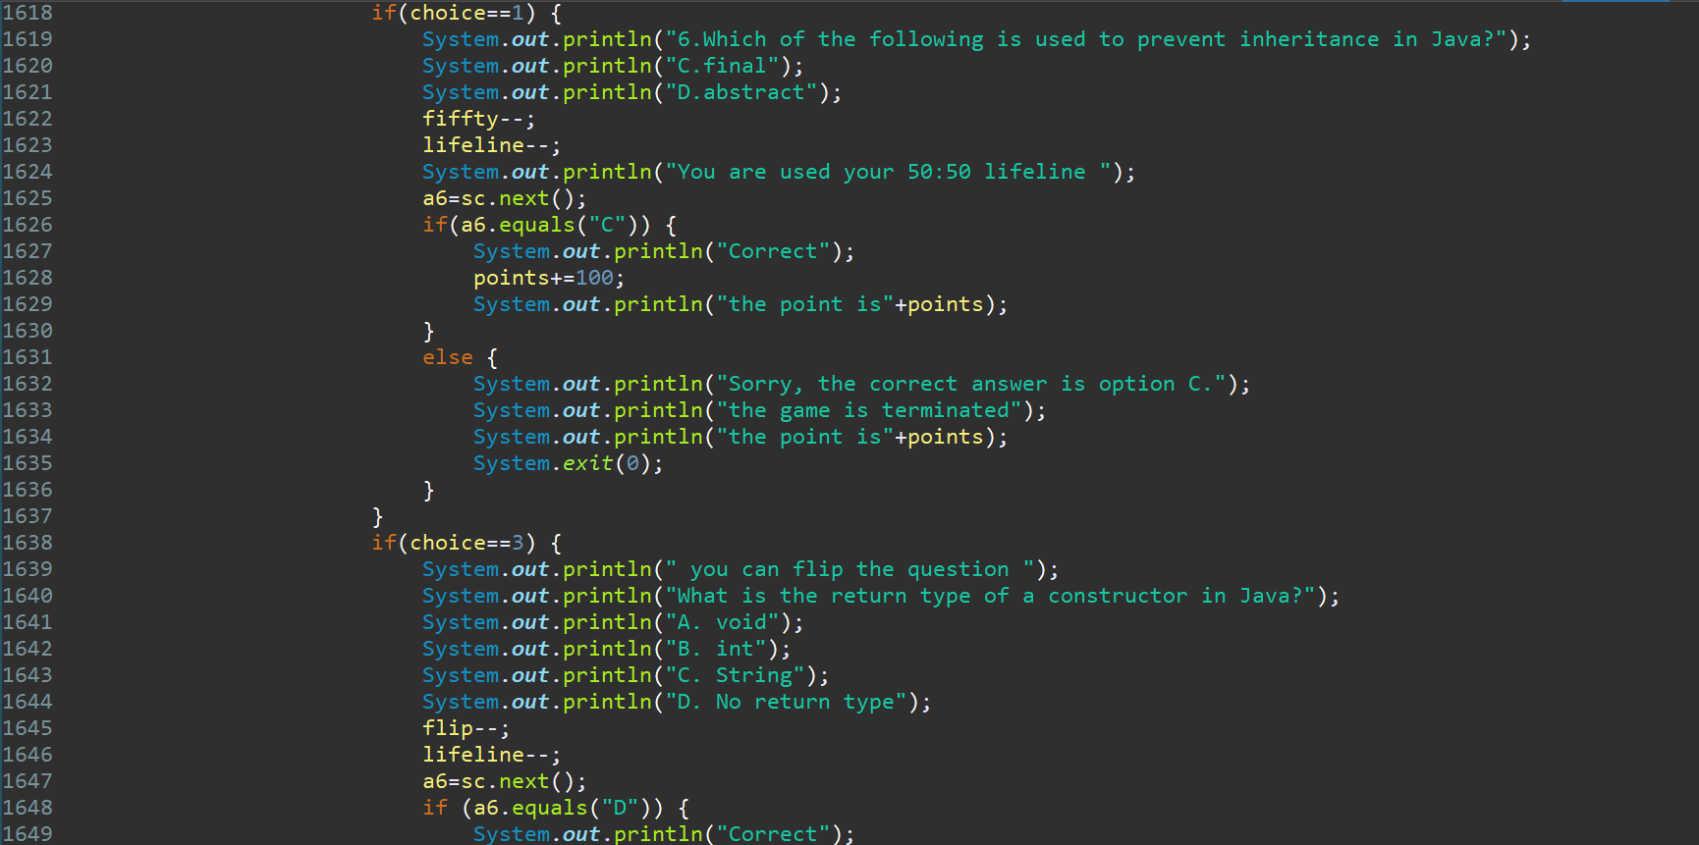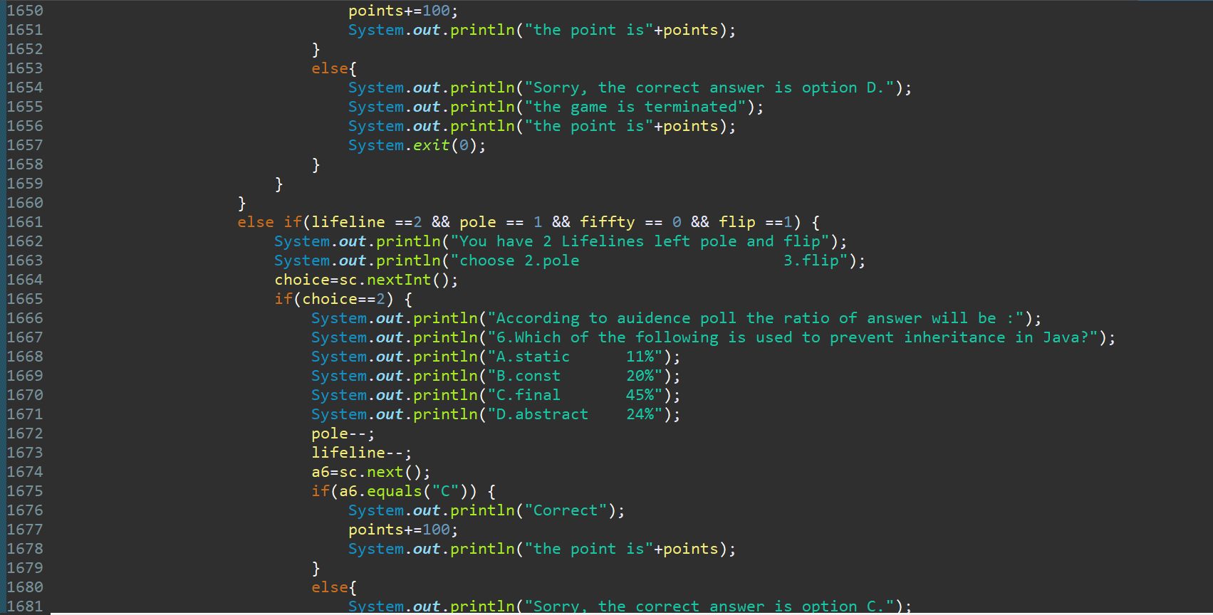

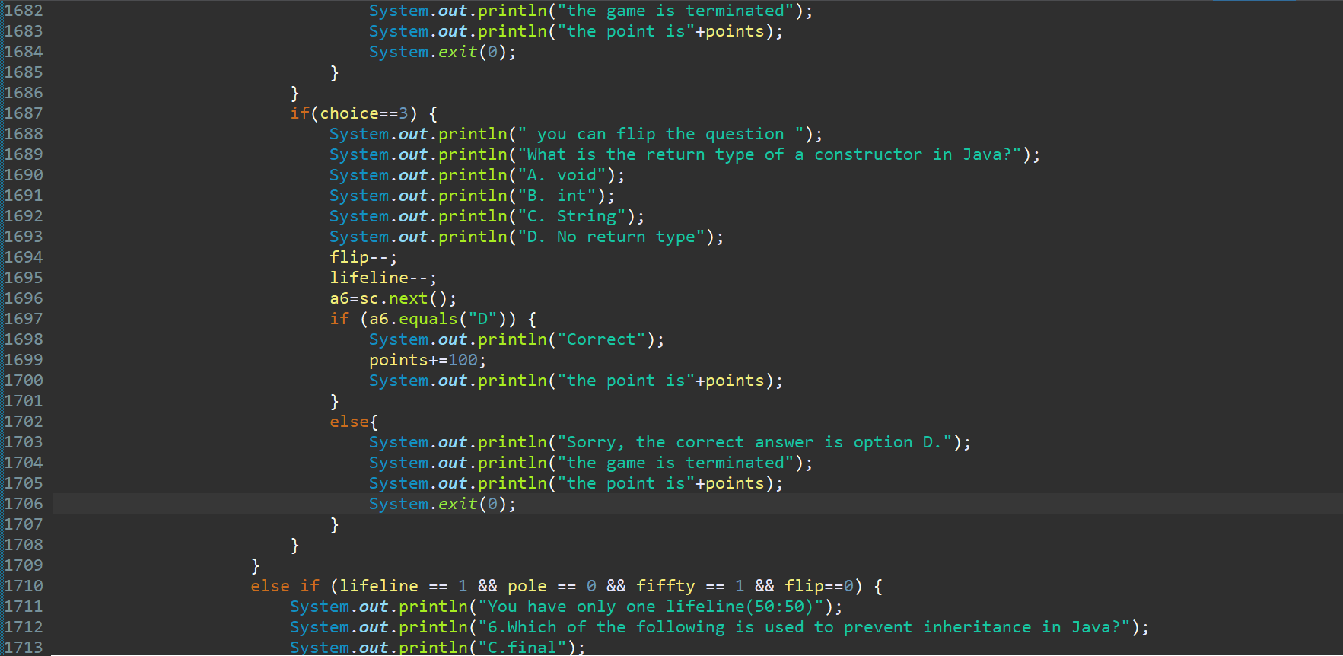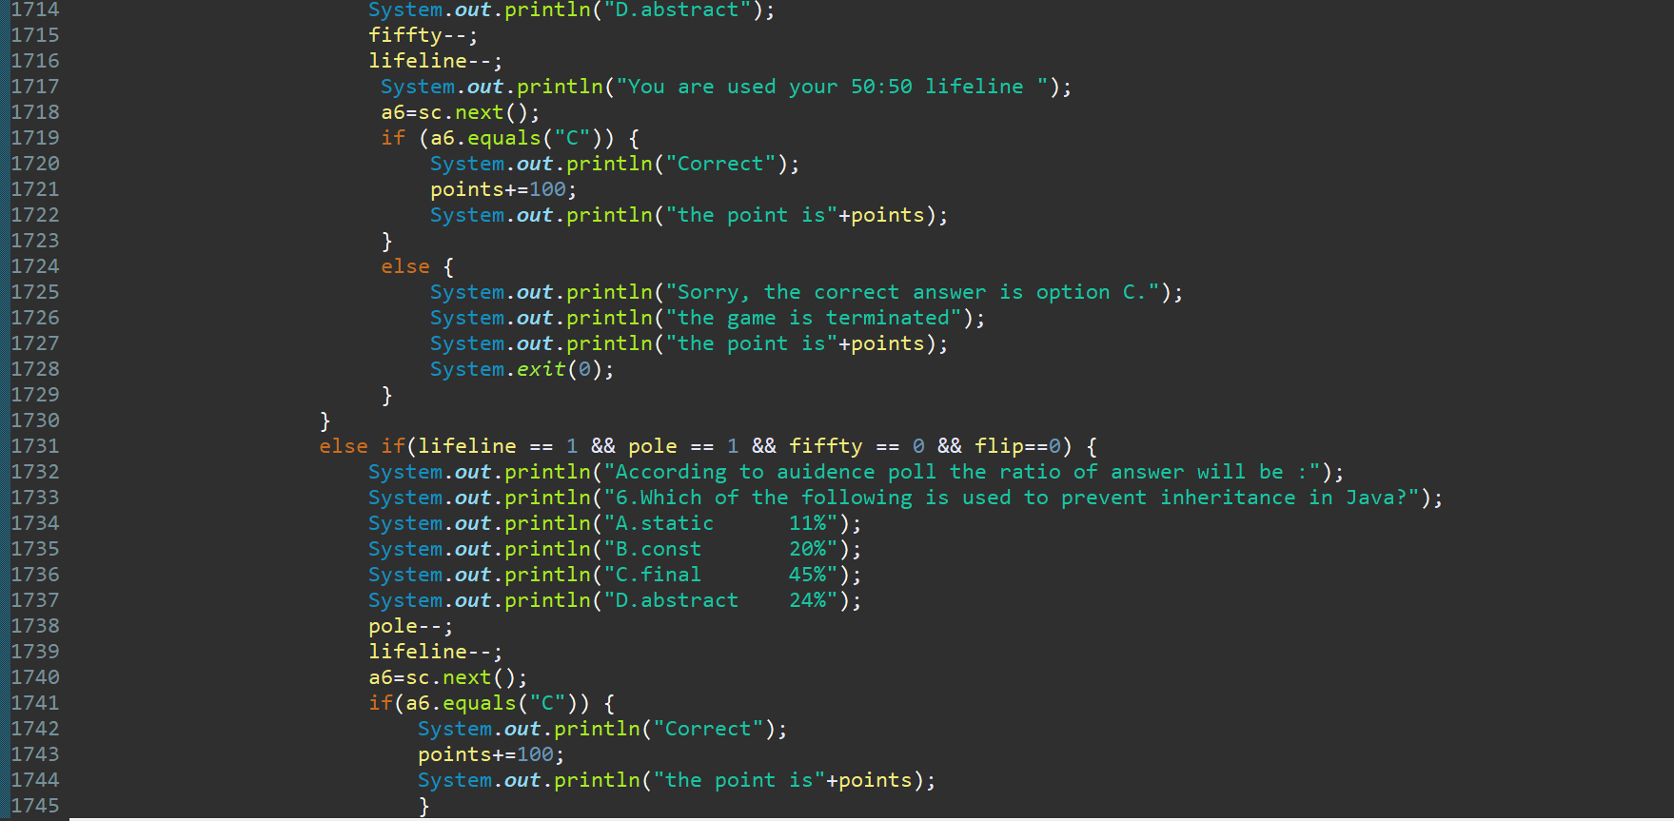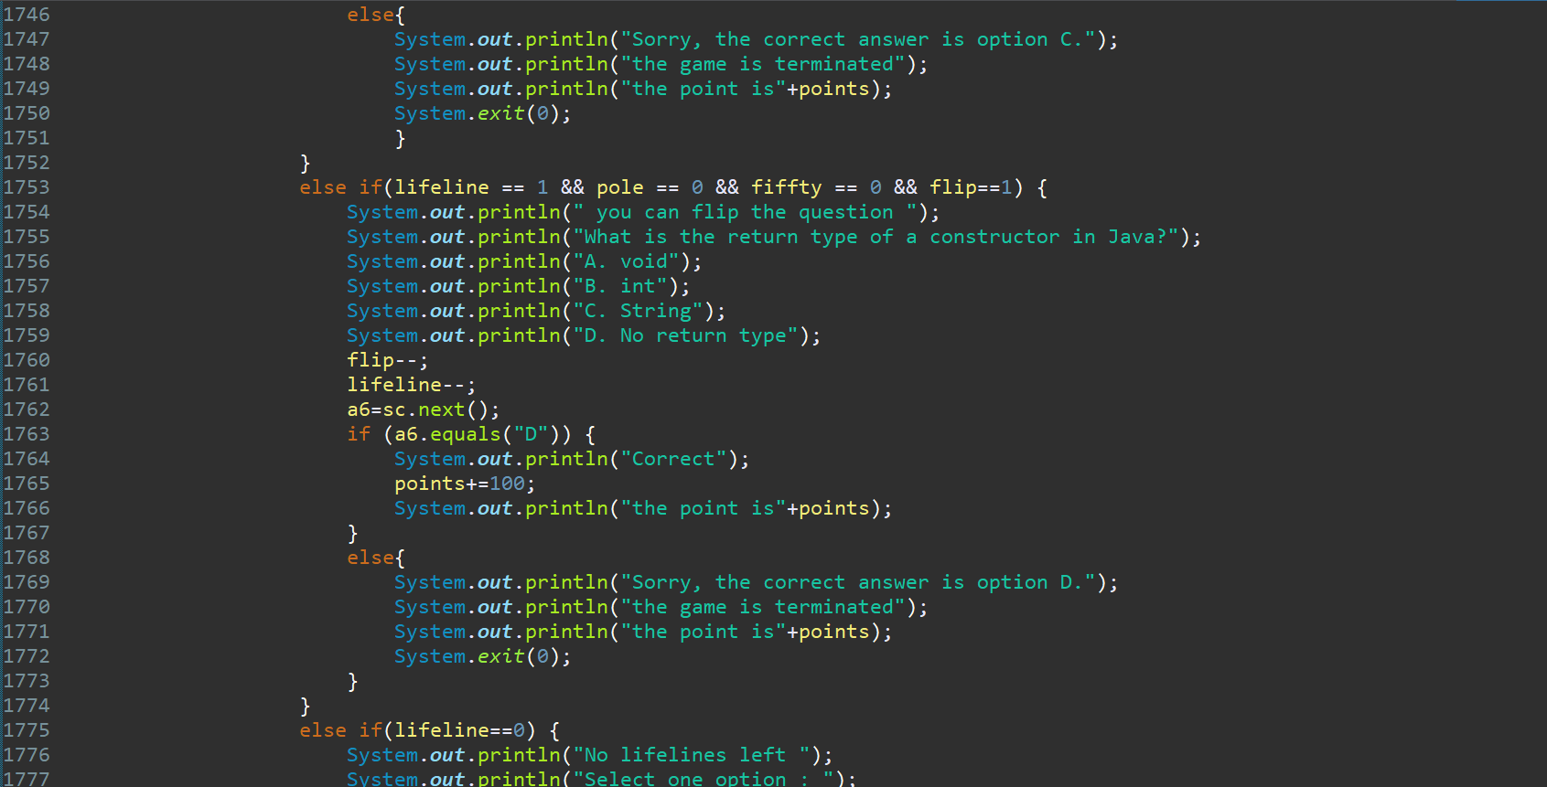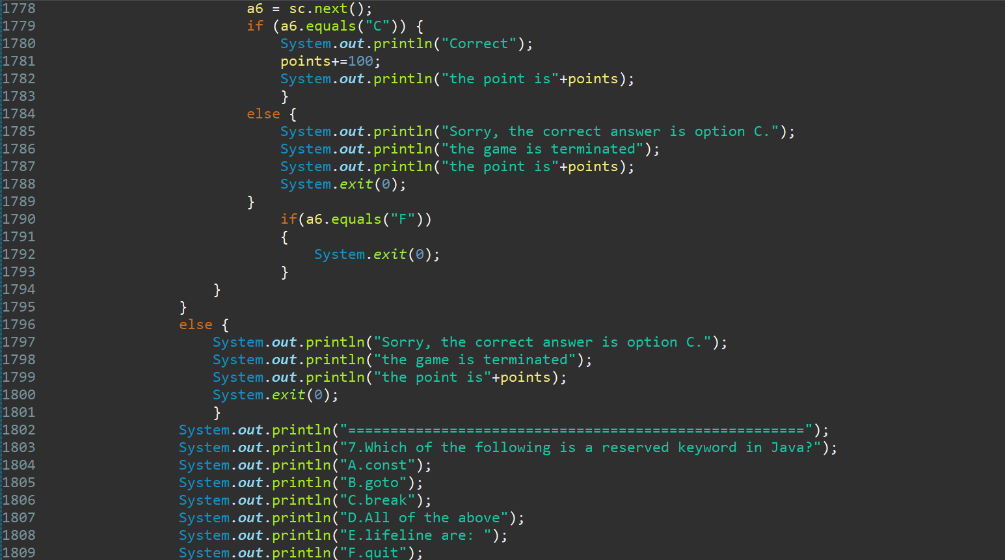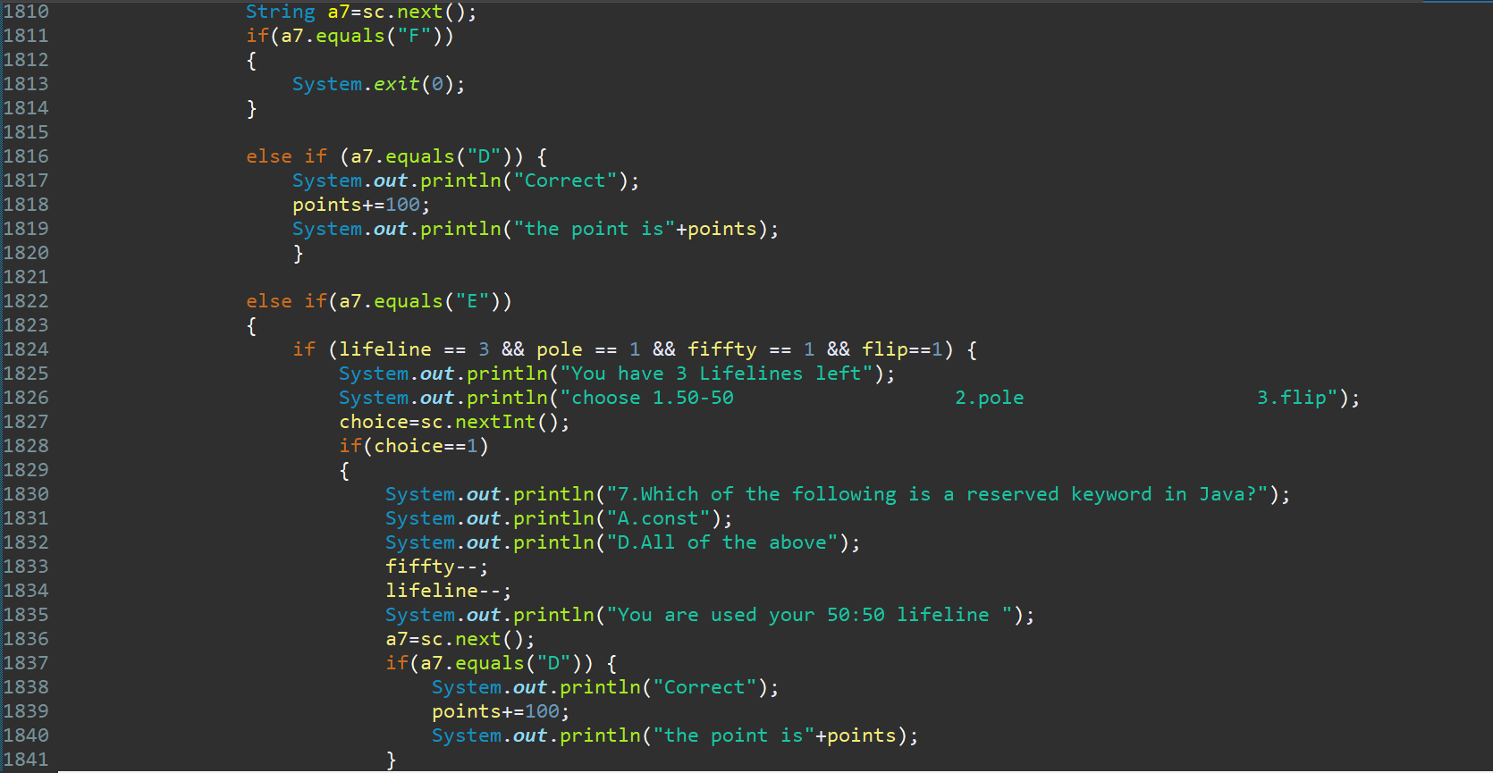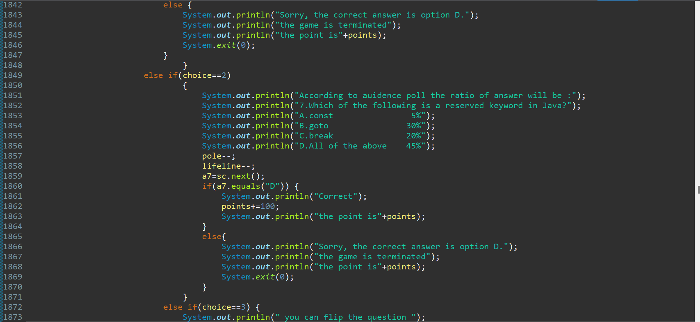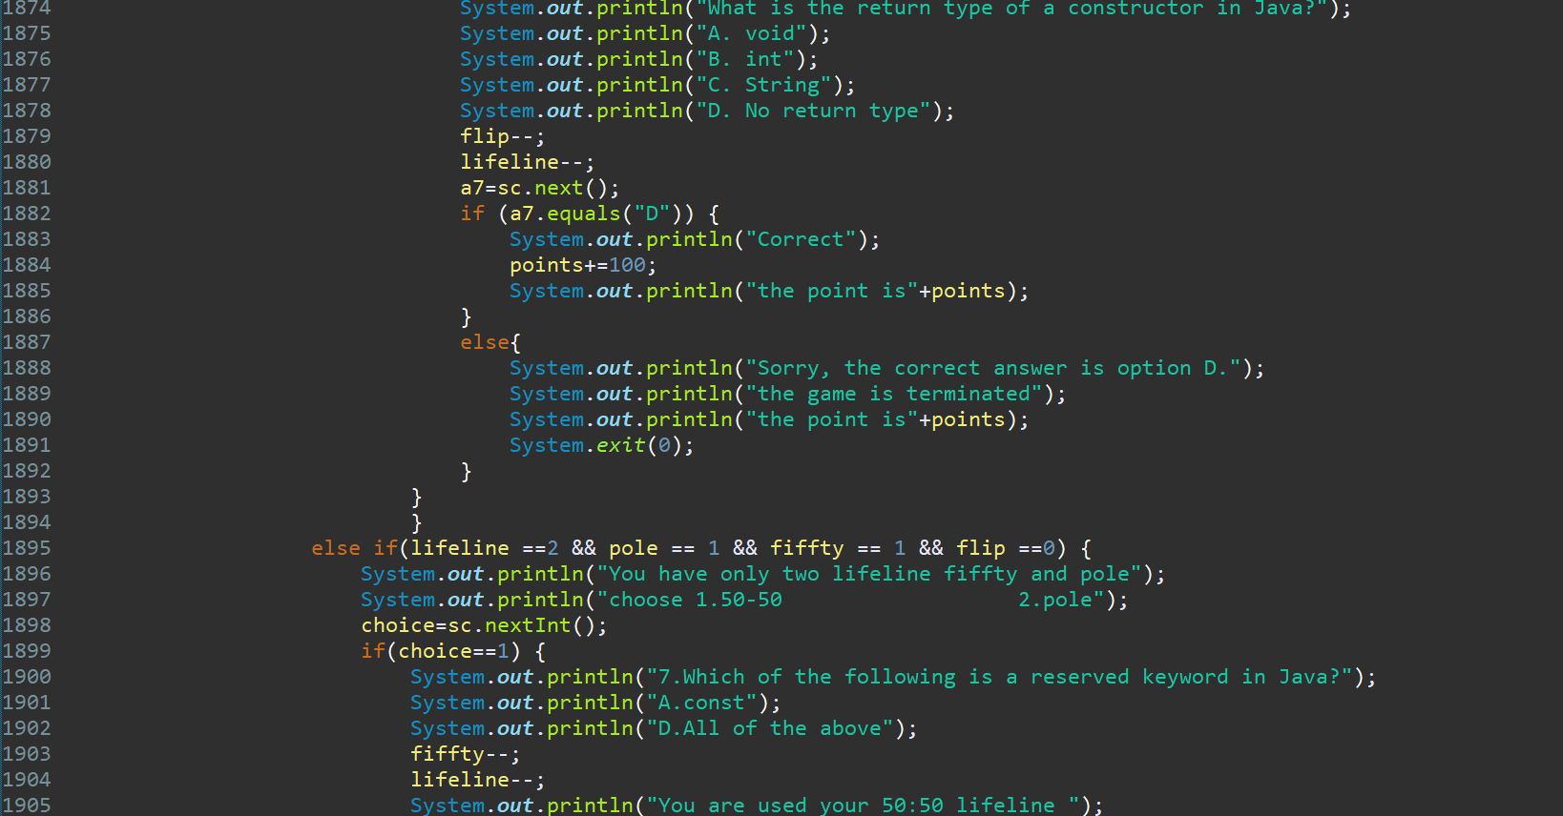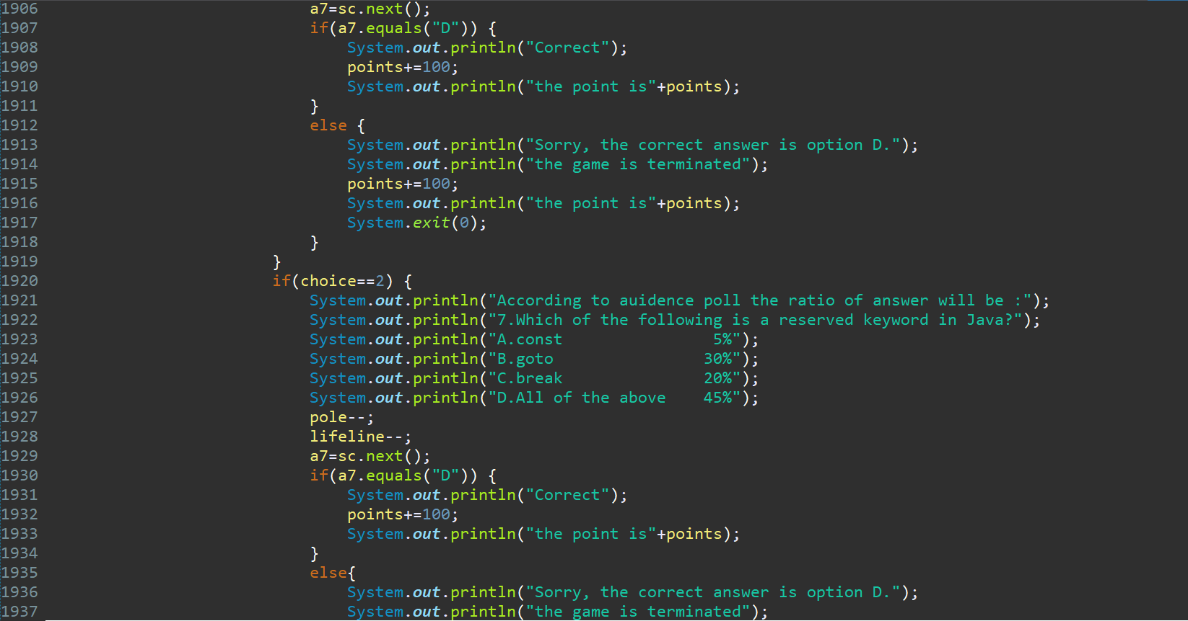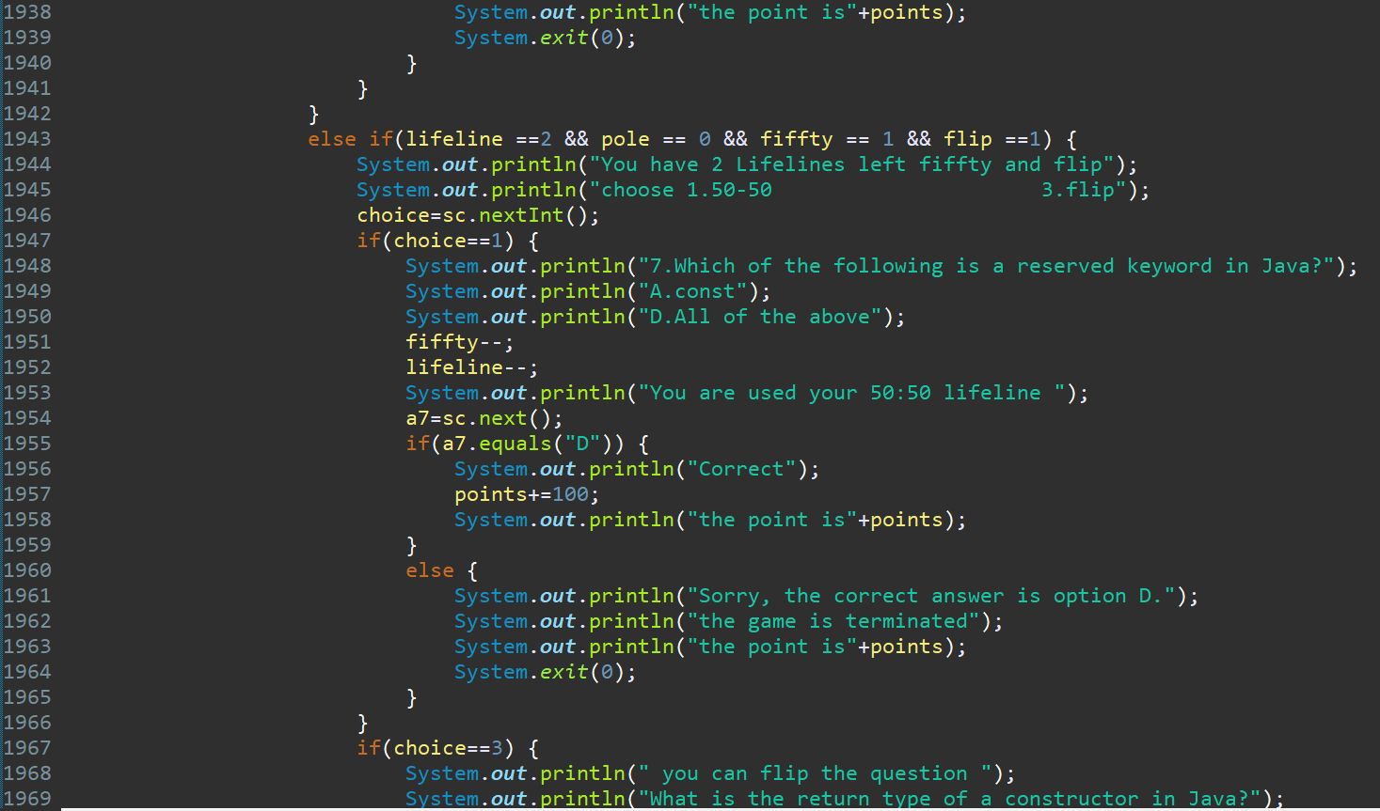

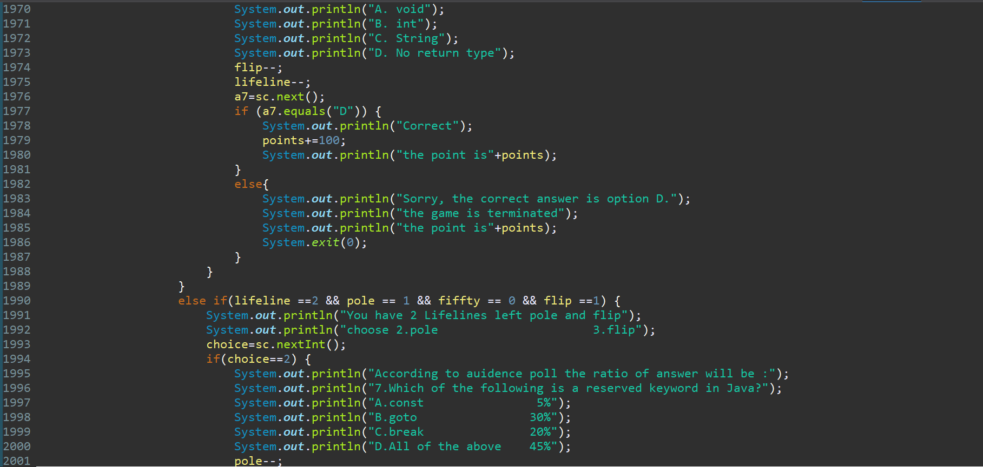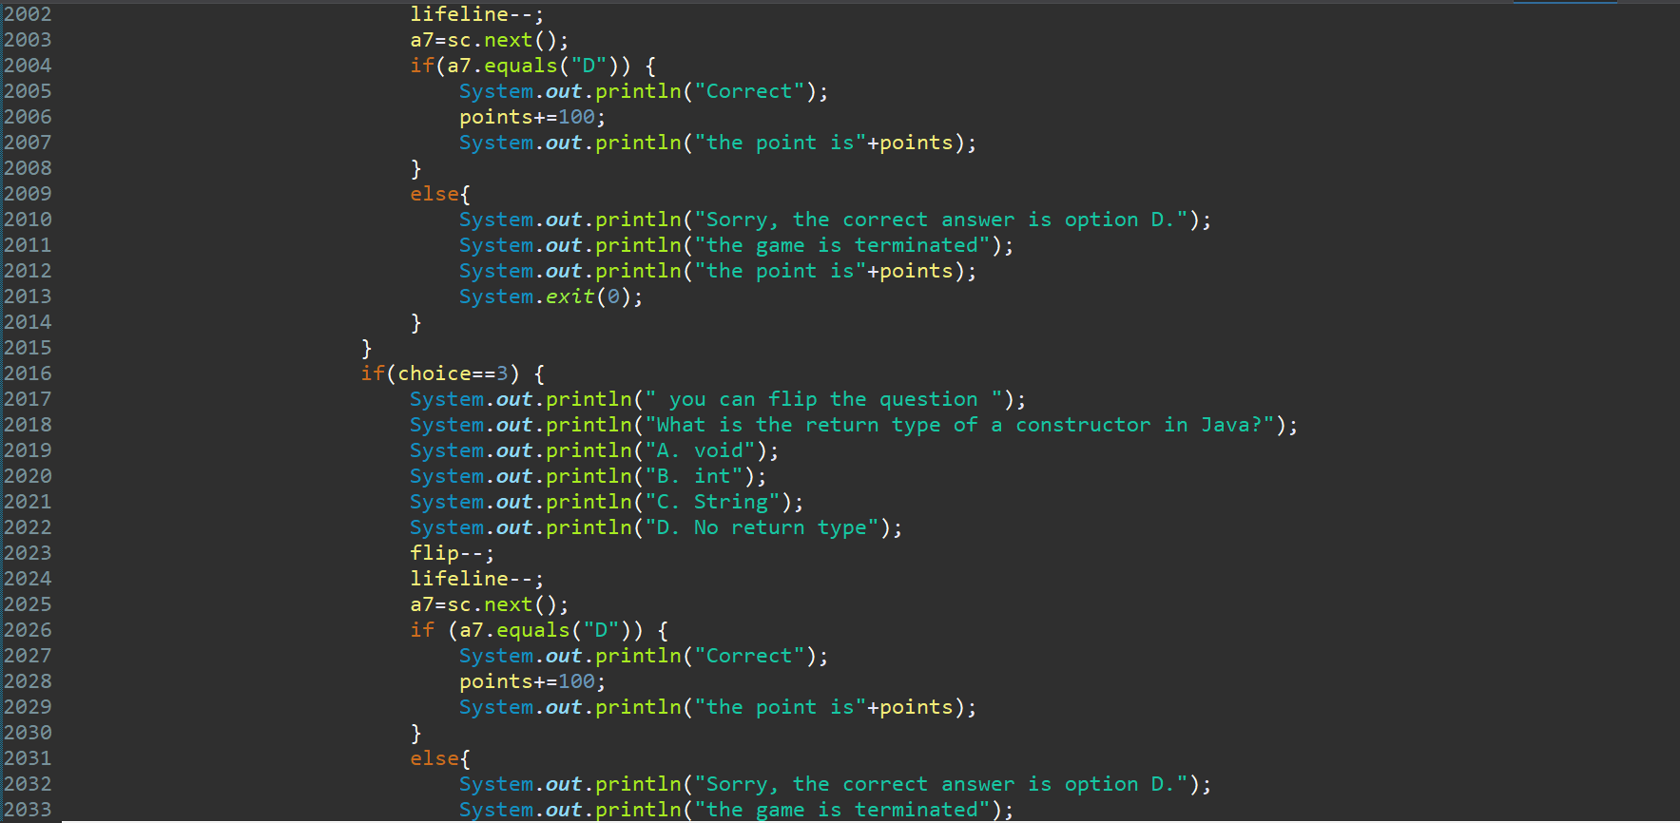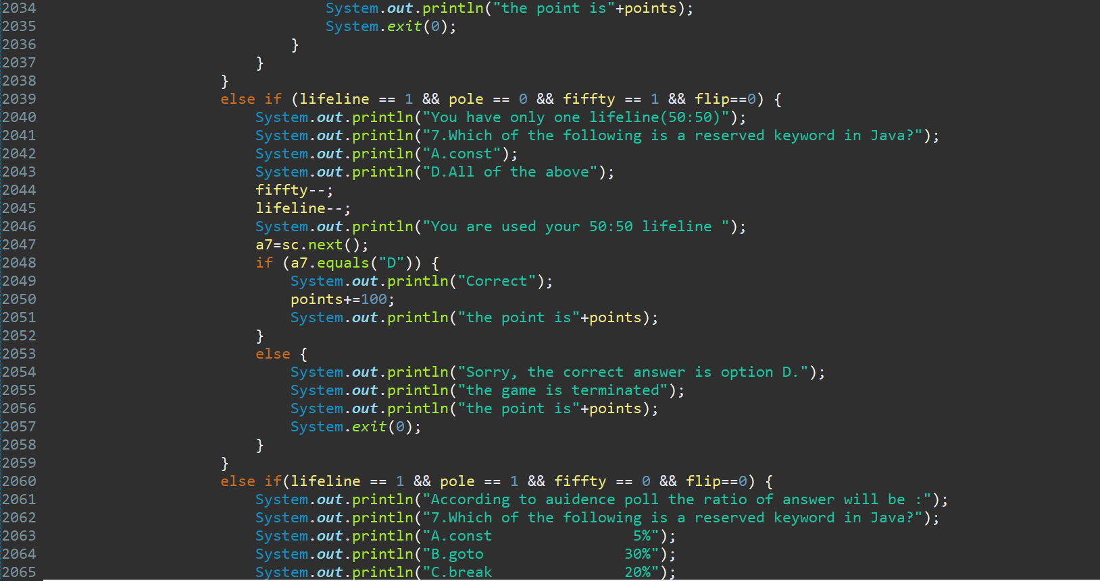

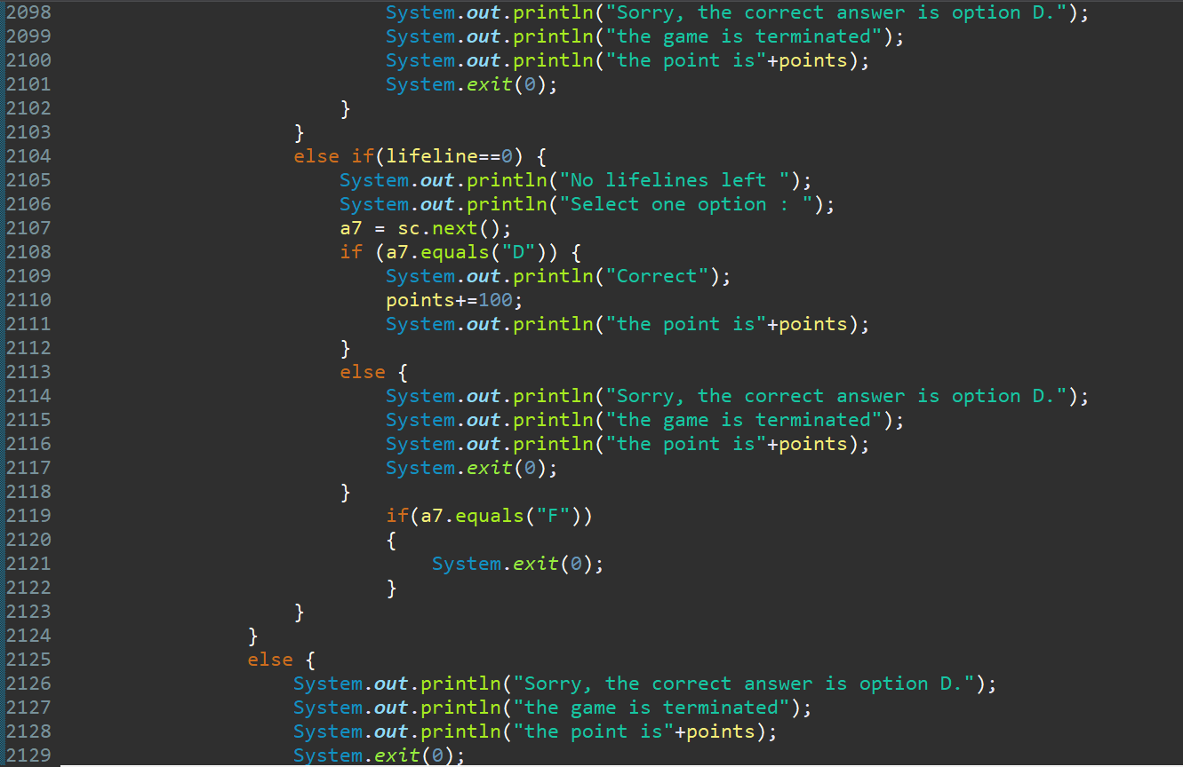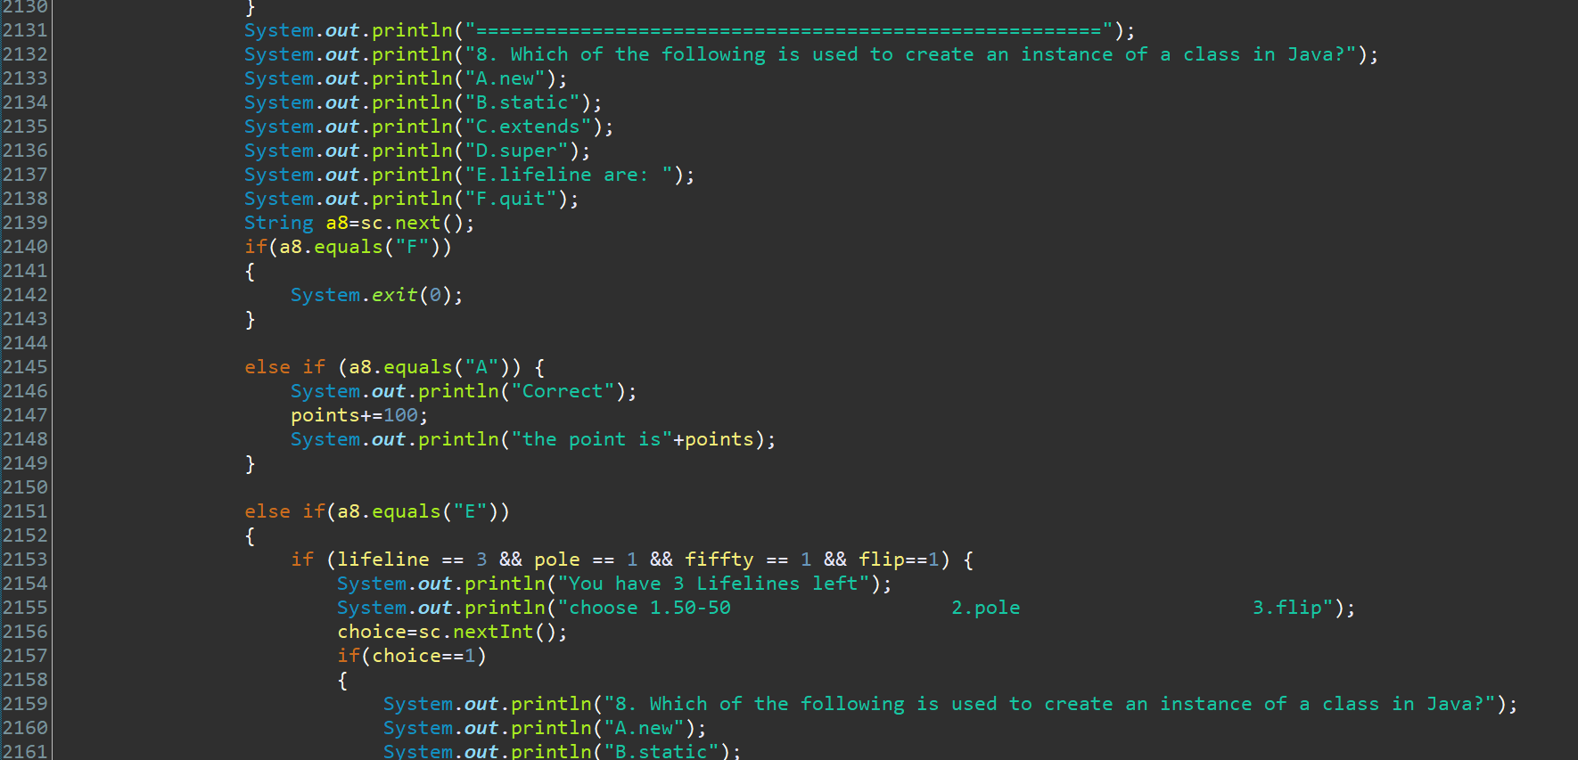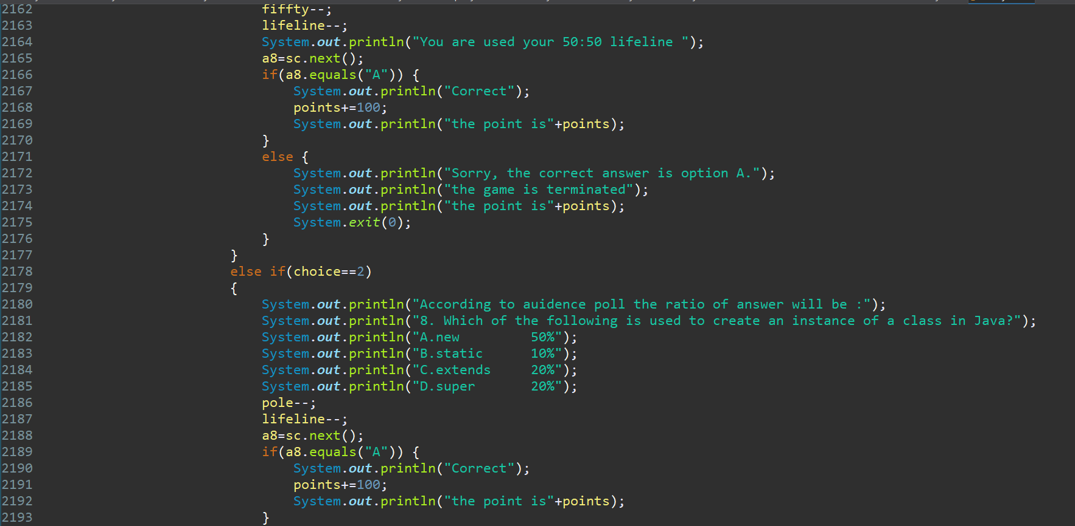

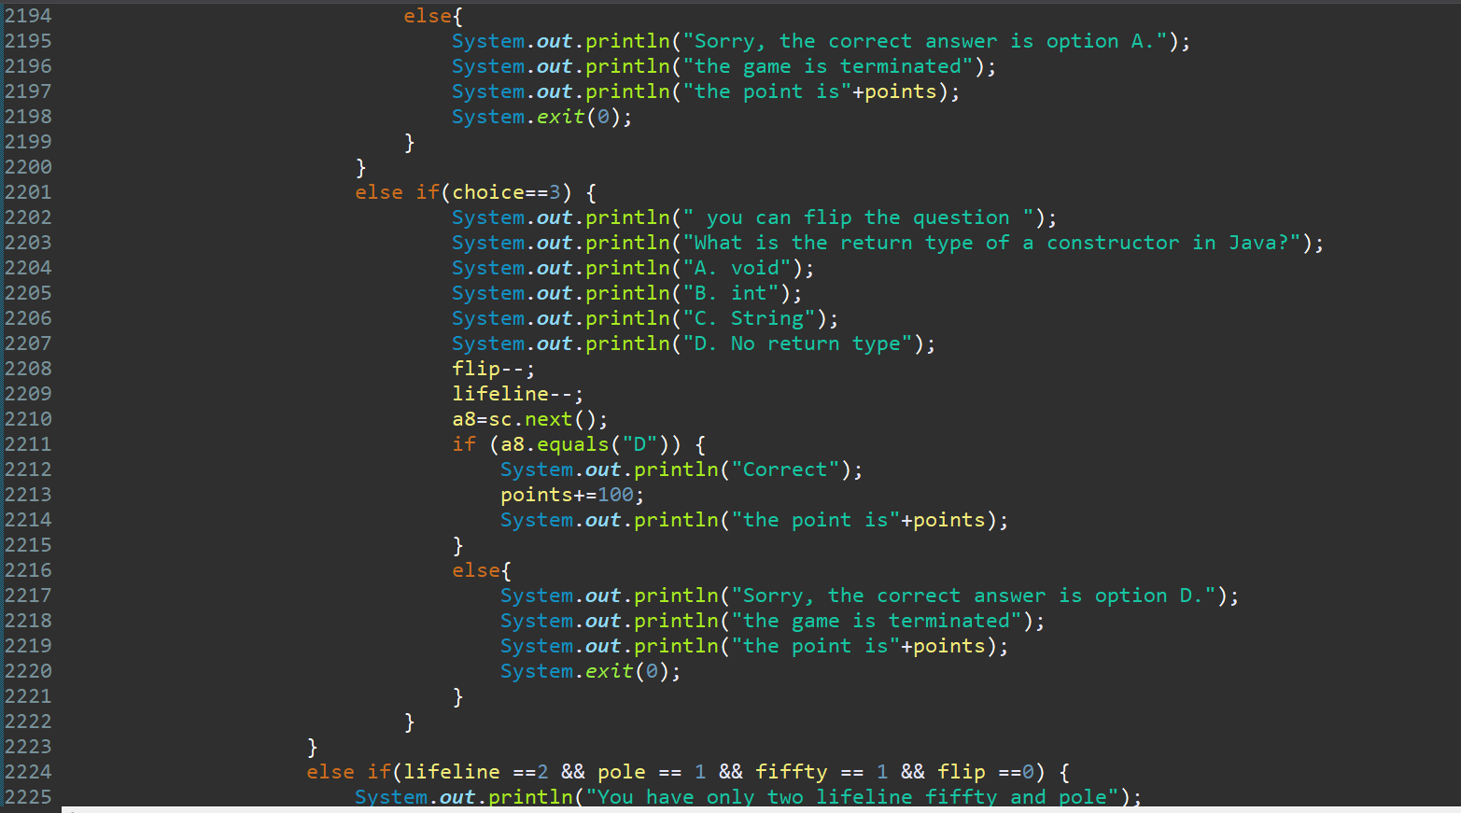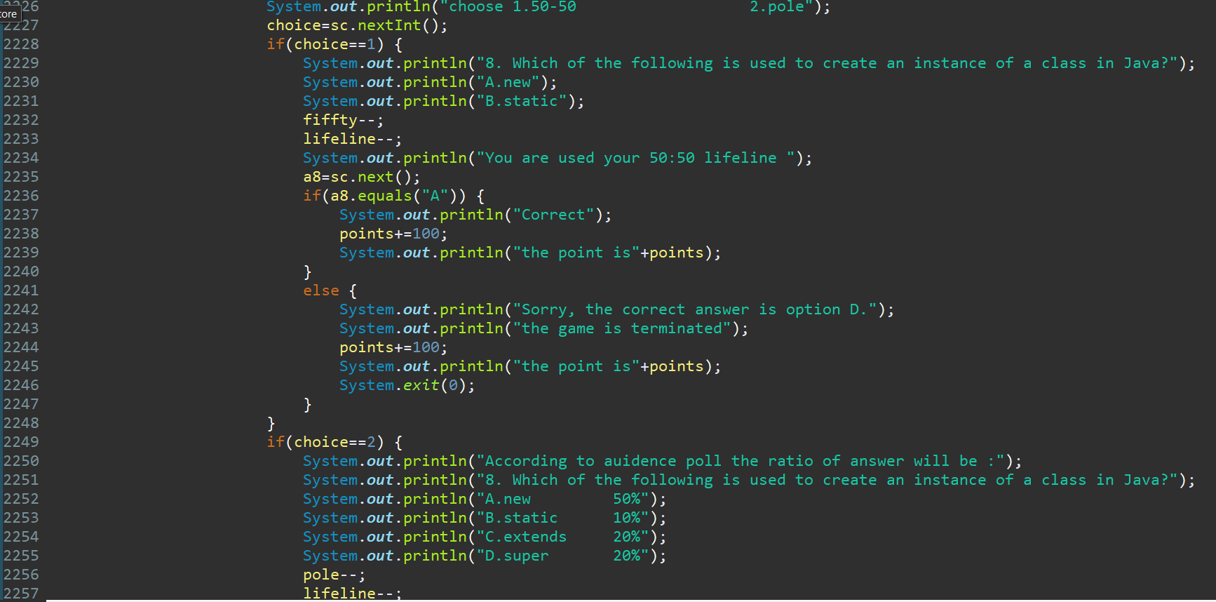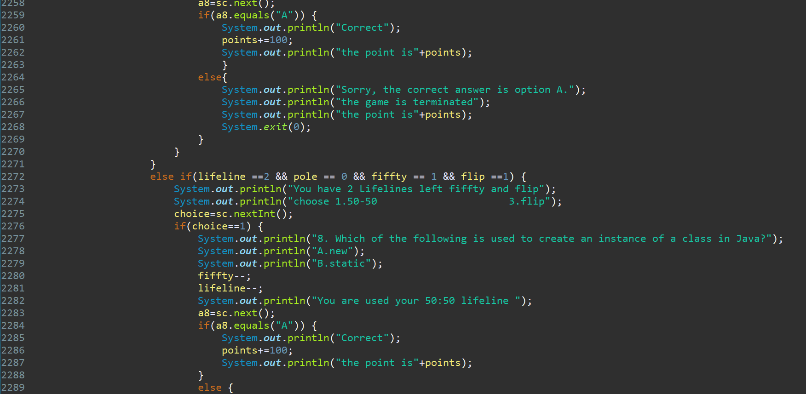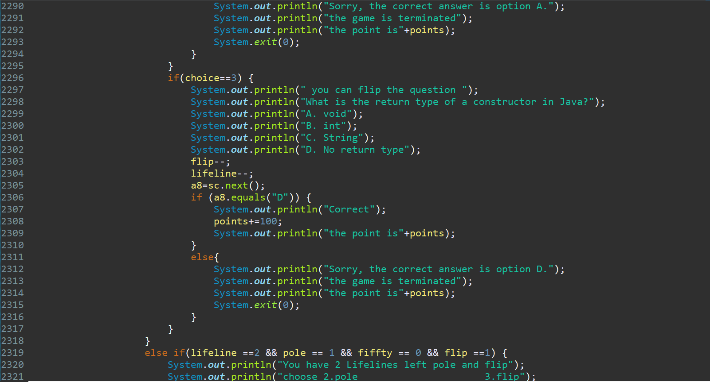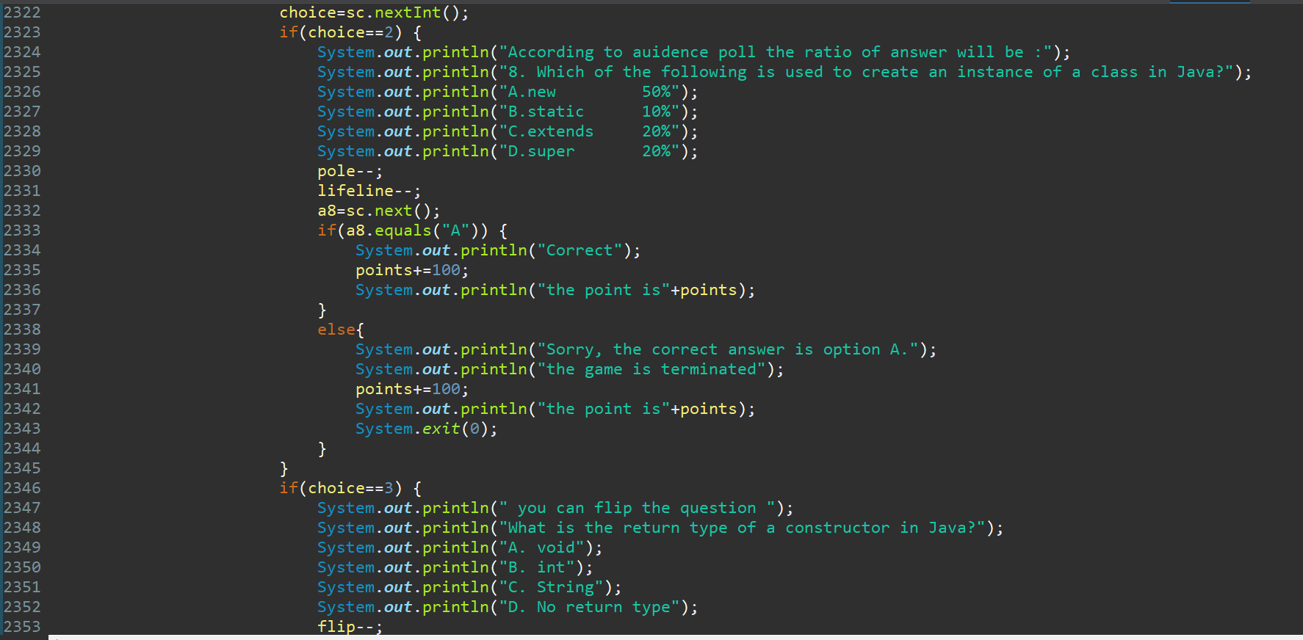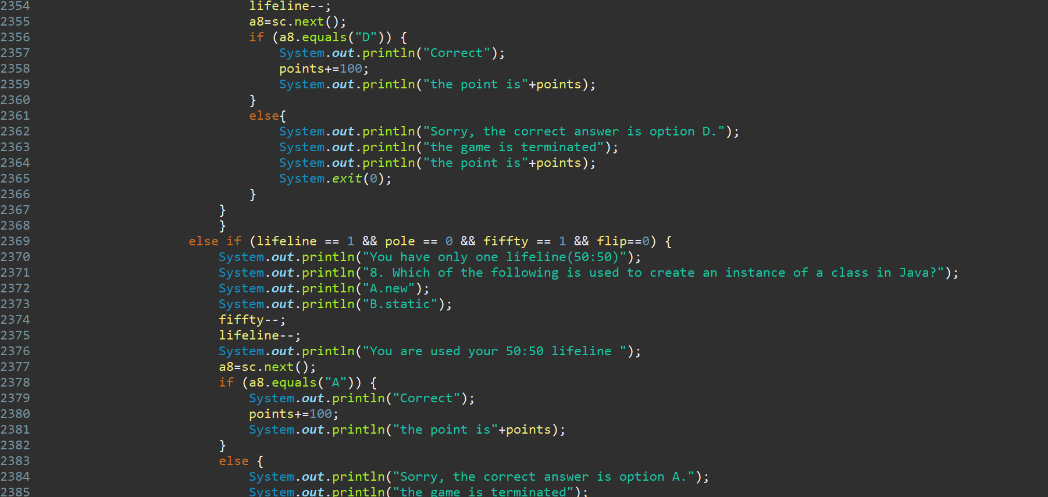

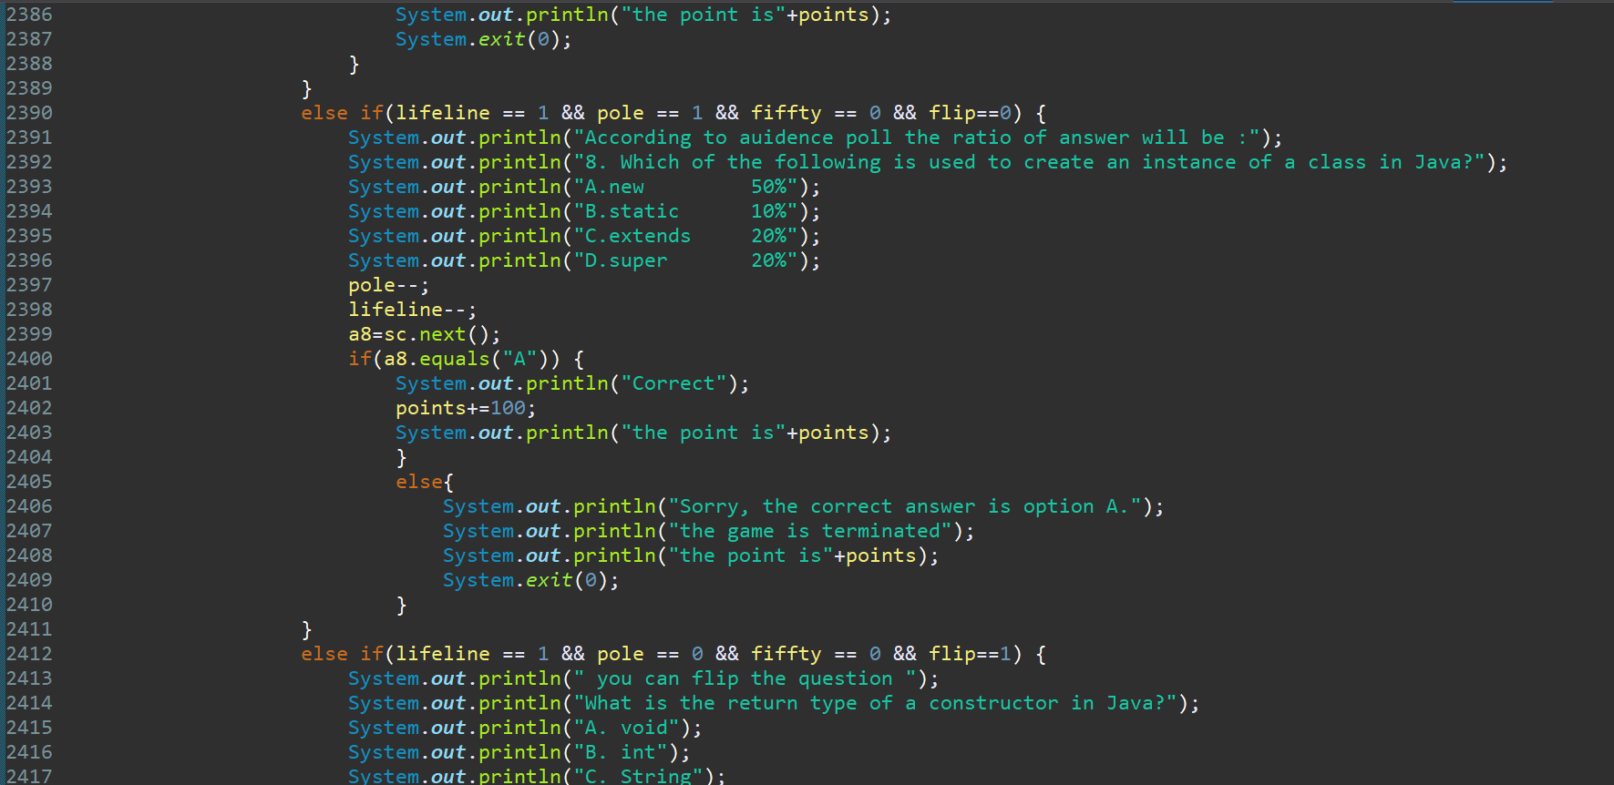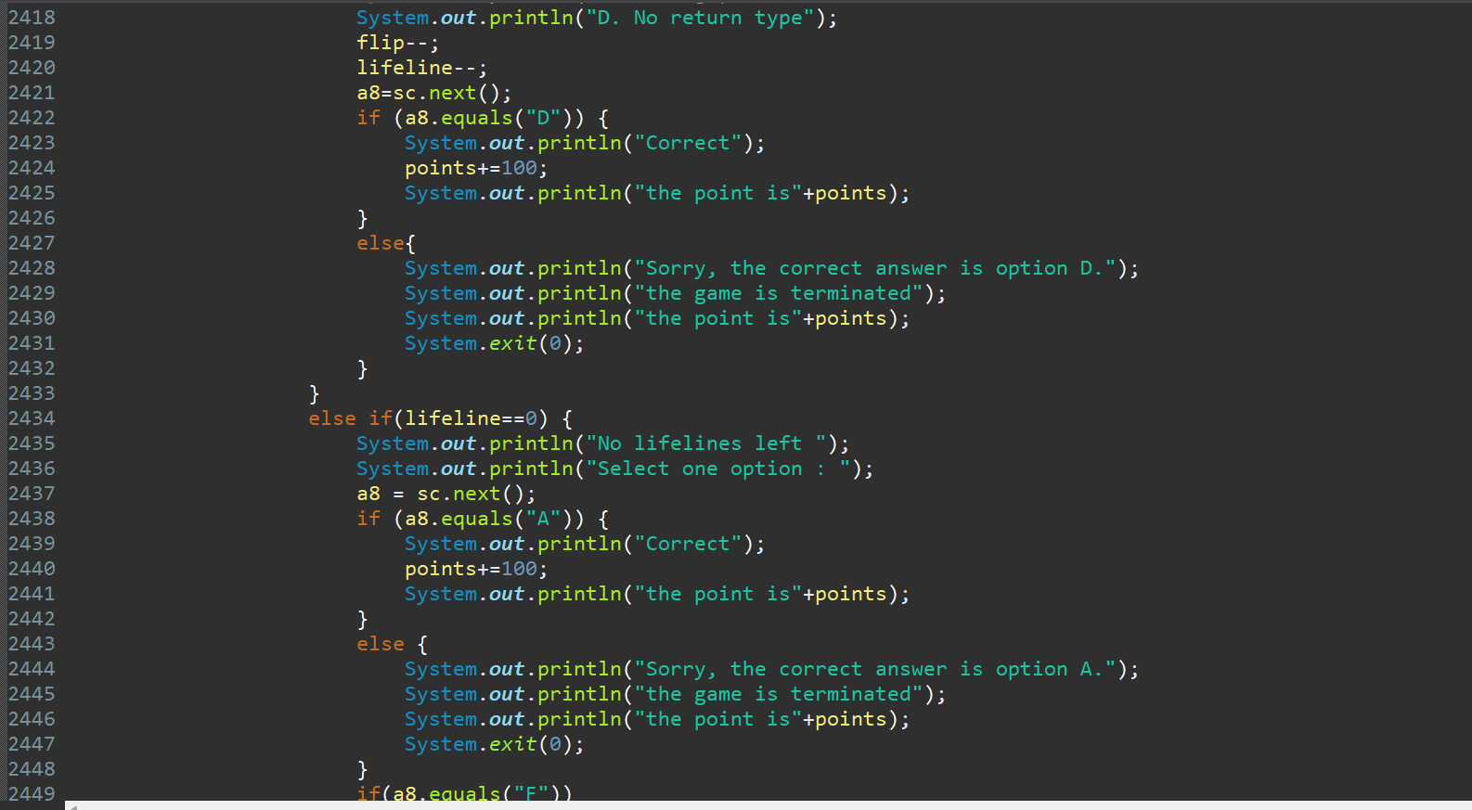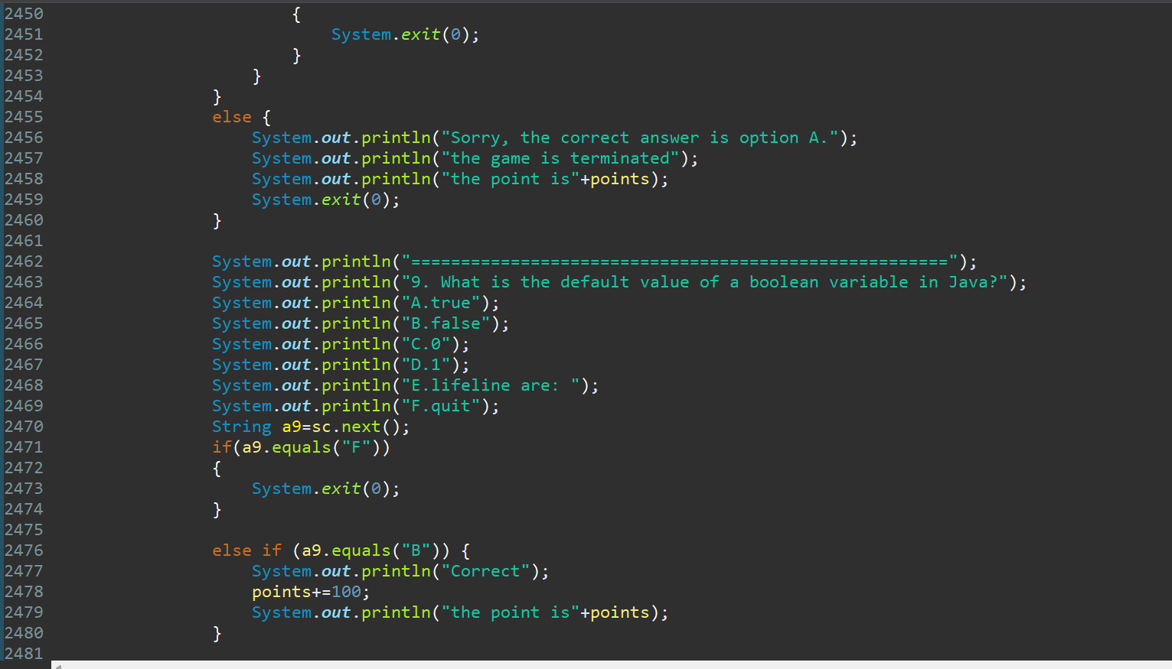

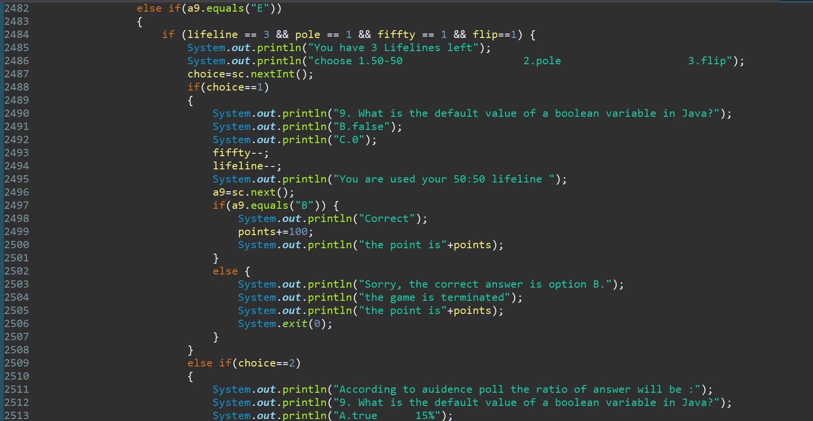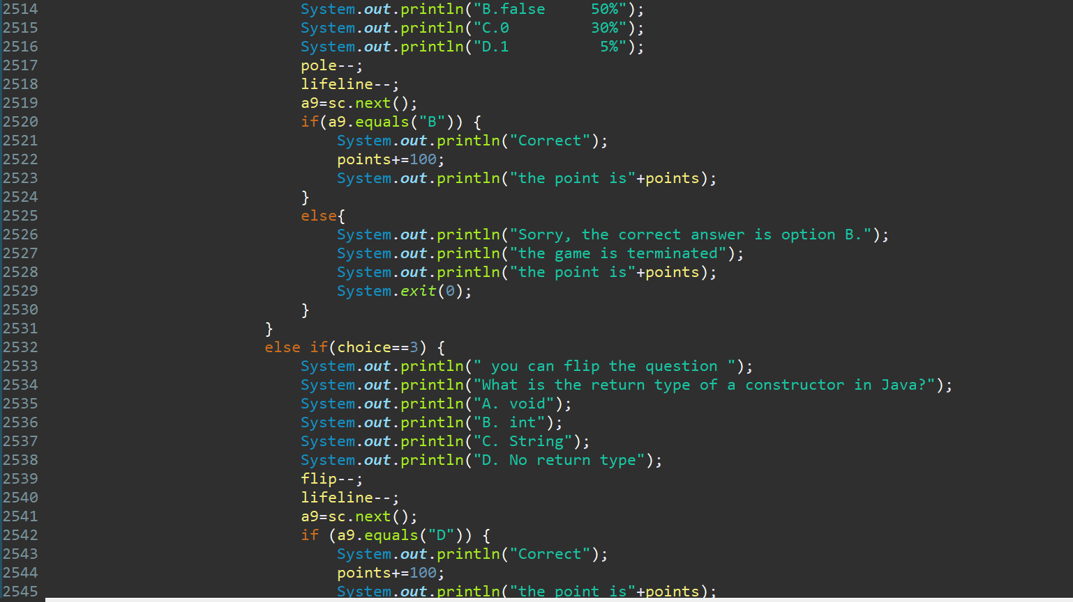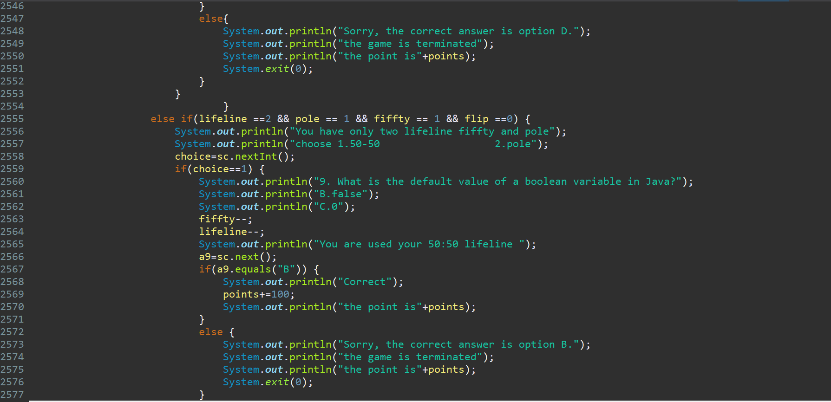

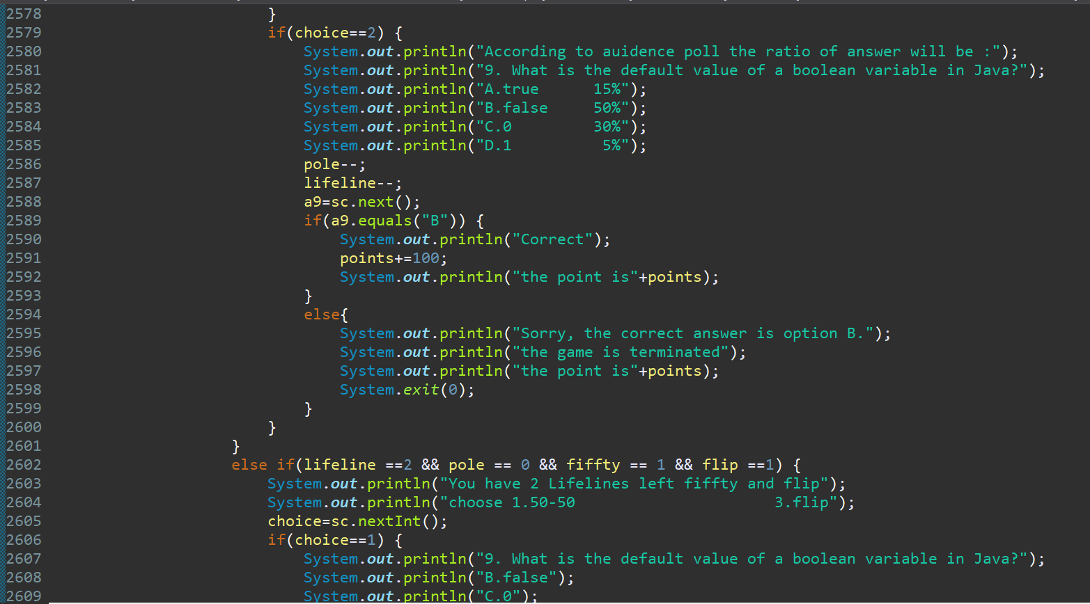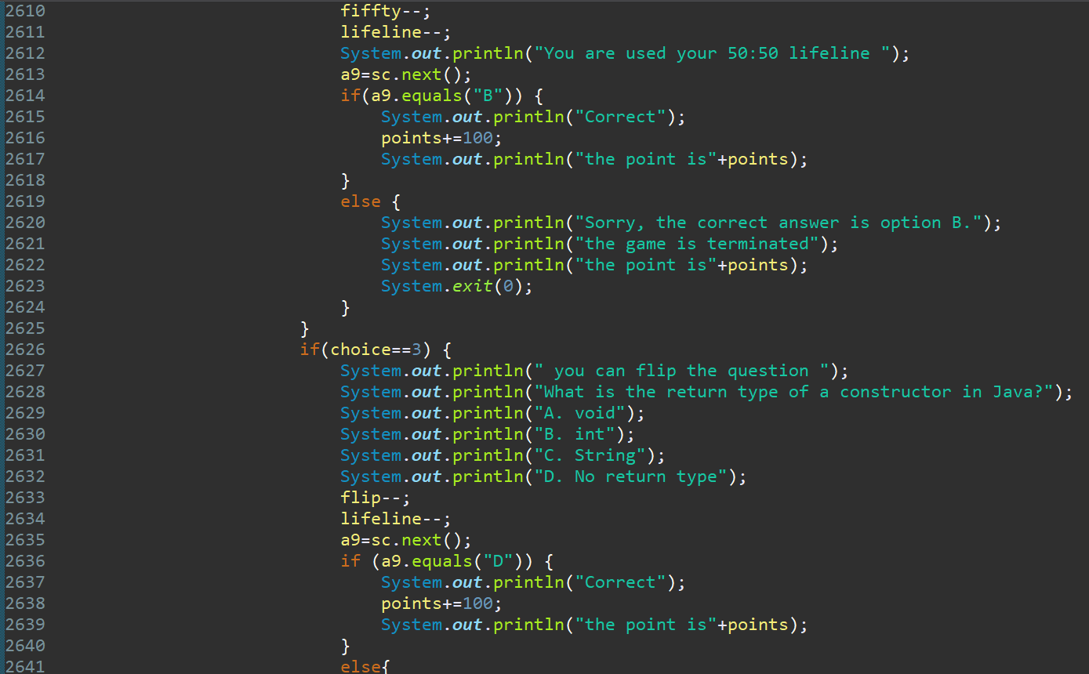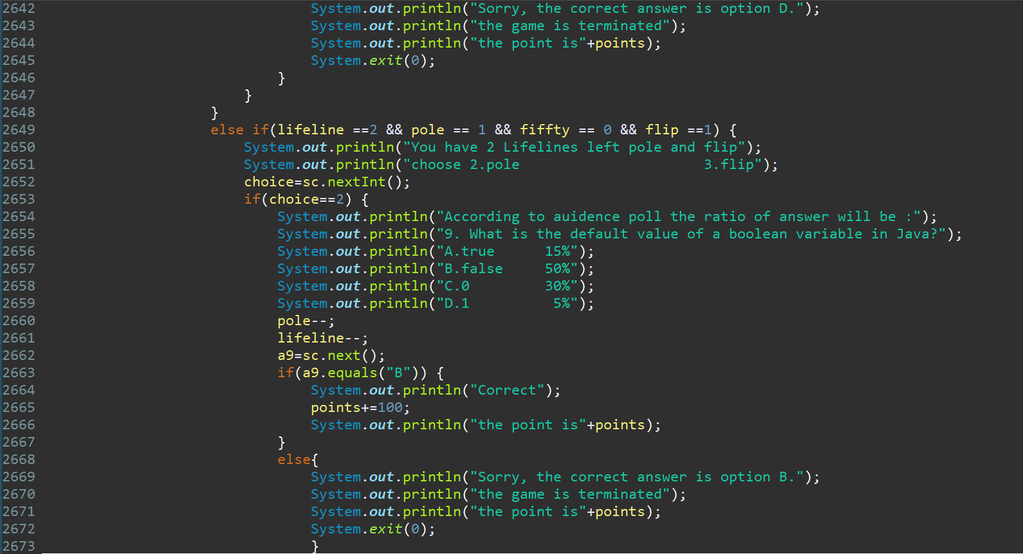

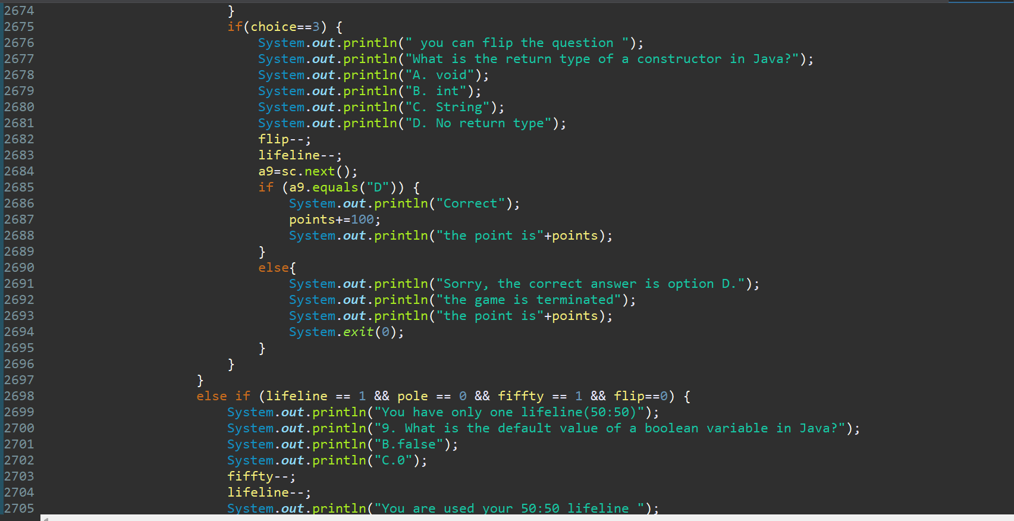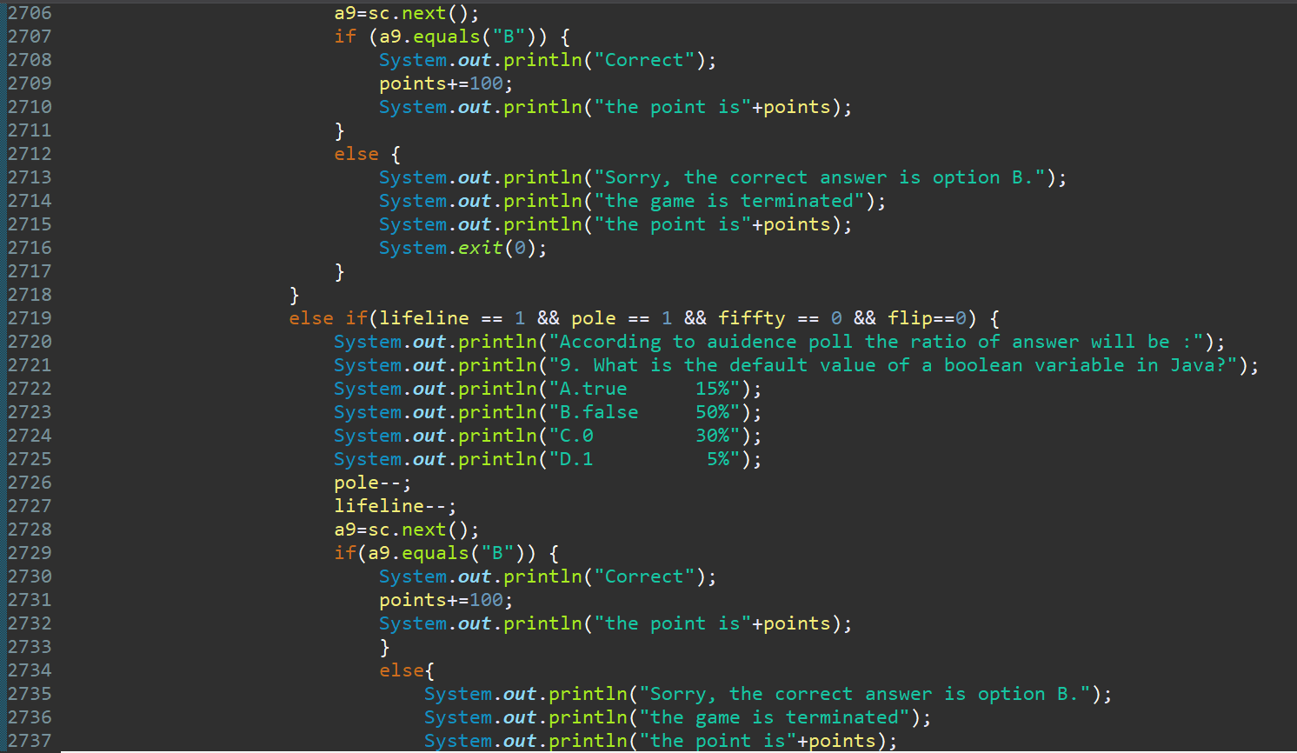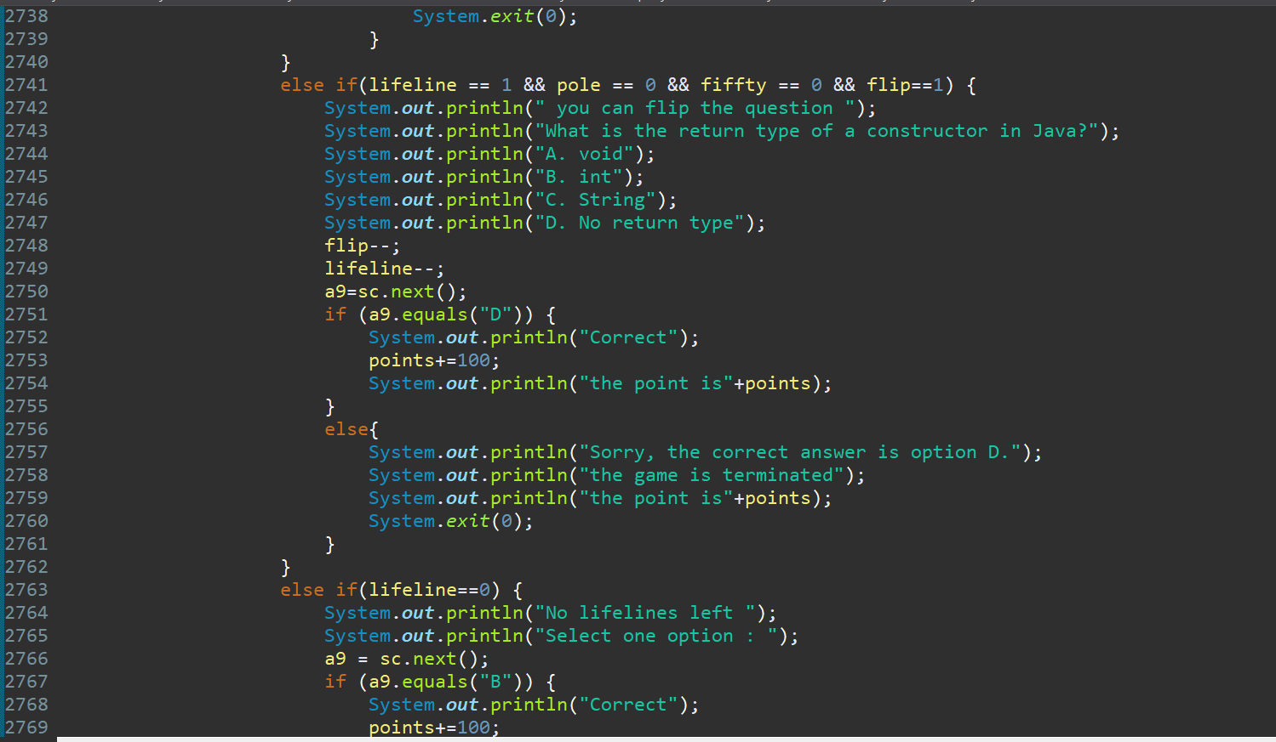

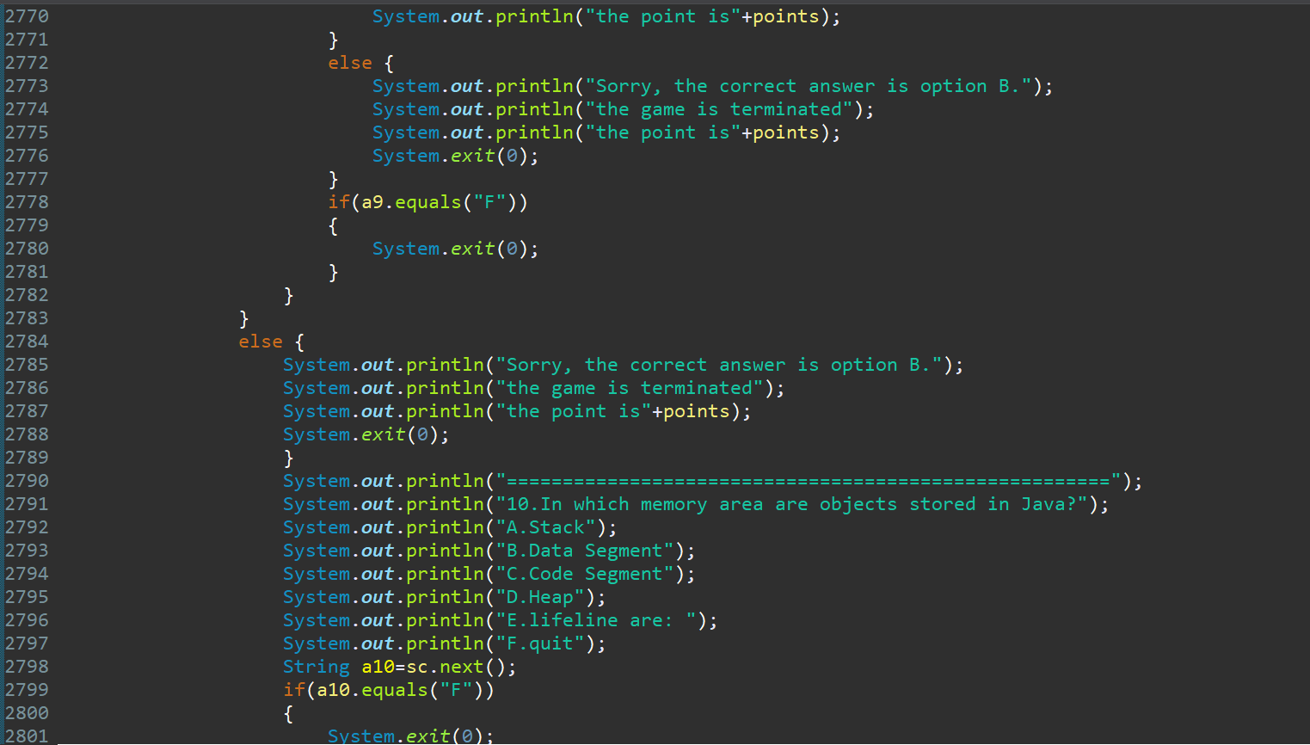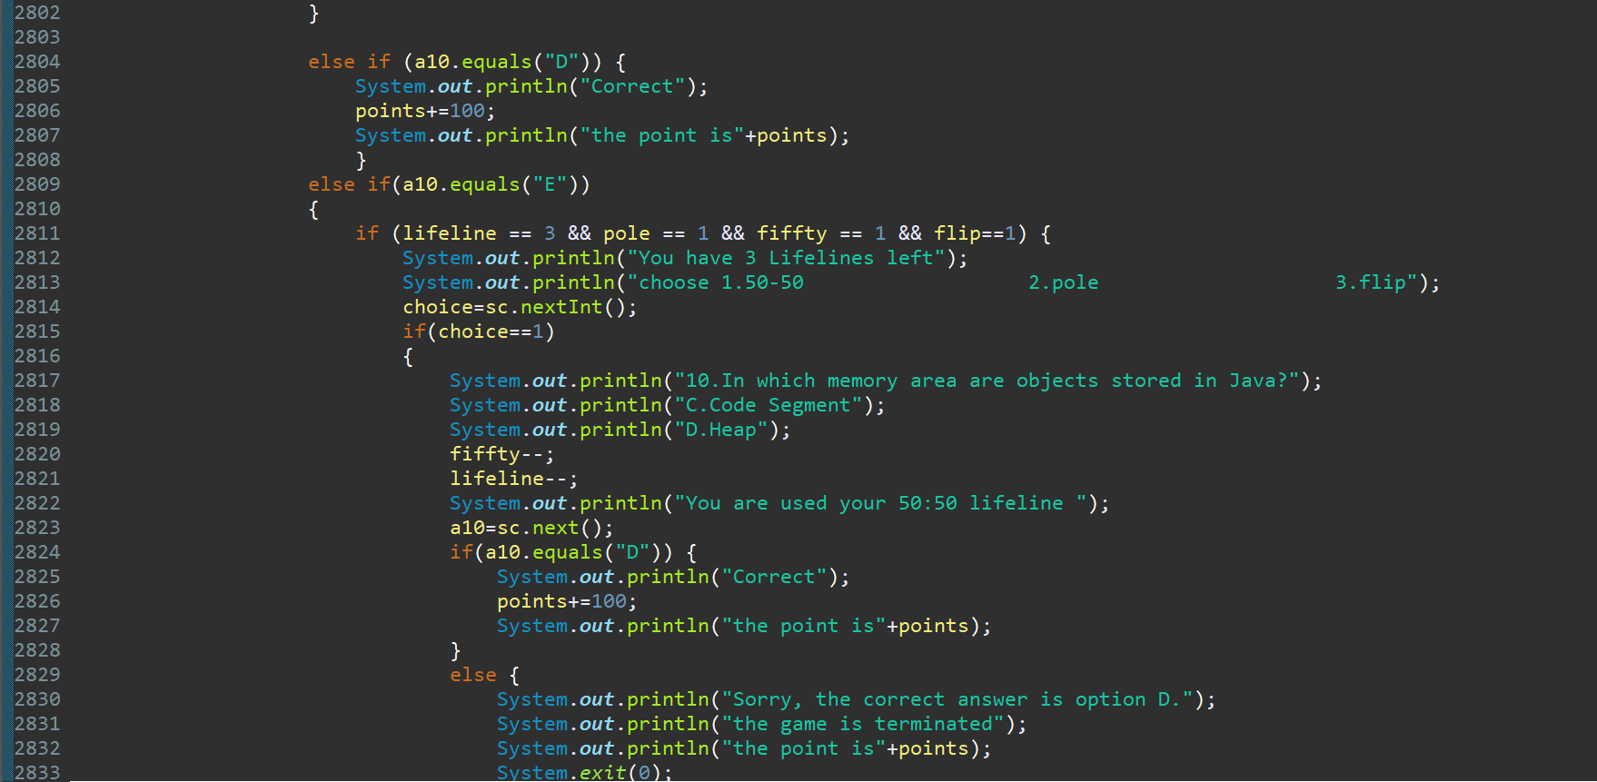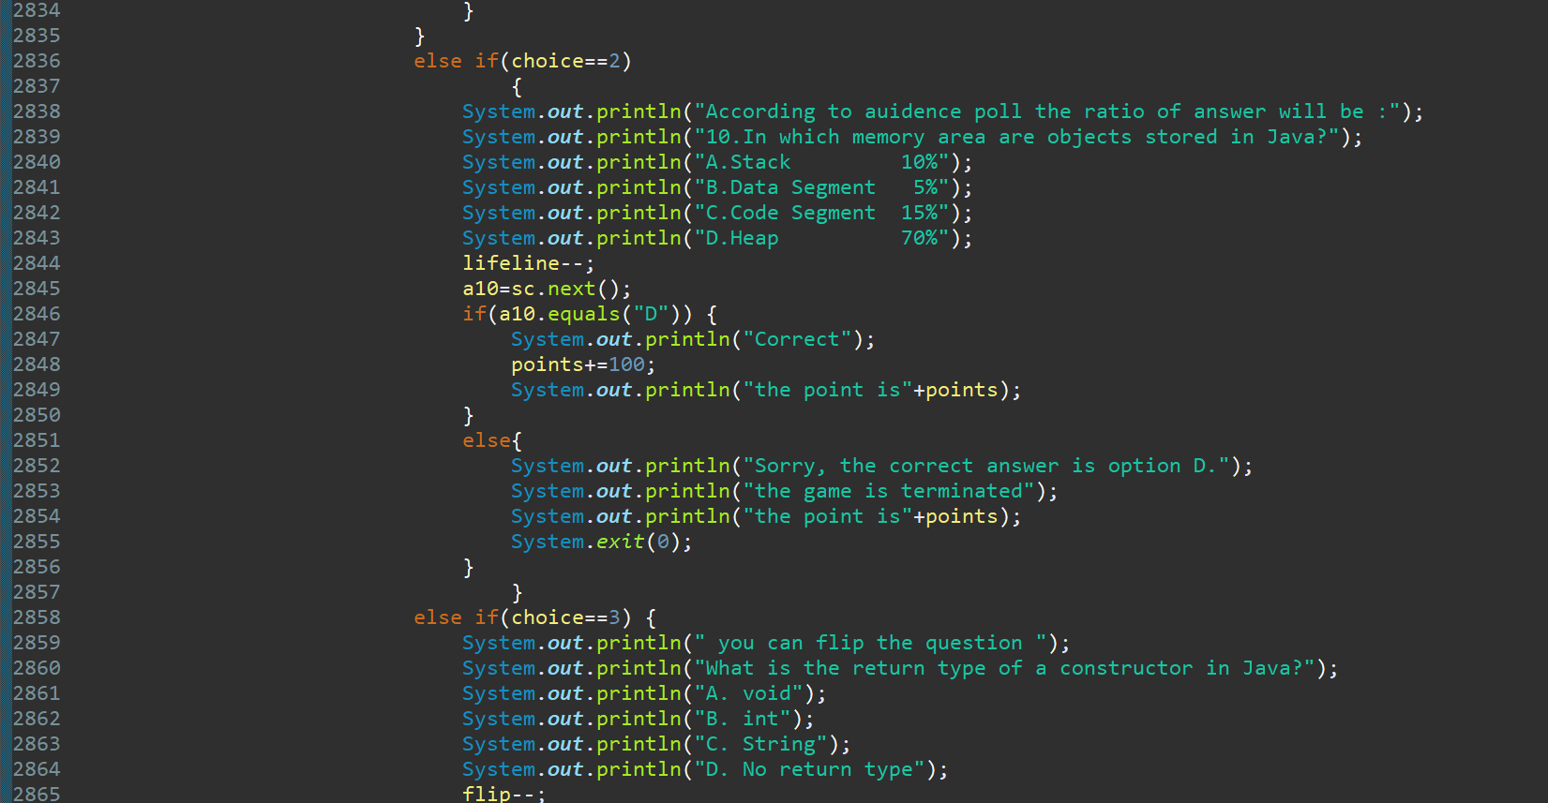

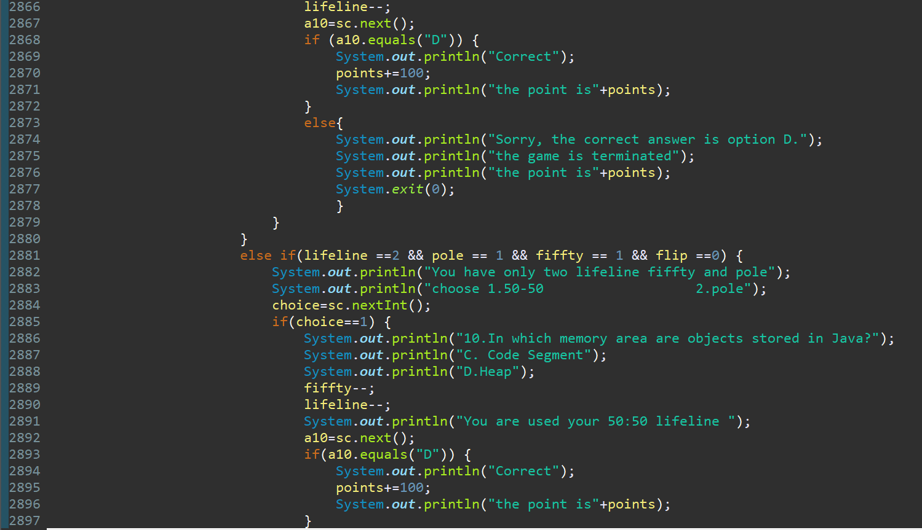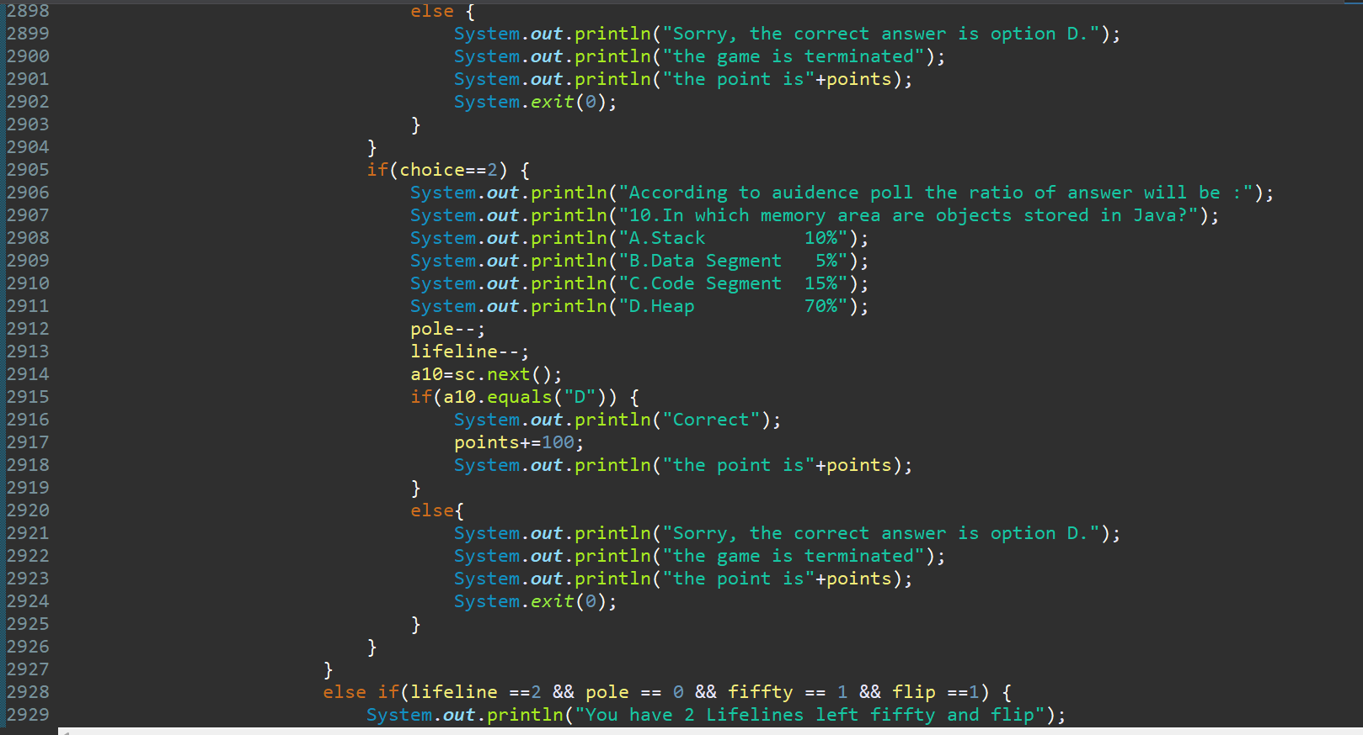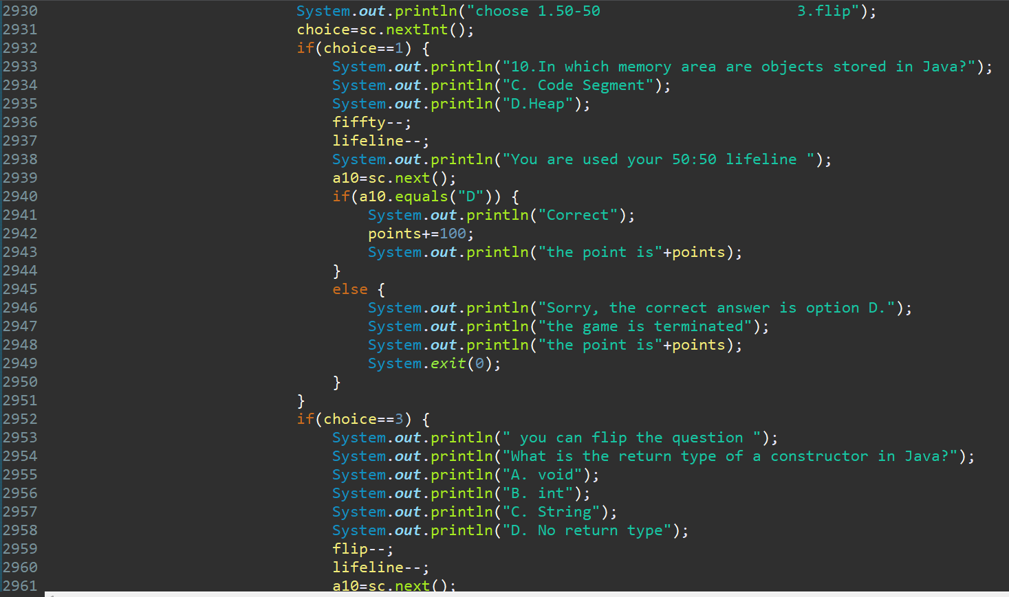

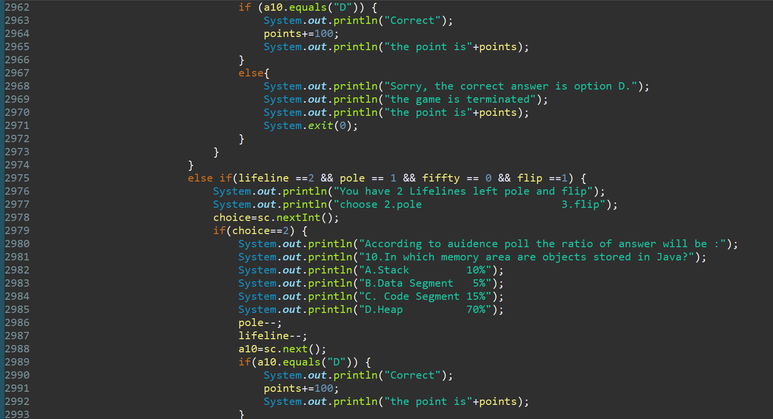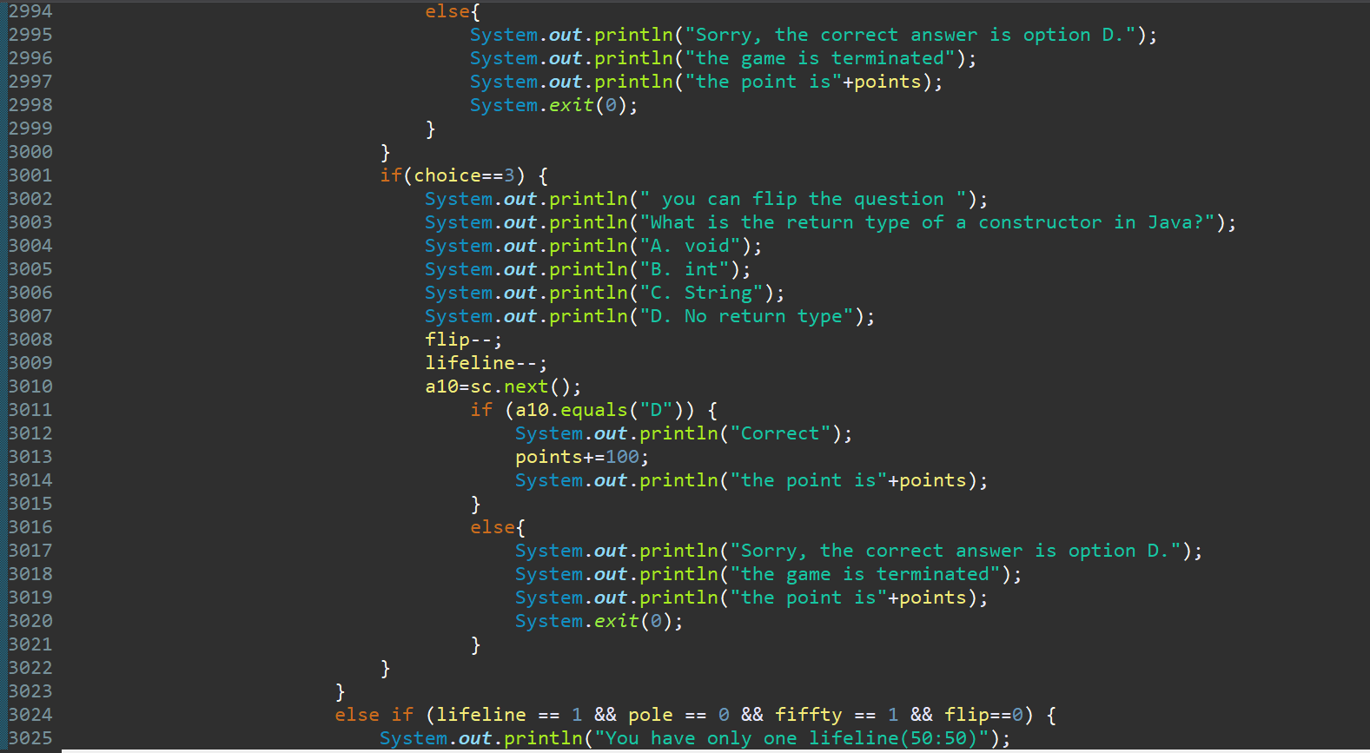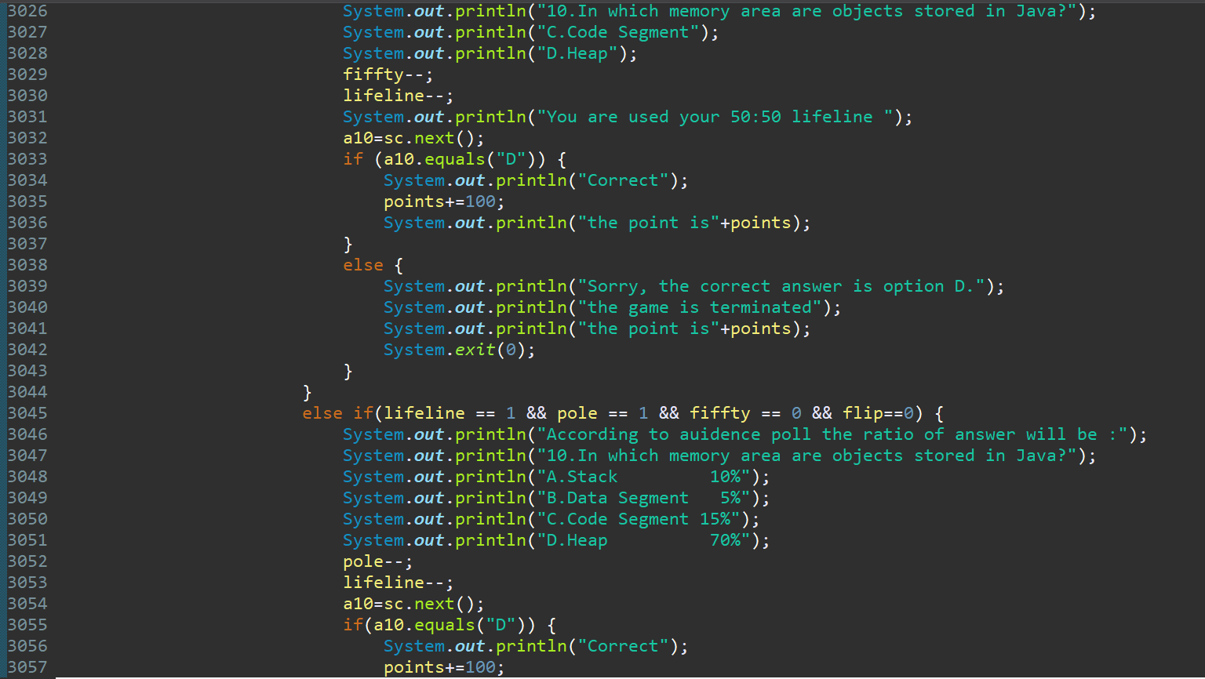

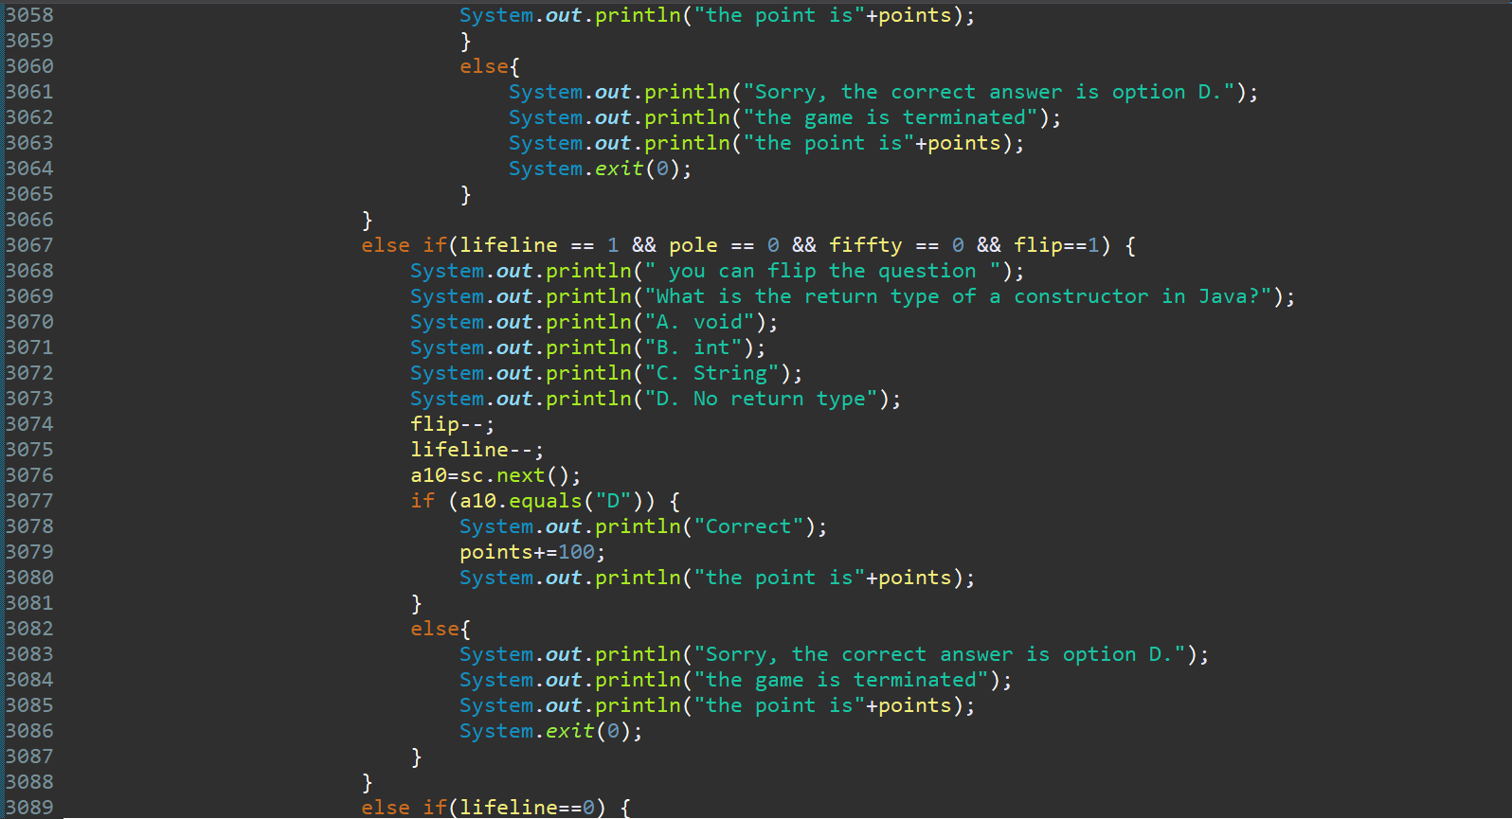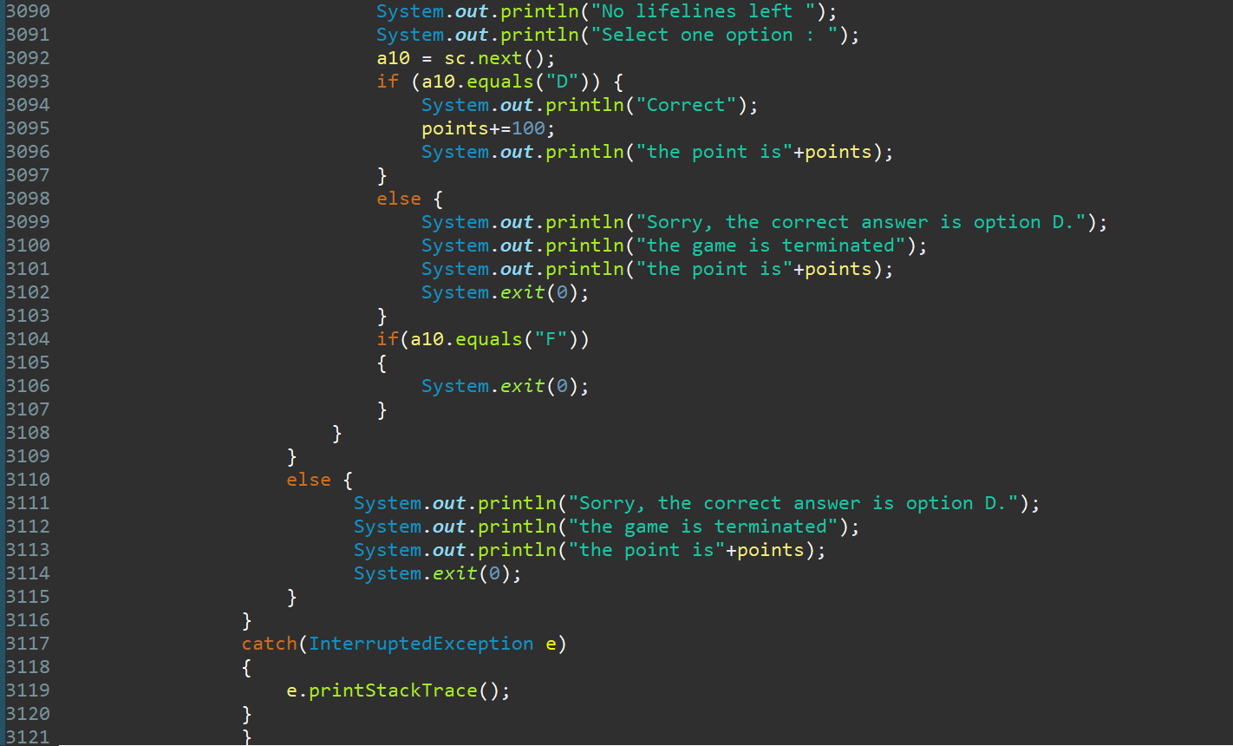

# 08. Output Screenshots

The screenshots illustrate the quiz’s interaction flow, including user input, lifeline usage, and scoring. 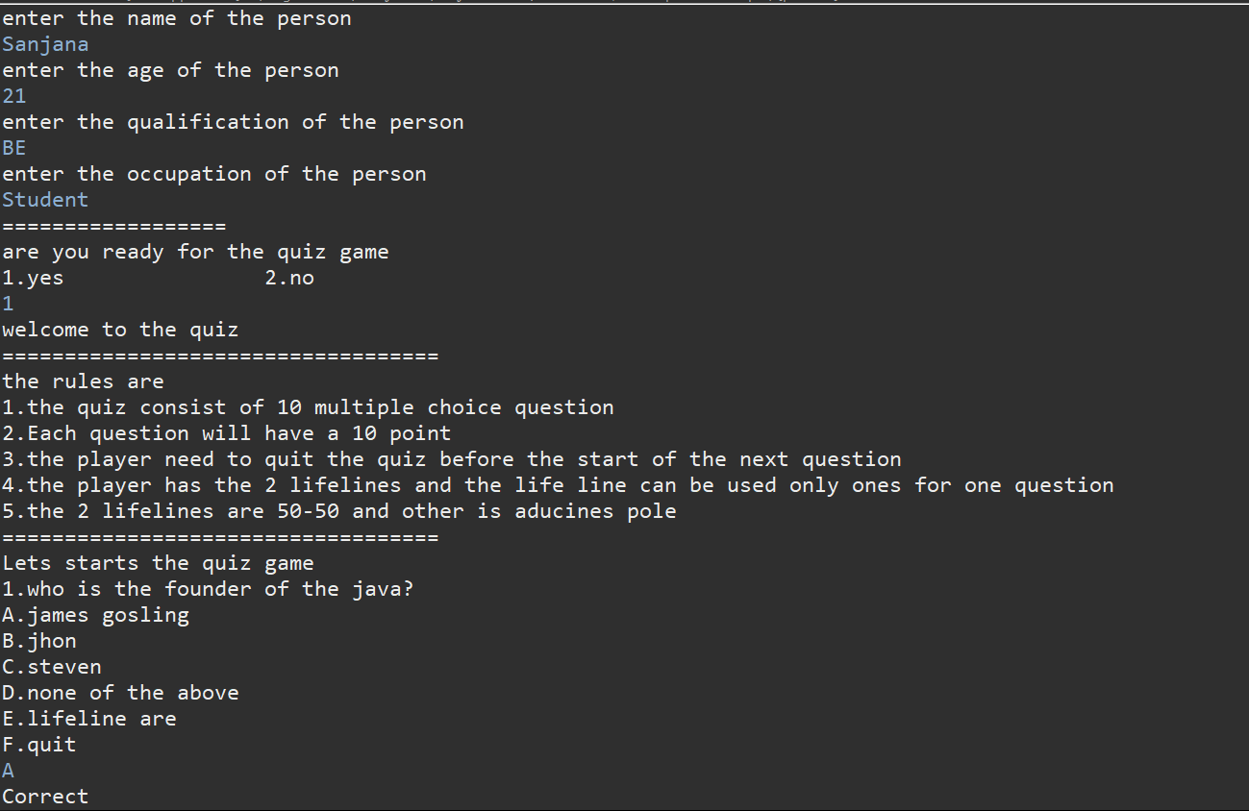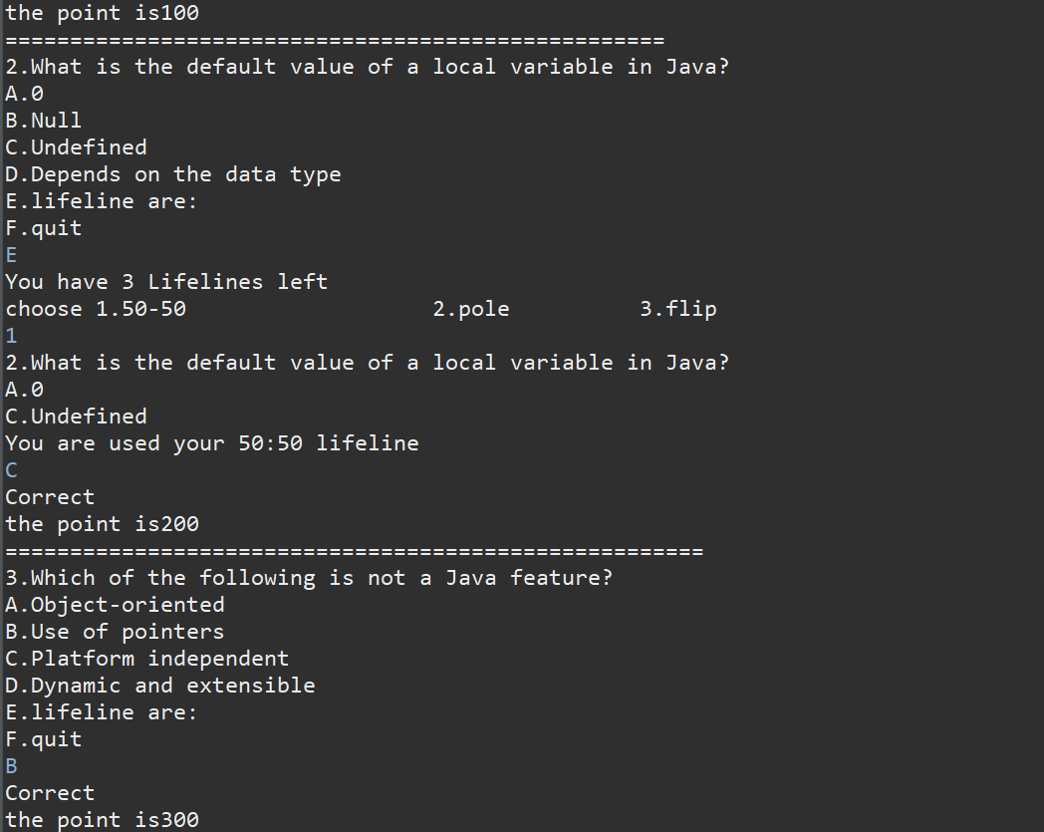

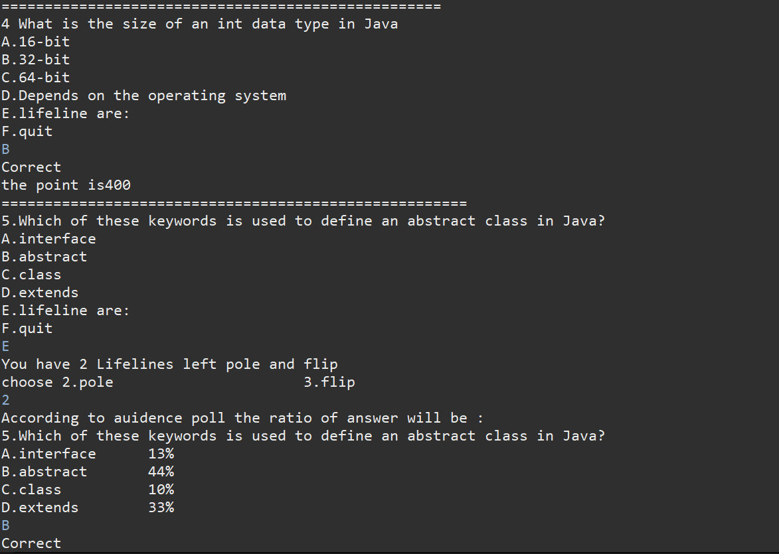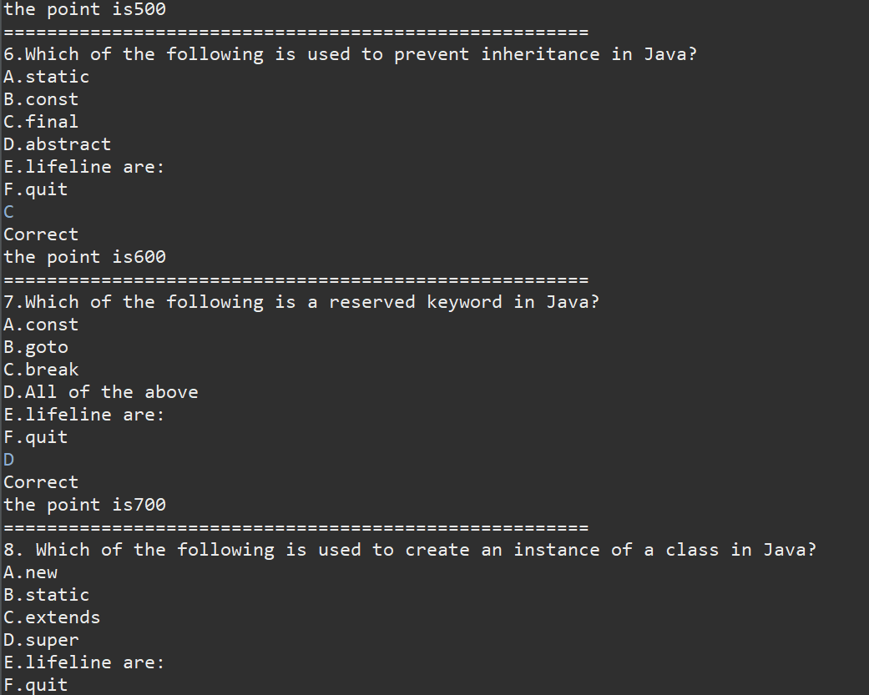

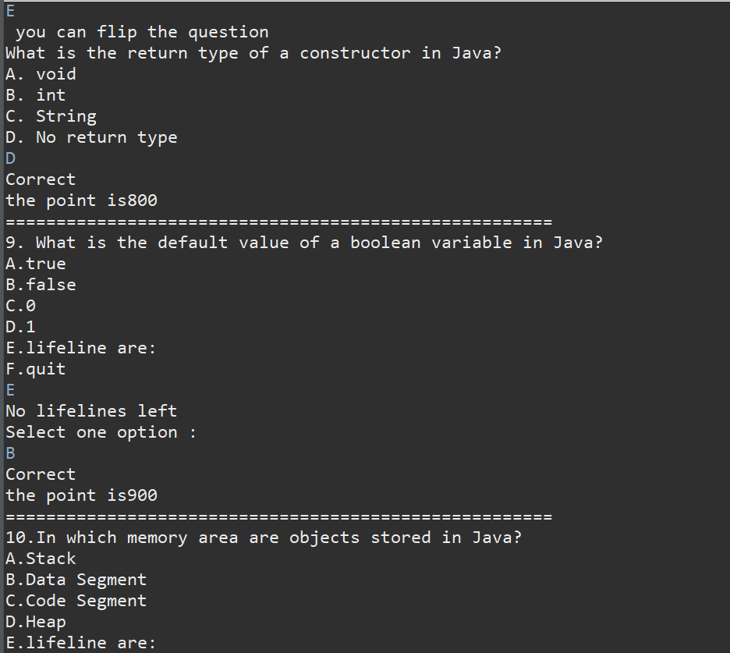

# 09. Conclusion

The Console-Based Quiz Application provides a balanced mix of education and entertainment. Its Java-based design ensures stability and efficiency, while lifelines add depth to the quiz experience. The single-class architecture simplifies maintenance and expansion.